TI 24 – 11 Technology Example – Flare Gas Recovery System (Zeeco) Rev 02
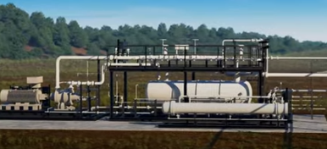

What Is a Flare Gas Recovery Unit?
A flare gas recovery unit (FGRU) is a system that captures flare gases and redirects them back into production workflows for reuse as fuel gas. This process helps to reduce routine flaring and emissions while saving operators on long-term production costs.

How Does a Zeeco Flare Gas Recovery Unit Work?
The flare gas recovery process is made up of several steps. To begin, gases are redirected from the flare header to the FGRU. Gases pass through a compressor and then go to a separator to remove any liquids. The gases then leave the separator, are cooled, and go to a knockout drum to remove any condensates before heading back to the plant or facility for reuse. If, at any point, an upset occurs that requires a flaring event, the flare gas recovery process is stopped so that waste gases can be safely destroyed by the facility's flare.

Typical FGRU Sizing:
  - Flowrate ranges: 0.1 to 10MM SCFD (11,100 NM3/hr)
  - Pressure ranges: 35 to 300 psig (20.7 barg)

This is an example of this technology, Note: NSTA do not endorse or recommend specific technologies.
This is an extract from the Vendors website page for this product, the link for the full webpage is below for further information.

Vendors Website link: Zeeco Flare Gas Recovery Units

