

UKSS SECTION GUIDE
LICENSING

This section will appear for all licences that you have, including any that were relinquished in the current survey year.

If you think there are any errors with allocation, please contact
stewardshipsurvey@nstauthority.co.uk

Date of publication 29/10/2025

The document can be found on the NSTAs website.

© NSTA Copyright 2025
URN

You may re-use this information free of charge in any format or medium, under the terms of the NSTA’s User Agreement. To view this, visit: https://www.nstauthority.co.uk/site-tools/access-to-information/ or email correspondence@nstauthority.co.uk

This document is available in large print,audio and braille on request.
Please email: correspondence@nstauthority.co.uk with the version you require.

Enquiries to:
North Sea Transition Authority
50 Broadway
London
SW1H 0DB

Email: correspondence@nstauthority.co.uk

Published by the North Sea Transition Authority

Contents
1. UKSS 2025 CHANGES 4
2. PREVIOUS PROSPECTS 5
2.1 Proposed exploration and appraisal wells 5
2.2 Constrained wells 5
3. LICENCE ACTIVITY 6
3.1 Licence activity 6
3.2 Section A: Divestment or M&A activity 6
3.3 Section B: Geophysical datasets & work programme fulfilment 7
3.3.1. 2D and 3D Seismic surveys 7
3.3.2. Reprocessing 8
3.3.3. Other geophysical activity 9
3.3.4. Seismic data summary 10
4. PROPOSED EXPLORATION AND APPRAISAL WELLS 11
4.1 Proposed exploration and appraisal wells 11
4.2 Prospects copied forward from a previous survey 14
5. DRILLED EXPLORATION AND APPRAISAL WELLS 15
5.1 Drilled exploration and appraisal wells 15
6. CONSTRAINTS 17
6.1 Constraints 17
7. CHECKLIST 20
8. CONTACT DETAILS 21

- UKSS 2025 CHANGES

The following changes are being implemented in the Activity section of the survey:

- Guidance has been updated to clarify the definition of a purchased 2D seismic survey, an acquired (i.e. shot) 2D seismic survey, a purchased 3D seismic survey, and an acquired (i.e. shot) 3D seismic survey.

- PREVIOUS PROSPECTS

Wells that were proposed or constrained in the previous survey will be listed, and a number of actions can be taken based on the current status of the well.
Once all prospects have been updated you will be able to continue with the section.

Proposed exploration and appraisal wells
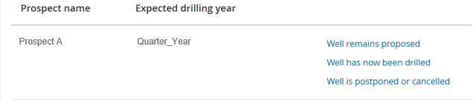For each previously proposed exploration and appraisal well:
- If the well has previously been proposed for a year other than the current survey year, and that remains the case, then it can be moved to the Proposed wells page (i.e. “well remains proposed”)
- If the well has now been drilled the prospect can be moved to the Drilled wells page
- If the well has been postponed or cancelled, the prospect can be moved to the Constraints page where you should add commentary to explain the reasons for postponement or cancellation.

Constrained wells
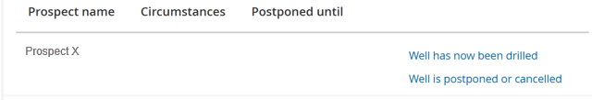
For each previously constrained well:
- If the well has now been drilled the prospect can be moved to the Drilled wells page
- If the well has been postponed or cancelled, the prospect can be moved to the Constraints page.
- LICENCE ACTIVITY

3.1 Licence activity
The questions relate to the ‘survey year’.
This section applies to any licence held during the survey year and extant at the time of the Survey invite. Please contact the help desk if a licence was held for only a short part of the year, or you have assigned the licence elsewhere and not done any work in the survey year (please say when assignment took place and who the licence was assigned to).
Notes:
- This survey replaces the requirement for the Quarterly Licensing Report.
- Only hydrocarbon activity should be entered into the Licensing section at this time. Please do not provide details of activity on Carbon Storage licenses at this time.
Please use the comment boxes to provide supporting detail.

3.2 Section A: Divestment or M&A activity
Answer either Yes or No to following questions:
- Is the licence subject to current divestment activity, or planned activity within the next 12 months?
e.g. Farm-down to provide funding to drill an Obligation well.
If Yes, then briefly describe the activity.
- Do you plan to relinquish this licence in the ‘survey year’?
- Was the licence relinquished during the ‘survey year’? (Do not include partial relinquishments).
Answer yes only if the appropriate relinquishment documentation has been supplied, an application to relinquish submitted via PEARS and the request accepted by the NSTA.
If Yes, then describe the relinquishment.
- Do you have an activity plan document to upload?
If No, then please explain why you don’t have a document.
If Yes, then upload the activity plan. Please attach a file that describes the Activity Plan in terms of key line items and timeframes (e.g., Virtual Data Room from date XXX to Date YYY; Well investment decision by Date ZZZ).

3.3 Section B: Geophysical datasets & work programme fulfilment

3.3.1. 2D and 3D Seismic surveys
Please provide data on all seismic surveys that have been in active use on this licence during the last 12 months.
These should include all purchased 2D and 3D seismic surveys, as well as all acquired 2D and 3D seismic surveys, for the licence in the last 12 months.
These should not include any surveys that have been acquired on a Carbon Storage licence or for the purpose of defining carbon storage potential.
Please provide a description of the data, including survey name, general survey design (fold, cable length etc.), acquisition and processing contractors, and acquisition date (for purchased surveys only).
NSTA would prefer the NSTA Survey Identifier Standard (formerly CS9) name, but the contractor survey name is acceptable.
For any seismic surveys purchased or shot, the following data will be requested:
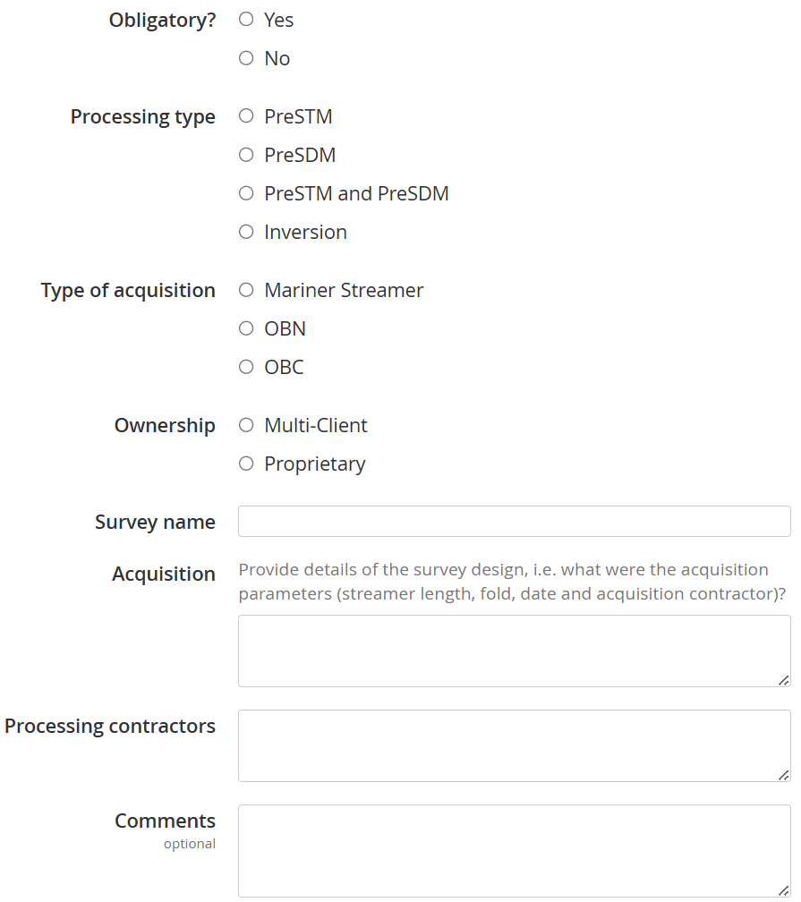
Notes:
- When stating the survey name, the NSTA would prefer the NSTA Survey Identifier Standard (formerly CS9) name, but the contractor survey name is acceptable.
- For the acquisition, please provide details of the survey design.
i.e. what were the acquisition parameters (streamer length, fold, date and acquisition contractor).
- There is a dedicated space provided for you to include any additional comments.

3.3.2. Reprocessing
If there has been any reprocessing of seismic data on a licence, then the following data will be requested:
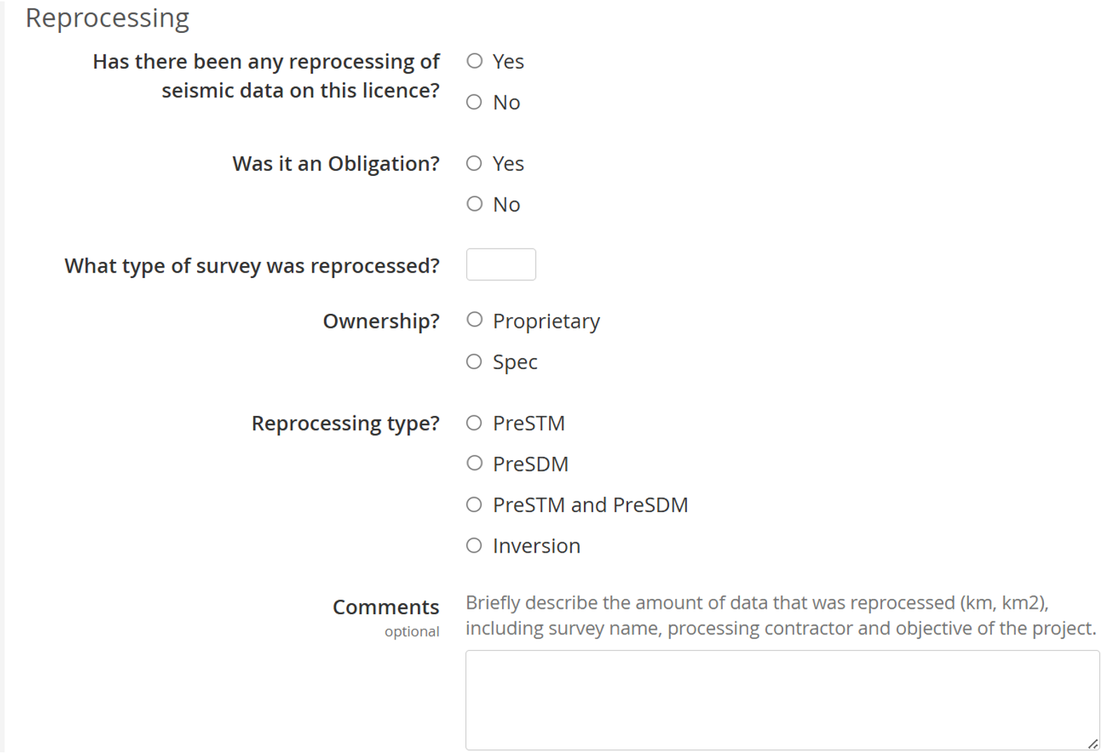
Notes:
- The ‘What type of survey was reprocessed?’ options are: 2D, 3D, OBN, or OBC.
- There is a dedicated space provided for additional comments that briefly describe the amount of data that was reprocessed (km, km²), including survey name, processing contractor and objective of the project.

3.3.3. Other geophysical activity
If there has been other geophysical activity for this licence in the last 12 months,
then select and fill in the requested data:
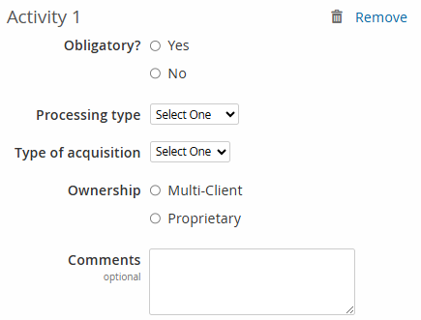
Notes:
- Processing type options are:
  - PreSTM
  - PreSDM
  - Inversion
  - Gravity
  - CSEM 2D/3D
  - Aeromag
  - IP
  - Other
If ‘Other’ is selected, then please provide details in the comment box.
- Type of acquisition options are:
  - Site survey
  - Gravity
  - Magnetic
  - IP
  - CSEM 2D
  - CSEM 3D
- There is a dedicated space provided for you to include any additional comments.
- Any activities added in the survey year can also be removed.

3.3.4. Seismic data summary
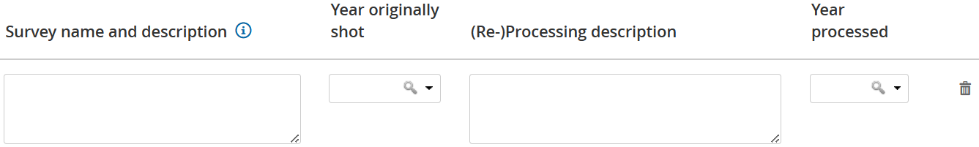
The purpose of this section is to provide a full inventory of the seismic data that is being used in the licence, and when this dataset was processed. Please click on to list all seismic surveys that are in active use on the licence, following the indications below:
Survey name and description - Year acquired (the date originally shot):
- Start with the most recent seismic survey
- Name of the survey (indicate if it is 2D or 3D)
- Year acquired pertains to the date that the survey was originally shot
- Seismic Data that is not being used (old 2D's etc) does not have to be included
- Seismic surveys over the licence but not available to or used by the licence holder should not be included.
(Re)processing description - Year processed:
- Type of processing PSTM, PSDM, Broadband, Inversion?
- Please indicate the year when the latest processing was completed
- If the processing was done as part of a multiclient purchase, please indicate the year it was completed.
Notes:
- You can also remove seismic surveys by clicking on the delete icon .
- Please add seismic surveys (whether purchased or shot) where activity was within this survey year only.
- Year processed is now mandatory.

- PROPOSED EXPLORATION AND APPRAISAL WELLS

4.1 Proposed exploration and appraisal wells
Please tell us about all the prospects and discoveries you consider will or may mature towards drilling. The Licence Operator should complete this section for all E & A wells planned in any Licence Term, including those where the Well Operator is different from the Licence Operator.
If ‘Yes’ is selected for the question
Are there any prospects or discoveries you may mature towards drilling during the Initial Term of the Licence (or during the next four years in any other term)?
Then use the button to include all prospects in this section unless drilled or cancelled.
If the prospect is postponed, please include in this section and provide further details on the 'Constraints' page.
For each prospect/discovery the following data will be requested:
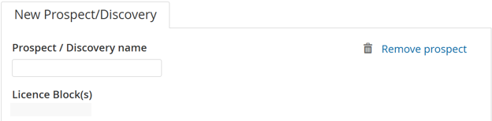
Note 1: The licence block(s) is prepopulated.
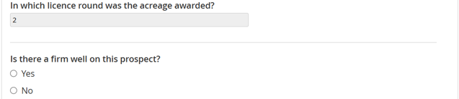
Note 2: If there is ‘No’ firm well licence commitment, then you must
- indicate to the nearest month 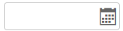when a firm drilling commitment / investment decision will be made
- indicate what outstanding activity this decision is dependent upon.
Please include equity changes, commercial and subsurface considerations as appropriate.

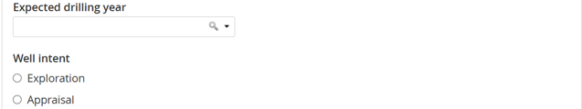
Note 3: An Exploration well is the first well to drill into a Prospect at a particular Stratigraphic horizon. This includes exploration “tails” on development wells where the intent of drilling the tail is to test a target deeper than the development target.
An Appraisal well is drilled after the discovery of oil or gas to establish the limits of the reservoir, the productivity of wells in the discovery, and the properties of the oil or gas already discovered, etc.
Note 4: Please note the Total gross cost of the well is captured in the WELLS section of the survey.

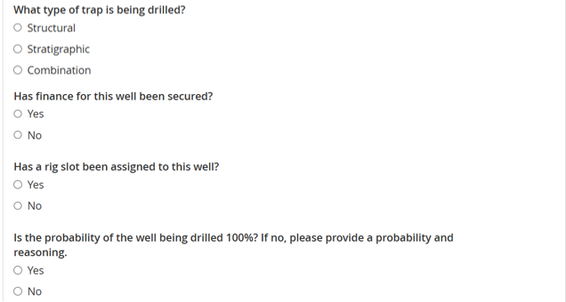
Note 5: If there is not a 100% probability of the well being drilled, then you must state and explain your chosen probability.
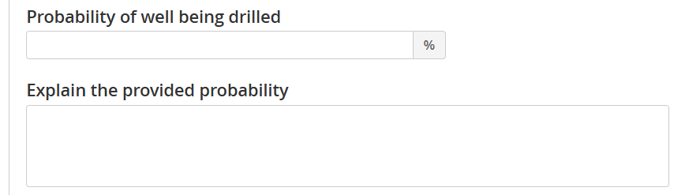
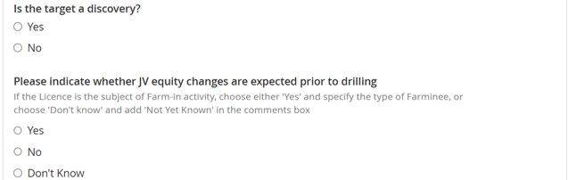
Note 6: If the Licence is the subject of Farm-in activity, choose either 'Yes' and specify the type of Farminee, or choose 'Don't know' and add 'Not Yet Known' in the comments box.
Note 7: If ‘Yes’ is selected, then data will be requested about the Expected co-venturers and ownership proportions:
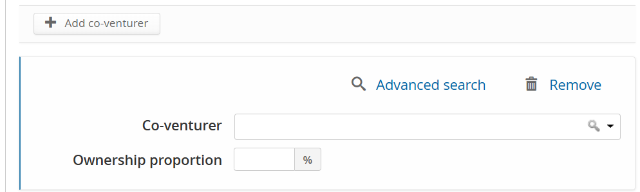
Please indicate the expected co-venturers in the well, indicating the proportion ownership for each co-venturer. This information will be used to inform HMRC's modelling of future tax payments only and will not be used by NSTA or HM Treasury to inform future policy development nor will companies be held to the responses given. It is understood by Government that the information is subject to change.

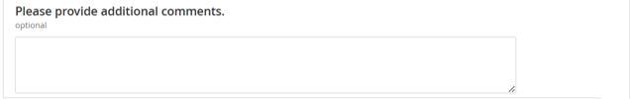
In the additional comments box, include additional subsurface, project or commercial risks. Please tell us about all the prospects and discoveries you consider will or may mature towards drilling during the Initial Term of the Licence (or during the next four years for second term licences).

4.2 Prospects copied forward from a previous survey
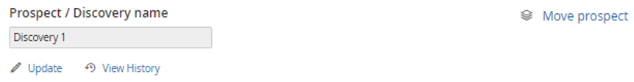
Although a prospect copied forward cannot be removed, it can be marked as cancelled by moving it to the Constraints page. e.g.
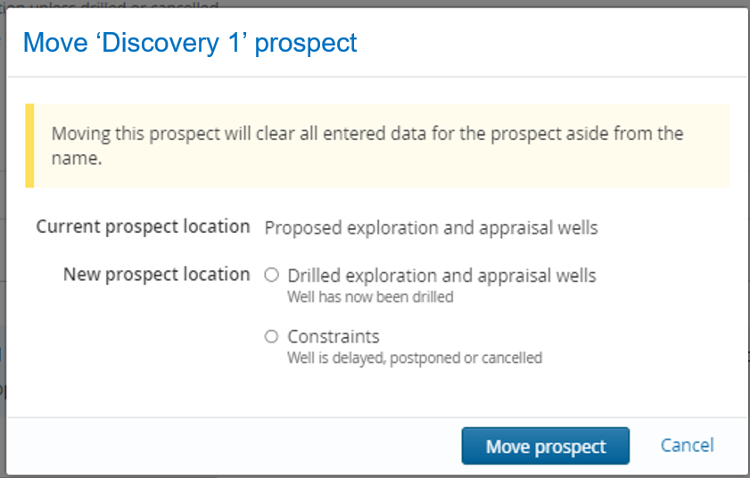
Moving a prospect will clear all entered data for the prospect aside from the name.
Cancelled prospects will not be copied forward into next years survey.

- DRILLED EXPLORATION AND APPRAISAL WELLS

Drilled exploration and appraisal wells
Please tell us about the outcome of each exploration and appraisal well spudded during in the survey year (please also include wells spudded in the previous year, but not completed until the survey year).
If ‘Yes’ is selected for the question
Were any Exploration or Appraisal wells drilled on the licence in the ‘survey year’?
Then use the button to include all prospects in this section.

For each prospect/discovery the following data will be requested:
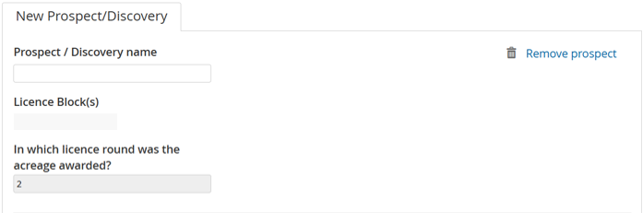
Note 1: The licence block(s) is prepopulated.
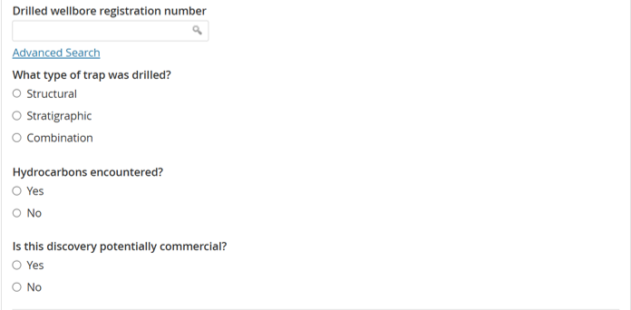
Note 2: If ‘No’ is selected, then a comment is required to detail why the discovery is not commercial.
Note 3: There is a dedicated space provided for you to include any additional comments.

- CONSTRAINTS

6.1 Constraints
Please tell us about the constraints that affected Exploration and Appraisal wells in the survey year.
The business environment for Exploration and Appraisal drilling has continued to change over the last 12 months. To investigate the extent and consequences of this change please indicate below, for wells planned to be drilled in the ‘survey year’ as outlined in your previous survey submission, but which were postponed or cancelled, what constraints affected the decision. Where not listed please describe the nature of the constraint.
If ‘Yes’ is selected for the question
Were any wells planned for the ‘survey year’ cancelled or delayed?
Then use the button to include all constraints information in this section and provide further well details on the 'Proposed exploration and appraisal wells' page.
For each well planned for the ‘survey year’ that were cancelled or delayed, the following data will be requested:
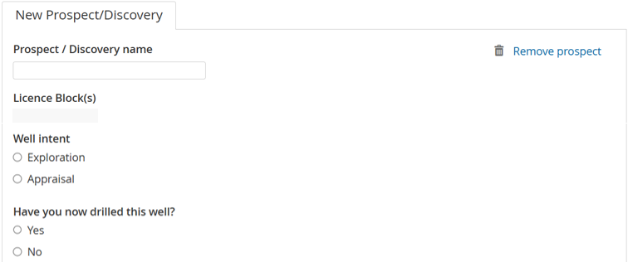
Note 1: An Exploration well is the first well to drill into a Prospect at a particular Stratigraphic horizon. This includes exploration tails on development wells where the intent is to test a deeper target.
An Appraisal well is drilled after the discovery of oil or gas to establish the limits of the reservoir, the productivity of wells in the discovery and the properties of the oil or gas, etc.
Note 2: The Total gross cost of the well is captured in the WELLS section of the survey.

Note 3: If ‘Yes’ is selected, then you must enter the wellbore registration number
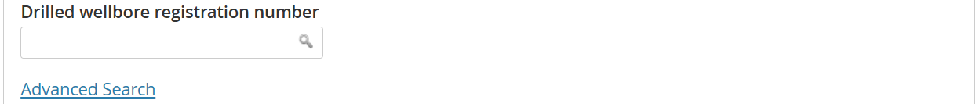
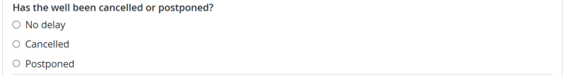
Note 4: Cancelled prospects will not be copied into next years survey.
Note 5: If ‘Postponed’ is selected, then you must enter an estimated drill date (to the nearest month) for the well.
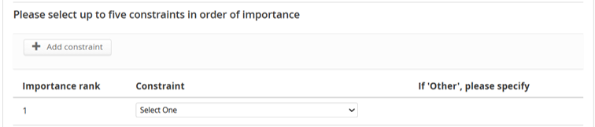
Note 6: Use the 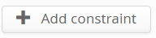 button to detail up to 5 constraints in order of importance.
Note 7: Constraint options are:
  - Drilling rig availability
  - Drilling rig rates
  - Drilling contractual complexity
  - Resource availability i.e. people / materials
  - Delay due to regulatory requirements
  - Seismic processing capacity
  - Seismic vessel availability
  - Screened out on Subsurface Evaluation
  - Cost escalation
  - Fiscal disincentives
  - Lack of external funding i.e. lack of farminees / partner drag
  - Lack of internal funding
  - Reassignment of budget outside of UK
  - Awaiting additional fiscal incentives
  - Oil price environment
  - Expiry of oil price hedging options
  - Other
If ‘Other’ is selected, then please specify in the space provided.
Note 8: Constraints can be deleted by clicking on the remove icon .
Note 9: There is a dedicated space provided for you to include any additional comments.

- CHECKLIST

Below are the some of the detailed QC steps that each section will go through. If you think your data will not pass these checks, please add as much information in the general comments section as possible to help us understand why.
- Is the timing of activity being described in the survey consistent with the Initial Term Licence deadlines (e.g., is a firm well delivered before the end of Phase C? Or is seismic acquisition completed before the end of Phase B?)
- Are survey year spend levels consistent with major work items carried out?
- Are future year spend forecast levels consistent with likely timing for exploration and appraisal well delivery?
- Is a proposed or possible well correctly classified as exploration, appraisal, or development?
- Is any Out of Round licensing activity ongoing in neighbouring areas?
- Have Firm Work Programme commitments been delivered yet?
- Do NSTA need to request additional proof of this?
- Check relinquishment status for licences where UKSS states that relinquishment has taken place in survey year?
- Would the planned licence activity timing require extension of a licence phase?
- Is the activity subject to an agreed Alternative Work Programme, and has that been correctly represented in the UKSS?

- CONTACT DETAILS

If you have any issues when using the UKSS Stewardship Survey then please email stewardshipsurvey@nstauthority.co.uk and the stewardship team will respond as quick as possible.

If you find any errors with the data or question options presented on this survey form, then please report the error to the UK Energy Portal Service Desk by calling 0300 067 1682 or email ukop@nstauthority.co.uk.

