Introduction
Whether undertaking a new Data Check, Licence Application, Rectification or Restatement team and access rights are setup in exactly the same way.
The example below shows the steps you need take to setup a team and assign access for a new application.

Setting up a Team
Once an Application has been created (see section 4.2.1 of main PEARS user guidance) the Application Manager is required to populate the team with the people who are going to process the application. The Application Manager will have an action to ‘Manage Application’ in their work basket.
The ‘Manage Application’ link will take the Application Manager to the ‘Team Management’ screen where they can add individuals to the team by clicking the ‘Add Person’ button.

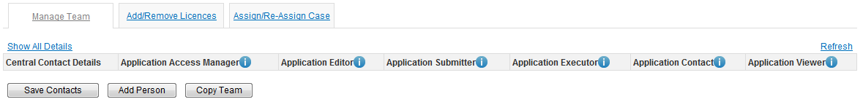

The Application Manager now has two options; they can either add themselves by clicking on the ‘Add Me’ button or enter the details of the people they wish to add to the team by clicking on the ‘Add Person’ button.

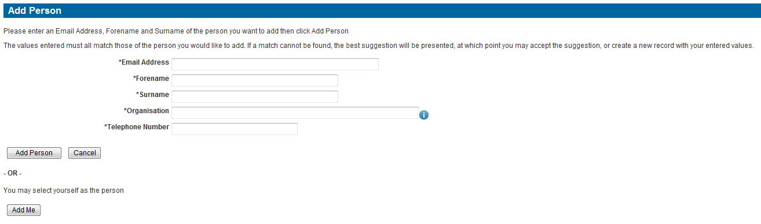

Once people have been added to the team the Application Manager can then assign them to a role(s) (for more details on the roles please see the ‘Security, accounts and roles’ document which is available on the PEARS Webpage).

To add a person to a role the Application Manager will need to check the relevant box(s) against the user’s name.
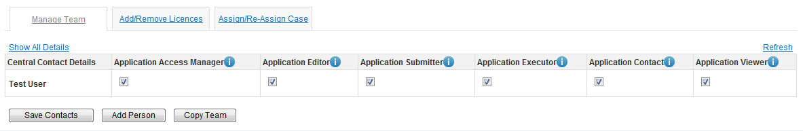

To add additional users, the Application Manager needs to click on the ‘Add Person’ button and repeat the process until the team is complete. Once the team has been set up the Application Manager needs to click on the ‘Save Contacts’ button.

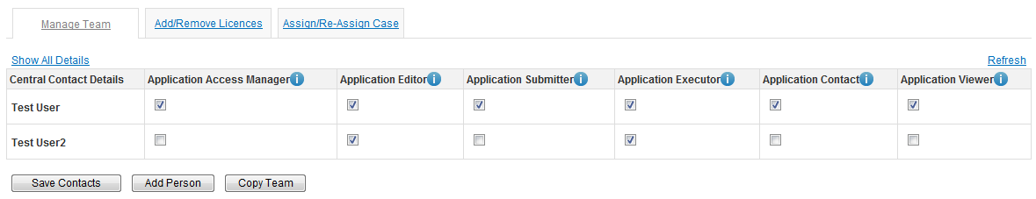

When saving the team, the Application Manager will be asked if he/she would like an email sent to users informing them of their new access. If the Application Manager does not wish to send an email, they will need to un-tick the check box before saving.

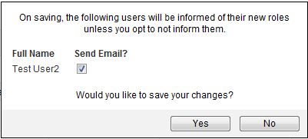

Assigning Case
Once the team has been set up and the licence(s) added The Application Manager needs to assign the case to a member of the application team by clicking on the ‘Assign/Re-assign Case’ tab.
There are now three options;
- ‘Pass Forward to Editor’, the case will be assigned to any member of the application team with the Application Editor role.
- ‘Reassign To New Manager’, the case will be assigned to a new Application Manager who will take control of the management of this case.
- ‘Take Ownership and Process’, this automatically adds the Application Manger to the team and assigns all roles.
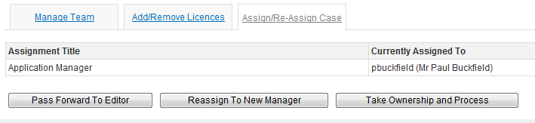
Once the case has been assigned, a Workbasket action to process the Application will be received by the assigned user.
