TI 25 – 03 Technology Example – Mocean Wave energy converter with Verlume Halo energy management system
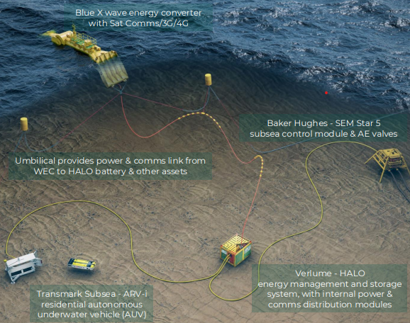
.
RSP is a Net Zero Technology Centre flagship project:
• “First-of-a-kind” commercial full-scale system to provide renewable power & communications offshore
• Combined system deployed, connected & operational as of February 2023 Demonstration via 12-month deployment:
• 3.5 nautical miles east of Orkney mainland; 50-53m water depth
• Remote comms, control & monitoring Qualification to a system TRL 6-7 (API): actual system completed & qualified via test and demo RSP aims to:
• Boost industry confidence in the proposed solution
• Pave the way to wider carbon mitigation via systems scalable in size and number across off-grid subsea power application

This is an extract from the Vendors website page for this product, the link for the full webpage is below for further information.

Vendors Website link:
Mocean Energy | Our pioneering wave energy converter technology

