NSTD Methodology for measuring the UK content of UK Energy Transition and Decommissioning projects
The following principles have been developed with input from Industry and are aimed at setting out, at a general level, the processes and tools the NSTA may utilise in support of the NSTD.
Executive Summary – Key Points
Information on UK content across the lifecycle for all new energy transition projects, as well as for offshore oil and gas decommissioning projects, is to be provided to the North Sea Transition Authority (‘NSTA’) as follows:
- Supply Chain Action Plans (‘SCAPs’) will gather information on delivery of the industry’s North Sea Transition Deal (‘NSTD’) commitments on local content;
- UK content refers to goods produced and/or services that are provided by a company carrying on business in the UK;
- project operators will gather relevant data from their chosen main contractor(s) (e.g. Tier 1 /EPC Contractor(s)) and will demonstrate that the relevant NSTD commitments have been considered throughout their full supply chain where applicable; and,
- the current SCAP process asks operators to provide relevant information on tenders, and this same process will be used to monitor local supply chain content and assist the NSTA to identify gaps in UK capability.

Introduction
Agreed in March 2021, the North Sea Transition Deal (‘NSTD’) is a transformative partnership between the UK Government and the UK’s offshore oil and gas sector. It will harness the power of the UK offshore oil and gas industry looking to create a net-zero basin by 2050, and in the process, unlock up to £16bn in investment by 2030, support for up to 40,000 supply chain jobs, reduce emissions by up to 60Mt (including 15Mt through the progressive decarbonisation of UKCS production) and a voluntary industry target that local content accounts for half the inputs into new energy transition projects and 30% of locally provided technology.
Mechanisms
The NSTA will apply its established processes and tools in support of the NSTD, where appropriate. In particular, SCAPs will be used to record information and drive positive behaviours over a number of areas, and are intended to keep additional burden on industry to a minimum.
Potential benefits to industry of such an approach include:
- an assessment of actual project delivery and a mechanism for industry to demonstrate its delivery on NSTD supply chain targets (50% Local UK content);
- using the already established SCAP process as a tool to collect data. A pragmatic approach to reporting and disclosing of the data (through industry consent or existing powers, as applicable) could reduce duplicative requests from Government to industry;
- gathering comprehensive contracting information via SCAPs will quickly provide much needed ‘real-time’ insights into the UK supply chain capability;
- the SCAP process, which is aligned to the NSTA’s Supply Chain Stewardship Expectation 12, will drive better behaviours into contracting strategies in a transparent way; and,
- the information gathered will be used by the NSTA to benchmark efficiencies in project delivery, highlighting best in class.
Local content Definition
For the purposes of tracking the stated NSTD commitments, the NSTA will generally use the following definition of ‘UK local content’:
- in respect of services, those services provided by a company carrying on business in the UK; and,
- in respect of goods, those goods which are being made, changed or improved in the UK (using the same definition as goods eligible for a UK country of origin certificate).

For the purposes of recording NSTD commitments, the following information should be included in the relevant SCAP:

- Details on all contracts for goods and services placed by the operator to be summarised in a SCAP. Information to be provided includes the relevant contracting strategy, the percentage of the overall contract price and an estimate of how many UK jobs will support the relevant contract.
- All subcontracts for goods and services with a value of £25 million or more placed by supply companies in support of contracts awarded to them by the relevant operator. Information to be provided includes the percentage of the overall contract price and an estimate of how many UK jobs will support the relevant contract.
- The overall UK contribution to an energy transition project (e.g. GHG reduction, CCS, Electrification, Hydrogen production etc), will be assessed by considering all contract / subcontracts which fall into the categories mentioned above.
- Where goods and / or services cannot be procured from the UK, operators should articulate, via the SCAP, why those goods and / or services cannot be sourced from a UK company. This will allow the NSTA to identify gaps in UK capability.

Worked Example
Case Study Details:

Decommissioning Programme

- Total Value of Contracts £100 Million
- 4 Scopes of work issued to 4 Tier One Contractors (A, B, C, D)
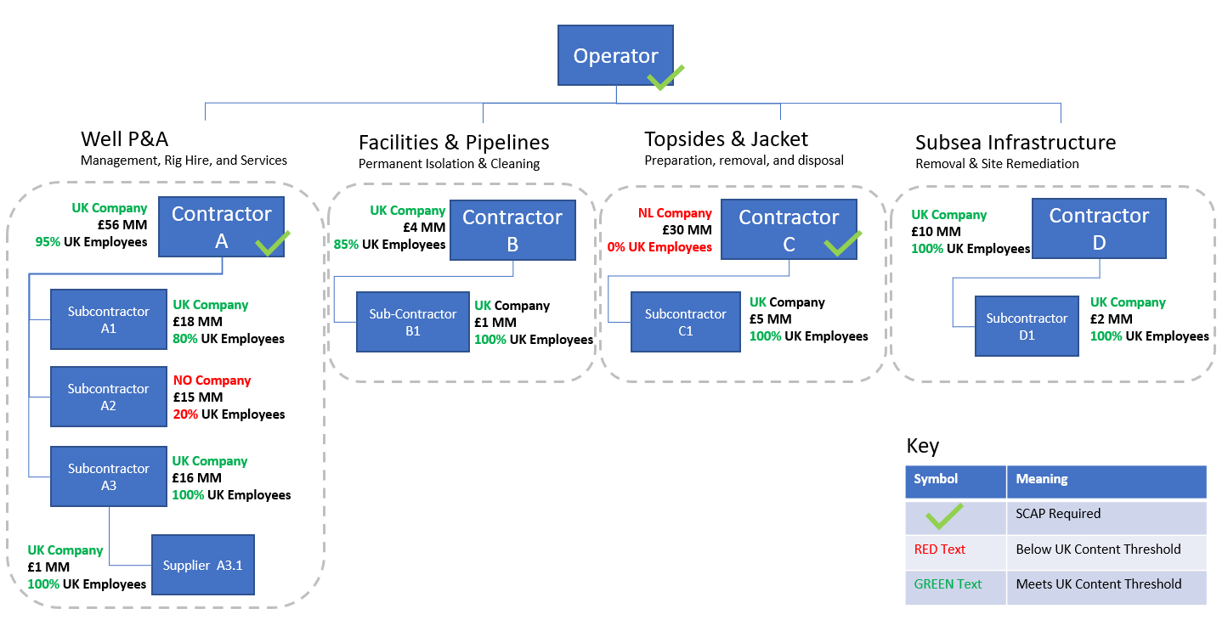
In the above scenario the Operator, Contractor A, and Contractor C would all be required to submit a SCAP. Local Content contribution for Contractor B would be estimated by the Operator on the basis that the contract between the Operator and Contractor B does not meet the £25MM threshold.
Contracting Table
Below is an example of the breakdown of Local Content Contribution for the overall project based on the principle of contract award value as a percentage of Total Project Third Party Costs.
Company | location | Value | Subcontractor Name | Subcontract value | Good and / or Service | location
Contractor A | UK | £100mm | A1 | £50mm | Vessels | India
Contractor A | UK | £100mm | A2 | £30mm | Valves | UK
Contractor A | UK | £100mm | A3 | £15mm | Piping | UK
Contractor A | UK | £100mm |  | £5mm | Other | N/A
Contractor B | UK | £100mm | B1 | £50mm | Electrolysers | UK
Contractor B | UK | £100mm | B2 | £30mm | Fuel Cells | UK
Contractor B | UK | £100mm | B3 | £20mm | Engineering | Denmark
Contractor C | Norway | £80mm | N/A | N/A | Fabrication

North Sea Transition Deal - GOV.UK (www.gov.uk)
North Sea Transition Authority (NSTA): Expectations - Asset stewardship - Exploration & <br/>production (nstauthority.co.uk)
Check your goods meet the rules of origin - GOV.UK (www.gov.uk)

