TI 25 – 06 Technology Example – ESI Fast Opening High Integrity Valves

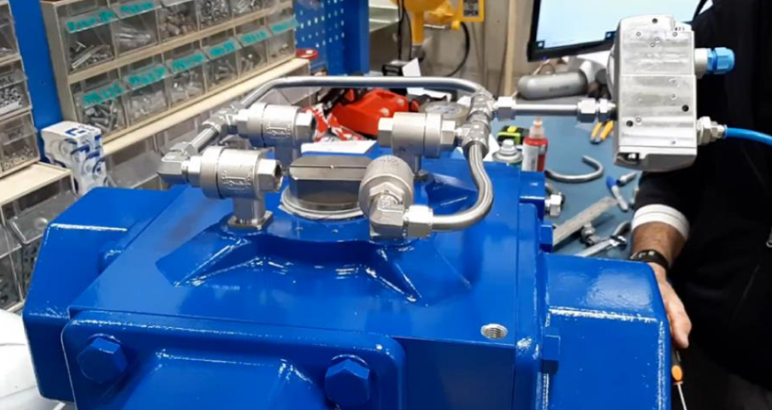

Larger High Torque Valves
At ESI, we have extensive experience in both valves and actuators. This enables us to supply highly reliable and optimized ESD packages for a wide range of industries and applications that meet the strictest safety standards and the most stringent requirements. Our ESD packages are certified to work in a SIL3 loop (SIL IEC 61508), providing reliable and rapid closure in the case of a system malfunction. They are tested and certified for transportation, harsh vibrating use, marine installation, and more.

Fastest closing times on the market
A fast closing time is essential for valves operating in ESD systems. Habonim’s proven, fast-action COMPACT™ actuator, which is the heart of our ESD package, meets and exceeds this need for both standard and high-torque valves used in ESD systems. This unique, quarter-turn rack and pinion actuator work in SIL3 loops to provide reliable and rapid closure in case of system malfunction. Using our patented four-piston design, which generates torque around a centrally-located piston, it doubles the torque of standard, two-piston pneumatic actuators. This reduces the package footprint and translates into double the power for the same size actuator or half the size for the same amount of power.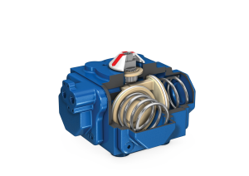
The COMPACT™ actuator is ideal for ESD systems as it offers the fastest shutdown speed on the market – approximately 0.2 seconds for our small 100nm actuators and with our unique adaptations, less than one second using our larger 3,000nm-4,000nm actuators. Moreover, it can be seamlessly integrated into ESD systems and allows millions of cycles before maintenance is required.

Unmatched performance for applied torques of more than 4,000nm

This is an extract from the Vendors website page for this product, the link for the full webpage is below for further information.

Vendors Website link:
ESDV - Emergency Shut Down Valve Automation for Large, High-Torque Valves UK & Ireland | ESI Technologies Group

