TI 22 – 57. Technology Example – Sevan 400 Cylindrical FPSO

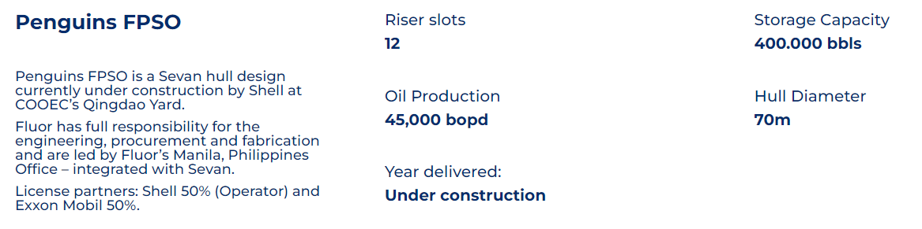Link to Vendors Website for further information:
Link: Penguins FPSO - Sevan SSP

