

UKSS SECTION GUIDE
SUPPLY CHAIN

This section will appear only once at organisation level.

If you think there are any errors with allocation, please contact
stewardshipsurvey@nstauthority.co.uk

Date of publication 29/10/2025

The document can be found on the NSTAs website.

© NSTA Copyright 2025
URN

You may re-use this information free of charge in any format or medium, under the terms of the NSTA’s User Agreement. To view this, visit: https://www.nstauthority.co.uk/site-tools/access-to-information/ or email correspondence@nstauthority.co.uk

This document is available in large print,audio and braille on request.
Please email: correspondence@nstauthority.co.uk with the version you require.

Enquiries to:
North Sea Transition Authority
50 Broadway
London
SW1H 0DB

Email: correspondence@nstauthority.co.uk

Published by the North Sea Transition Authority

Contents
1. UKSS 2025 CHANGES 4
2. WORKFORCE 5
3. INDUSTRY STANDARDS 7
4. SUPPLY CHAIN RESILIENCE 8
5. PAYMENT TERMS 9
6. CHECKLIST 10
7. CONTACT DETAILS 11

- UKSS 2025 CHANGES

No changes were made in the Supply Chain section of the survey.

- WORKFORCE

The aim is to collect information on workforce numbers and understand the changing trend in capability and capacity.
For this section, please provide actual numbers of permanent staff, contractors on your payroll, apprentices and trainees for the ‘survey year’ and the two years prior to the ‘survey year’. This should be completed by all oil companies (Operators and JV partners) for the whole workforce based only in the UK.
Workforce numbers should be taken on the 1 January each year.
Please ensure you enter numbers for the whole workforce, not just those engaged in Supply Chain activities.

Contractors are defined as those people on a day rate.
Apprentices are defined as those people who are learning a trade through a combination of employment & formal training via further education through a recognised industry trade body apprenticeship scheme such as: Opito, ECITB, City & Guilds.
Trainees are defined as those people with either paid or unpaid internship type positions, undergoing internal training for future deployment into a recognised paid role.
The workforce numbers is to be captured within the following three data requests:
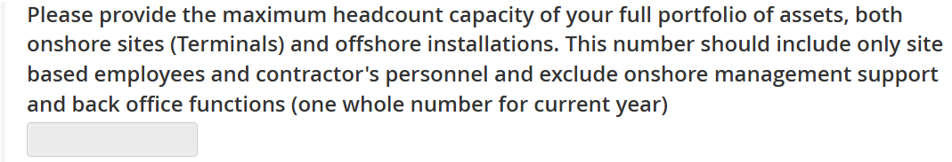
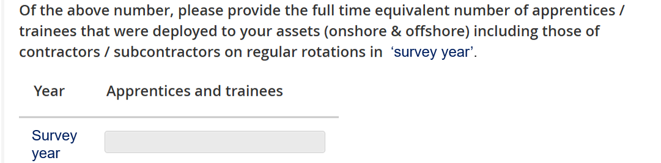
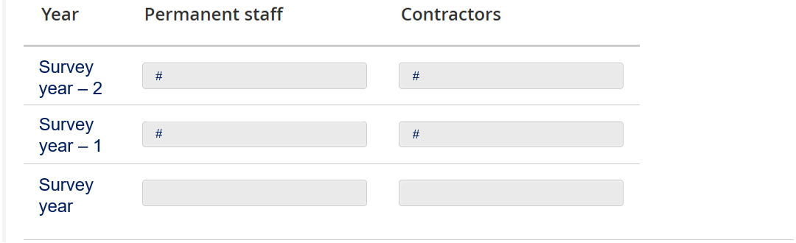

Note: Previous survey figures for Permanent staff & contractors will have now been copied forward.

- INDUSTRY STANDARDS

Industry standards have been developed over a number of years to introduce efficiencies and fair contracting practices across the Oil and Gas sector. The full benefits can only be realised through full compliance and this section is to gather information as to whether these standards are still appropriate and effective.

The following industry standards data request will be sought:
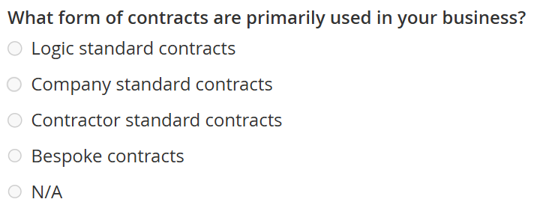

Please provide further details ion the comment box.

- SUPPLY CHAIN RESILIENCE

 You can paste values into table directly from Excel:
- The page will map your pasted cell values to the table cells, ignoring any overflowing rows or columns
- Input fields which have been pasted to will be highlighted green to allow a visual check.

Please provide the CAPEX, OPEX and Decommissioning Spend (£MMs) with the following companies in the ‘survey year’.
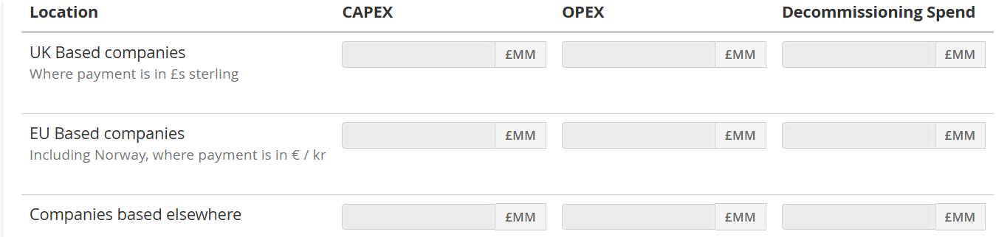
Notes:
- Please ensure costs are in £Millions e.g. £1,000,000 should be entered as £1MM.
- Spend should be exclusive of any general and administrative costs, or overheads not directly attributed to an operating field or project.
- "UK Based” company defined as any UK registered company.
- "EU / EEA Based” companies defined as any company registered in a European Union (EU) member state or those which are recognised in the single market as being within the European Economic Area (EEA). Further guidance at Countries in the EU and EEA - GOV.UK.

- PAYMENT TERMS

Only include invoices relating directly to OPEX, CAPEX or Decommissioning costs in the ‘survey year’.
Please do not include invoices for facilities costs etc.
A disputed invoice should be regarded as an invoice that has been placed on hold or rejected due to a genuine contractual dispute relating to the goods or services that the invoice relates to, and the value provided should be the net invoice value excluding VAT. Invoices that have been rejected due to administrative errors on the invoice itself should not be included.

All questions are linked to invoices received in the ‘survey year’ only. Therefore, the number of invoices in the following questions should not be more than the number received in the ‘survey year’.
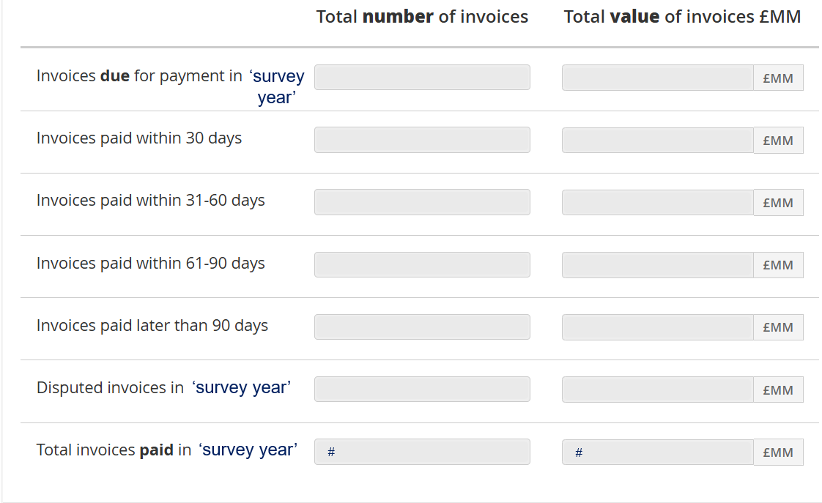
Total invoices paid is auto calculated:
Invoices paid within 30 days + Invoices paid within 31-60 days + invoices paid within 61-90 days + invoices paid later than 90 days

- CHECKLIST

Below are the some of the detailed QC steps that each section will go through. If you think your data will not pass these checks, please add as much information in the general comments section as possible to help us understand why.
- Check that the correct methodology is being used on £ values.
- Ensure values tally with the values supplied previously.
- Where appropriate, ensure that values given in the survey reflect those in the relevant Supply Chain Action Plans.
- Please use the general comments to explain the reason behind invoices paid later than 30 days.

- CONTACT DETAILS

If you have any issues when using the UKSS Stewardship Survey then please email stewardshipsurvey@nstauthority.co.uk and the stewardship team will respond as quick as possible.

If you find any errors with the data or question options presented on this survey form, then please report the error to the UK Energy Portal Service Desk by calling 0300 067 1682 or email ukop@nstauthority.co.uk.

