TI 25 – 04 Technology Example – SLB Petrel Multiphysics Plug-in
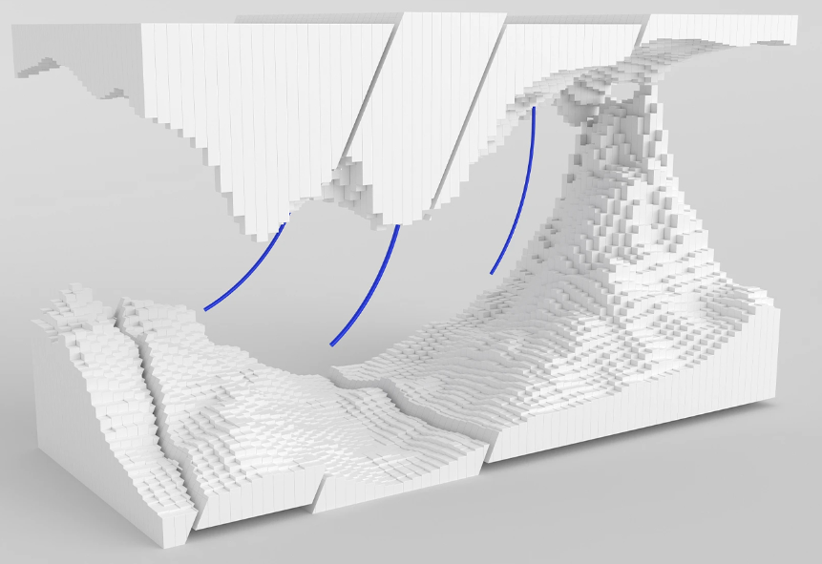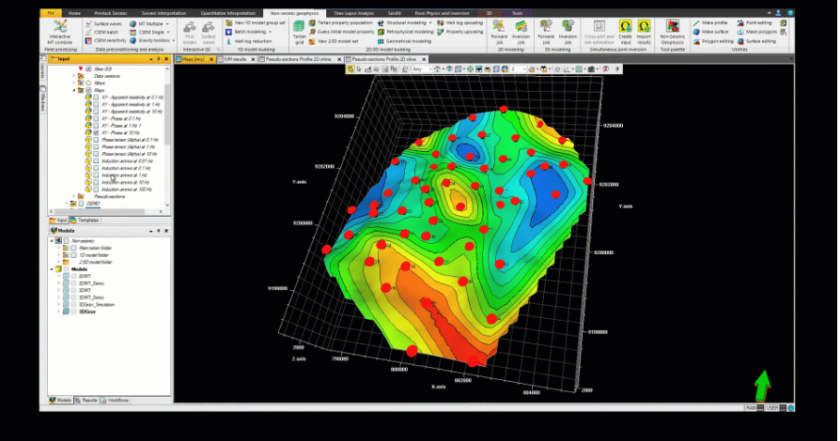
Optimized for large-scale surveys, the Petrel™ multiphysics plug-in provides tools to integrate electromagnetic (EM) and potential fields data with geological knowledge, seismic data, and well logs. Petrel Multiphysics comprises three individual modules: Petrel magnetotellurics (MT), Petrel controlled source EM (CSEM), and Petrel gravity and magnetics (GM).
The interactive environment of Petrel multiphysics, fully integrated within Petrel subsurface software, makes this an essential tool for reliable data integration and decision making through data processing, qualitative and quantitative analysis, and modelling.
Features
- Georeferenced data visualization of electromagnetic and potential field data
- EM data editing through sounding display, removal of outliers, and data resampling
- EM data QC through attribute maps and pseudosections
- Interactive potential fields data processing with a spectral analysis approach (band-pass filtering, upward and downward continuations, regional and residual filters)
- Interactive potential fields anomaly enhancement applying operators (tilt angle, vertical derivatives) and data transforms (pseudogravity) with 2D spectrum, radially averaged power spectrum, and rose diagram extraction
- EM modeling: 1D forward and inversion modeling, 1D CSEM sensitivity analysis, 2D MT forward and inversion modeling, 2D anisotropic CSEM forward modeling, and 3D MT forward modeling; plug-in can be integrated with the Omega platform for 3D HPC EM inversion modeling
- Potential fields modeling: 2D and 2.5D forward modeling of gravity and magnetic and first vertical derivative data; 3D forward modeling of gravity data
- Integration of geological and geophysical knowledge with multiphysics data throughout the workflow

This is an extract from the Vendors website page for this product, the link for the full webpage is below for further information.

Vendors Website link:
Petrel multiphysics plug-in | SLB

