TI 25 – 01 Technology Example – Oilenco e-line deployed hold open sleeve for TRSSSV’s
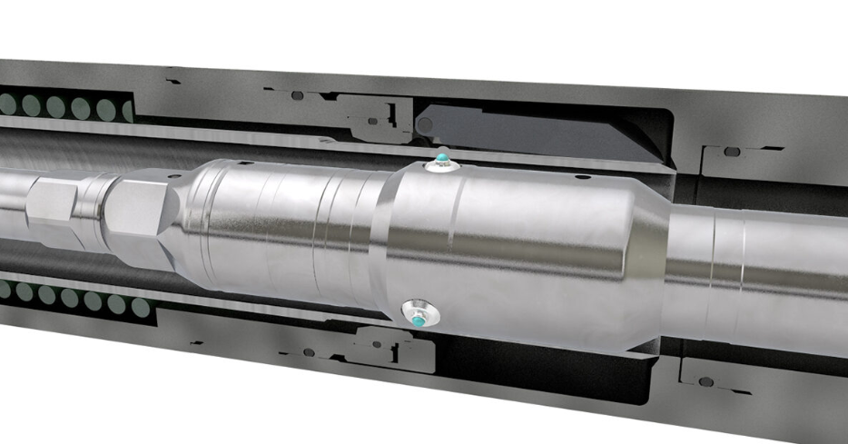
.
The Oilenco UniLOT (Universal Lockout Tool) provides a means to permanently lock-open a tubing retrievable subsurface safety valve (TRSSSV) so that it remains open with no obstruction from the flapper.
HOW IT WORKS
The mechanical UniLOT locks the flow tube in a position that prevents the flapper from closing once the control line pressure is bled off.
By running the Oilenco UniLOT, downward jarring is used to deform the walls of the flow tube, which permanently prevents travel back to the original position and keeps the bore of the TRSSSV clear.
PRODUCT FEATURES
- Does not rely on existing lockout profiles
- Versatile - suits a wide range of safety valve models from different manufacturers
- Incorporates a flapper check tool providing verification that the flow tube is permanently locked open
- Deformation and verification status of the flow tube completed in one run

This is an example of this technology, Note: NSTA do not endorse or recommend specific technologies.
This is an extract from the Vendors website page for this product, the link for the full webpage is below for further information.

Vendors Website link: The UniLOT - Universal Lockout Tool

