TI 25 – 08 Technology Example – EPIC Smart-trac POB system

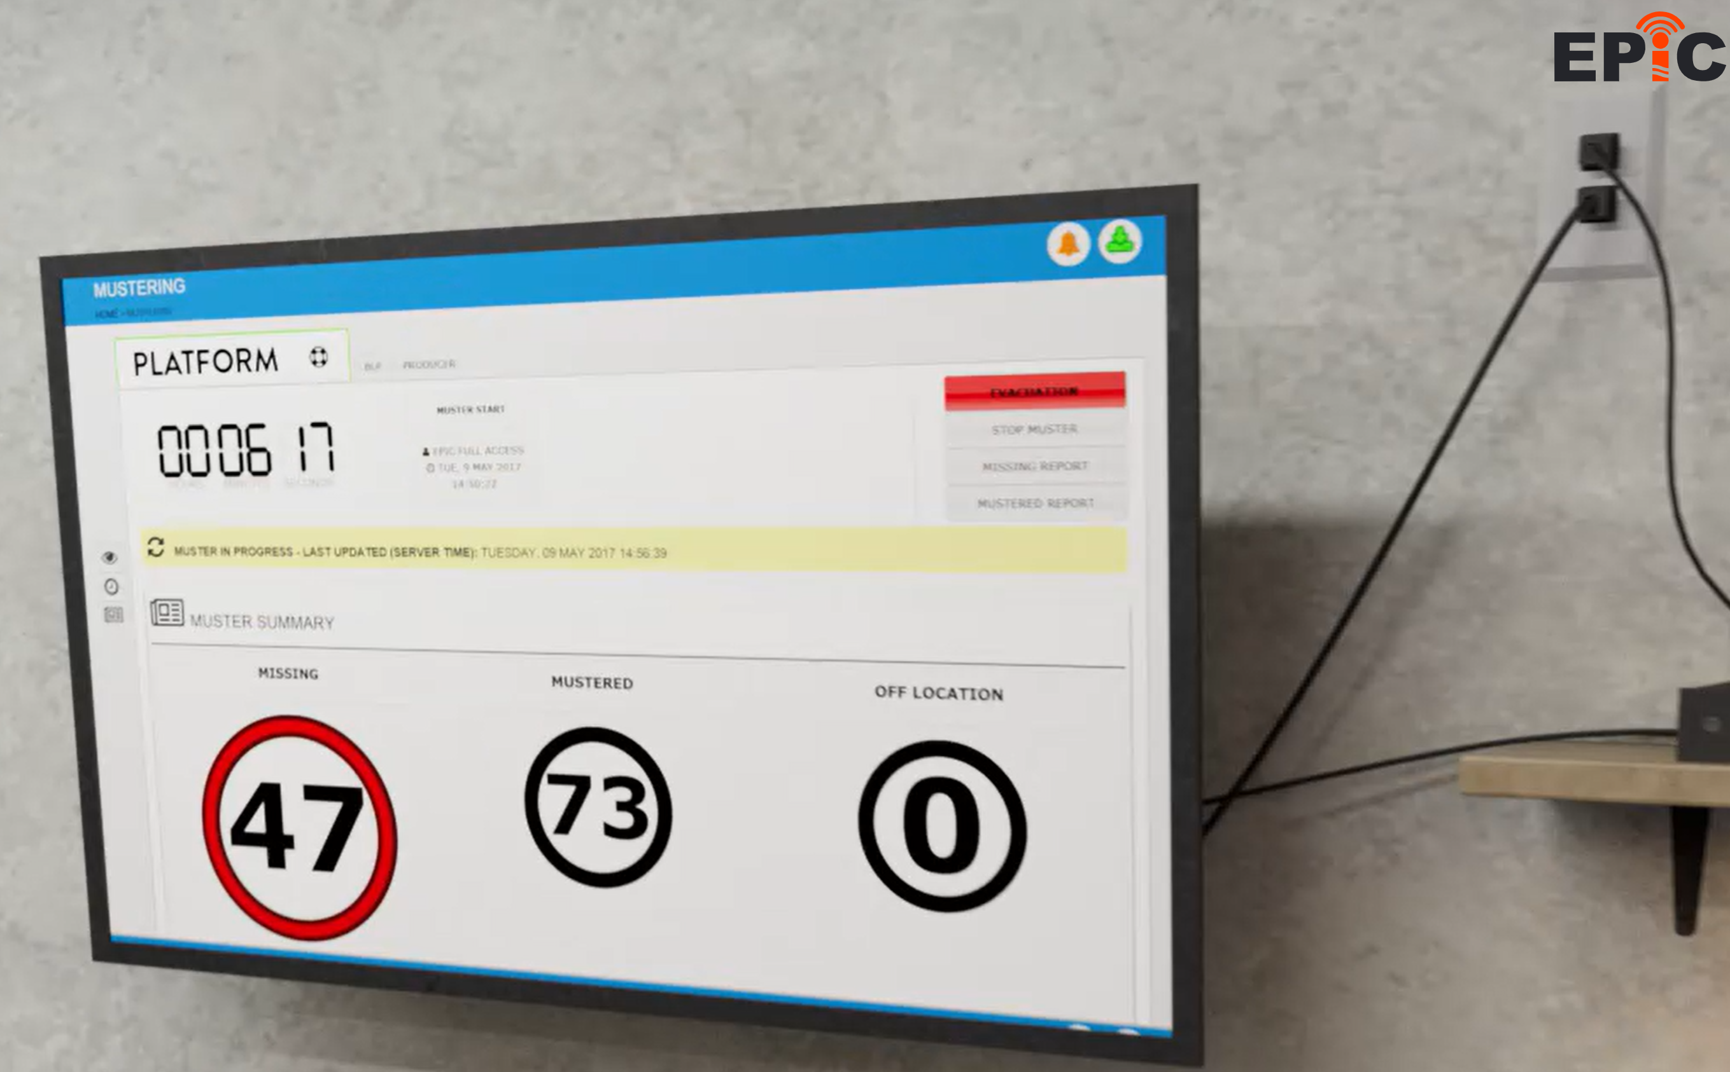
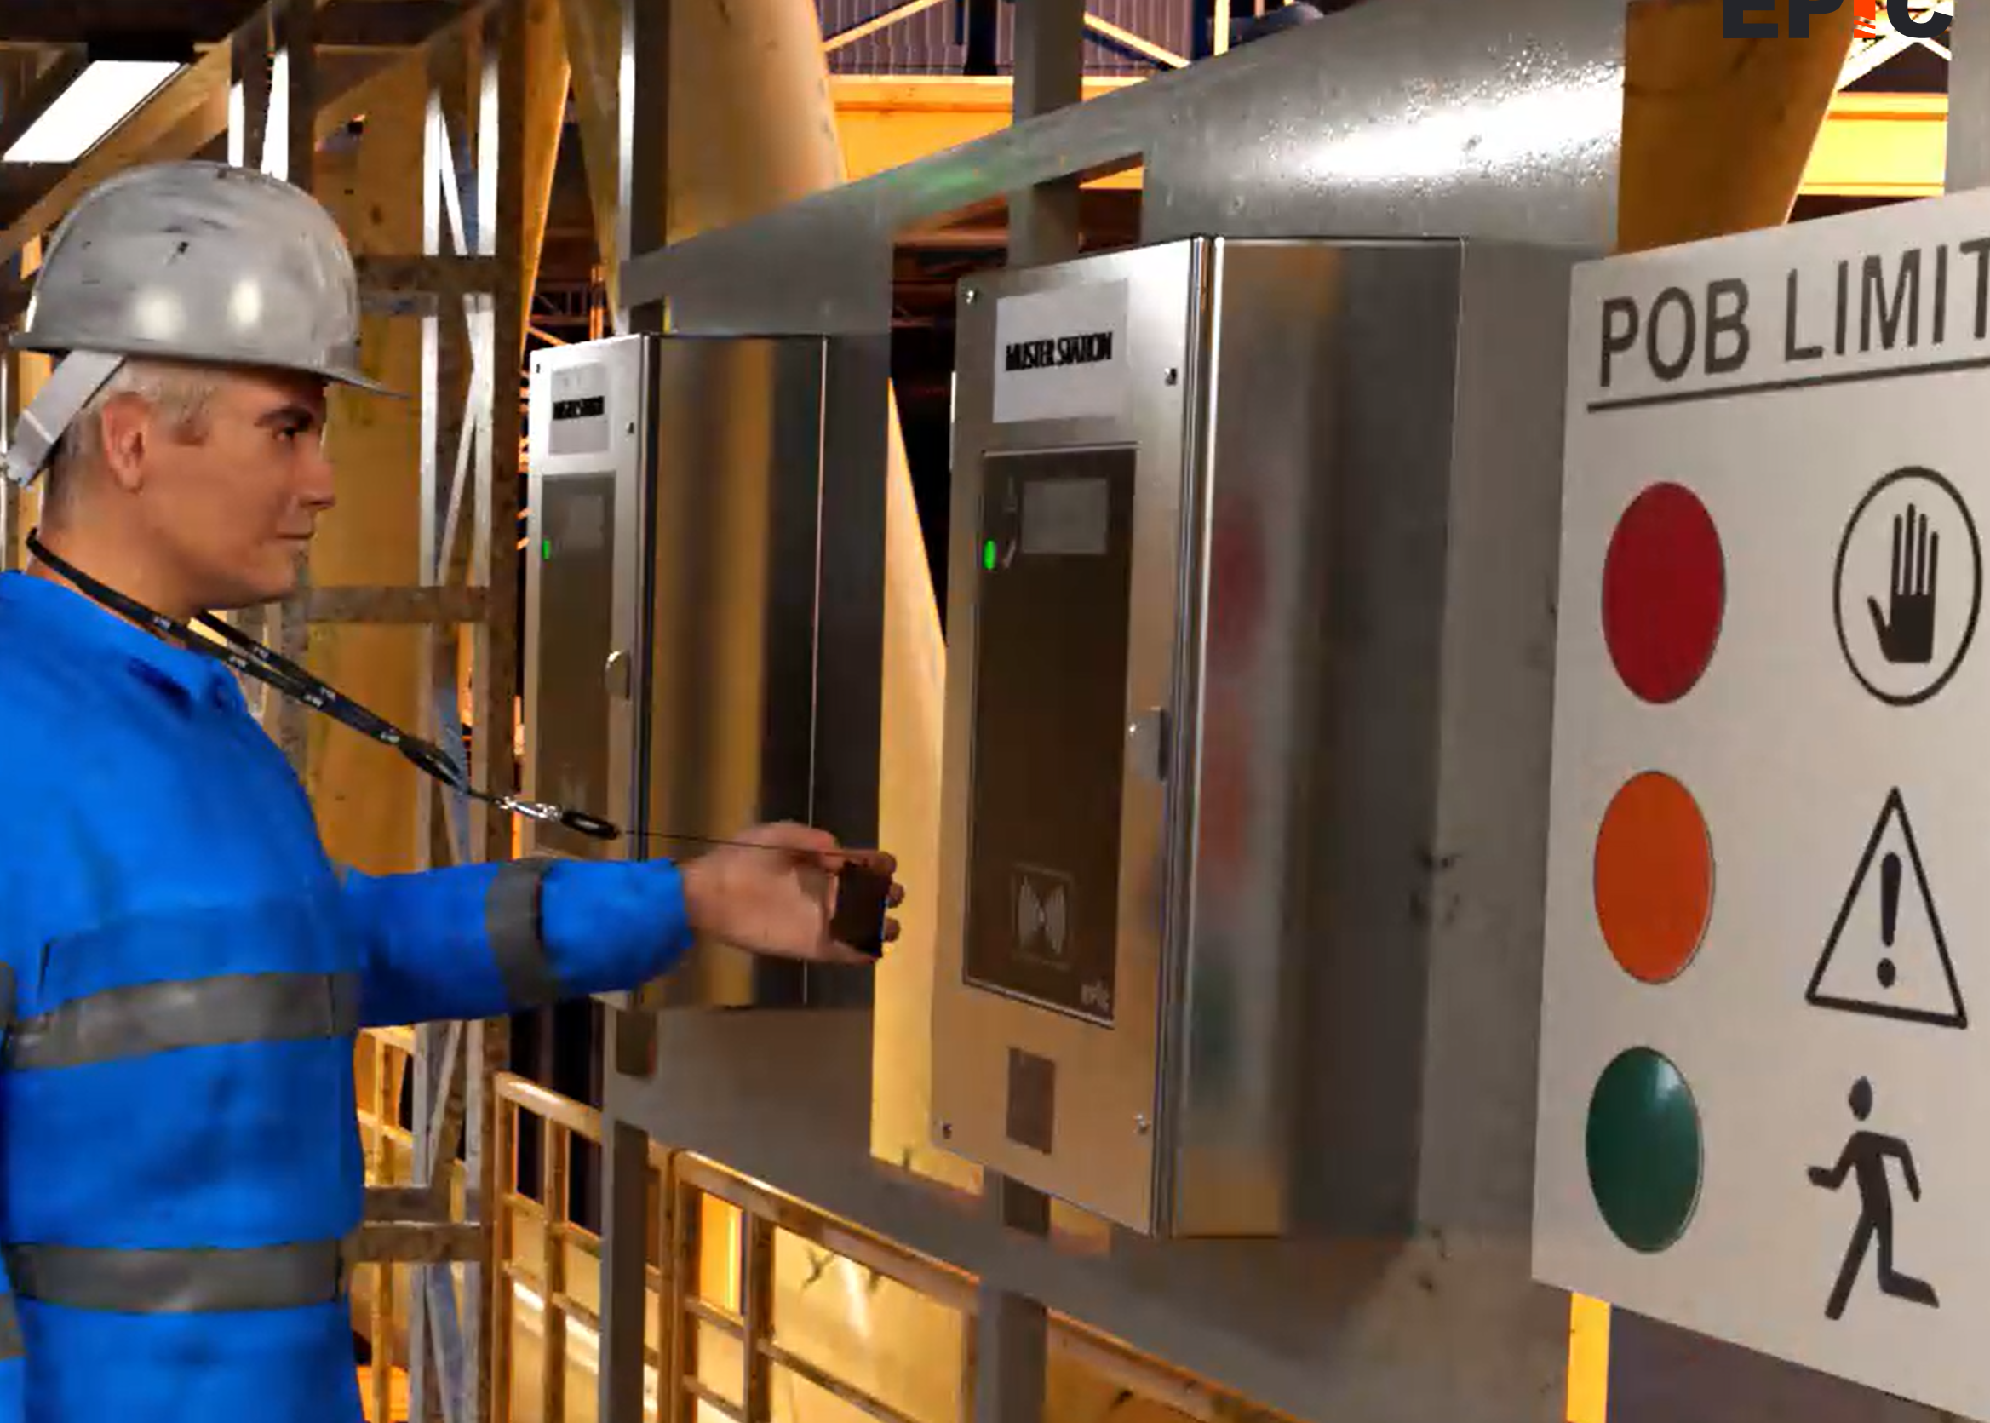

Mission & Vision
Your most valuable assets are your personnel, keeping them safe is our primary focus. EPIC have been supplying reliable and effective POB solutions to the marine, oil and gas sector for over 30 years. Our client list of oil majors and market leaders throughout the world speaks for itself.
We put our principles into practice through drive, ambition and honesty in everything we do.
EPIC’s vision is to be the global leader in the development and provision of technical systems that ensure the safe and timely handling of day to day POB management and during an emergency response in hazardous environments.
EPIC’s mission is to become the industry standard for Mustering and POB Management systems, driving safety, welfare, and efficiency across industries, across the world.

NSTA do not promote or endorse any vendors products this Technology Example is for information only.
This is an extract from the Vendors website page for this product, the link for the full webpage is below for further information.

Vendors Website link:
Home - EPIC POB

