TI 25 – 05 Technology Example – Baker Hughes Sound Track Acoustic Logging

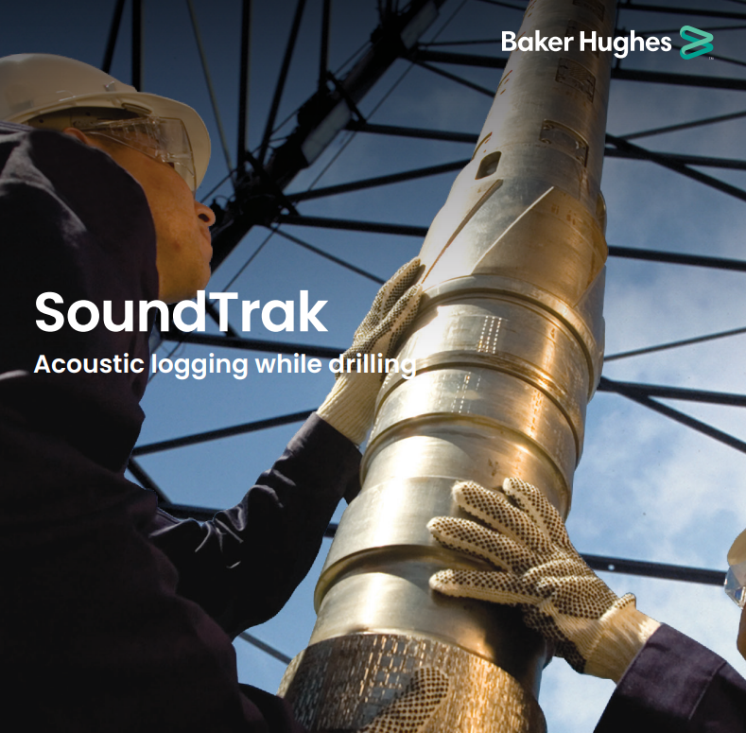

The SoundTrak™ service employs proprietary acoustic technology to directly measure valid formation slowness. Multi-frequency excitation ensures high data quality in both fast and slow formations, as well as in a wide range of hole sizes. These measurements can be used for a variety of real-time and post-well applications. These include:
• Seismic time-depth tie for quick, precise determination of formation depth and thickness
• Formation strength calculation to identify sanding potential and borehole stability issues at an early stage.

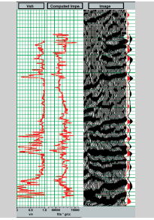

Comparison between synthetic seismograms derived from seismic (red) and LWD (blue). The LWD derived synthetic seismogram is superimposed on the CDP gather at the well location.

This is an extract from the Vendors website page for this product, the link for the full webpage is below for further information.

Vendors Website link:
SoundTrak Brochure.pdf

