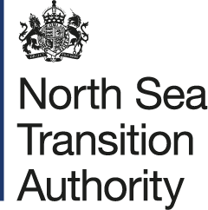

UKSS
USER GUIDE

This guide is split into two sections, your role when using the Stewardship Survey will define which section will be of use to you:

Single Points of Accountability (SPA)
– provides help and guidance on tasks specifically related to the SPA.
General Users
– provides more generalist help and guidance on the survey.

NOTE:
All sections of the survey have specific ‘in context’ help and guidance on the survey screens. Additional templates and Section supporting guides to help complete the survey can be accessed from the top of their particular survey section (or via the Asset Stewardship Surveys webpage).

If you have any questions, please contact stewardshipsurvey@nstauthority.co.uk
The 2025 UKCS Stewardship Survey will launch on Mon 3 November 2025 and closes on Fri 27 February 2026.
Please Note: The Activity section will close earlier, on Fri 16 January 2026.
Date of publication 03/11/2025

The document can be found on the NSTAs website.

© NSTA Copyright 2025
URN

You may re-use this information free of charge in any format or medium, under the terms of the NSTA’s User Agreement. To view this, visit: https://www.nstauthority.co.uk/site-tools/access-to-information/ or email correspondence@nstauthority.co.uk

This document is available in large print,audio and braille on request.
Please email: correspondence@nstauthority.co.uk with the version you require.

Enquiries to:
North Sea Transition Authority
50 Broadway
London
SW1H 0DB

Email: correspondence@nstauthority.co.uk

Published by the North Sea Transition Authority

Contents

INTRODUCTION 4
SURVEY MATRIX 6
Overview 6
Survey Matrix – Survey Section 10
Survey Matrix – Reporting Units 11
SURVEY STATISTICS 13
Viewing Statistics 13
SURVEY TEAMS 16
View or Update 16
SURVEY REQUESTS 20
Section Re-open Request 20
Operator Clarification Requests 21
Stewardship Clarification Requests 21
Any other requests 22
COMMENTS, WARNINGS, SUPPLEMENTARY GUIDES 23
General comments 23
Warnings 23
Supporting guidance documentation 23
SUBMIT SECTION 24
Autosave functionality 24
Submission 24

INTRODUCTION

The annual North Sea Transition Authority (NSTA) Stewardship Survey (the Survey) replaced the multiple previous surveys in 2016, streamlining the way that data is collected into a single source.

The Survey should be completed by the operators of all UKCS wells, licences, fields, infrastructure and hubs. Where a licence area has been subdivided, the licence administrator should complete the Survey only in respect of the subarea for which it is the operator (if any) rather than the entire licence area. Each additional subarea licence operator should also complete the Survey for their subarea of the licence.

The Survey data will be held by the NSTA in accordance with the Energy Act 2016 and will be used, among other things, to inform asset stewardship reviews and provide meaningful insights into current and forecast activity in the UKCS.

The information requested in the Survey is intended to support the central and supporting obligations set out in the NSTA Strategy for the UK and includes requests for data in ten areas:
- Licensing
- Exploration and Appraisal
- Reserves and Resources
- Activity, including production and costs
- Decommissioning
- Production Efficiency
- Technology
- Supply Chain
- Wells
- GHG Emissions
Note: (i) Each section has its own supporting guide.
(ii) Any reference to “survey year” is to be interpreted as the ‘calendar year’ that the
survey goes live on 1 November (i.e. 2025 this year).

Each organisation participating in the Survey is required to appoint a Single Point of Accountability (SPA) to coordinate its response.

This User Guide will assist an organisation’s SPA to manage and assign users to complete the Survey. It explains how users can be allocated to different parts of the Survey, so that they can complete the certain sections and questions for an organisation.

Data entered into the form is automatically saved. If you need more time to complete the form, you can return to the survey matrix or log off and any progress will be saved.

The 2025 UKCS Stewardship Survey will launch on Mon 3 November 2025 and closes on Fri 27 February 2026.

Please Note:
As in previous years the Activity section will close earlier, on Fri 16 January 2026.
This section closes earlier than the rest of the Survey so that up-to-date data can be used to inform the NSTA’s estimates and projections of expenditure and production which it provides to the Office for Budget Responsibility ahead of the Spring Statement.

SURVEY MATRIX

Overview
When logging onto the Energy Portal you will first be presented with the Workbasket page.
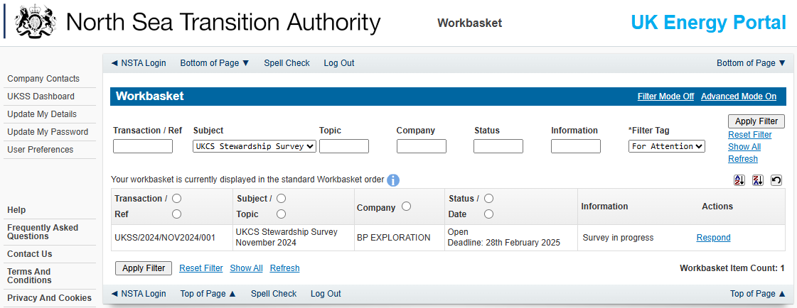
The data fields at the top of the page are:
Field | Description
Transaction / Ref | The reference for the Survey and the year it was opened.
Subject / Topic | The title of the Survey.
Company | The name of your organisation.
Status / Date | The status of the Survey, for example that the Survey is open and the deadline by when the Survey must be complete.
Information | The stage at which the Survey is in for example in progress.
Actions | Click on the Respond link to access the Survey.

You can access the current survey by either:
A. | Clicking the UKSS Dashboard on the left of the page.
  - This will take you to the UKCS dashboard where you can search for previous surveys, manage your team and view Current survey statistics.
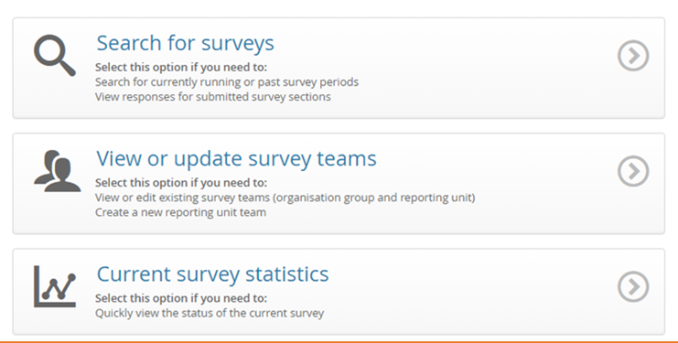
Or
B. | Clicking the ‘Respond’ action next to the UKCS 2024.  - This will take you directly to the current survey matrix page.

When accessing the survey by either clicking on ‘Respond’ or ‘UKSS Dashboard’, you are presented with four areas:
- Contact details:
  - for the UK Energy Portal Service Desk, who can help you with any questions you may have on the Survey or any technical issues.

- Survey deadline information:
  - stipulates the time and date when the Survey must be completed by.
Further information can be viewed by clicking on the ‘Show more’ text.
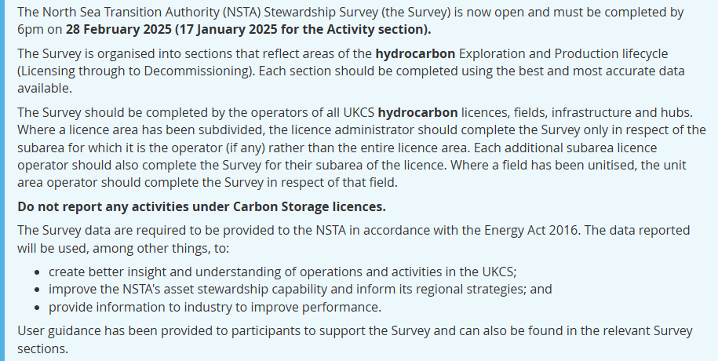

- Request for consent:
  - who raw Survey data may be provided to.
SPAs should complete this section before the final section submission, by ticking the relevant boxes.
Click on the ‘Show further information on permission’ link to view the details.
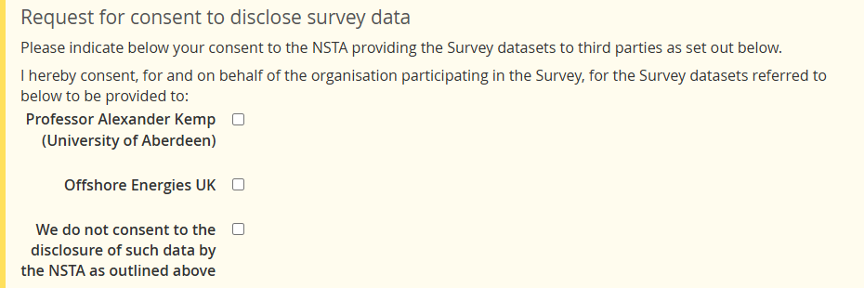
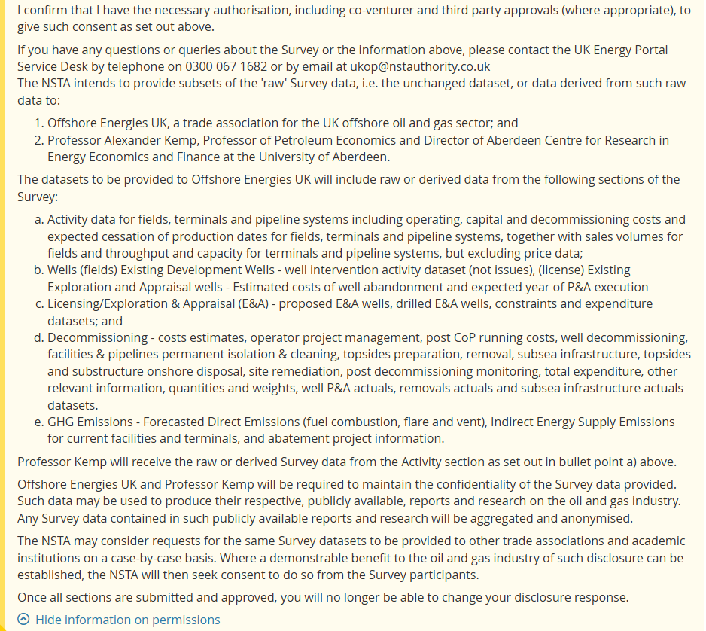
- Survey matrix:
  - the matrix will display the sections of the Survey that you are responsible for completing.
If you have queries on a Survey section you do not have the data for and cannot complete,
or if you need a Survey section added to your user account,
your SPA will be able to assist and/or update these details for you.
Please note, only sections that you have permissions for will appear in the Matrix.

Survey Matrix – Survey Section
The Survey has been organised into sections that reflect areas of the Exploration & Production lifecycle (Licensing through to Decommissioning). Each section must be completed with the most accurate data available.

Status Link
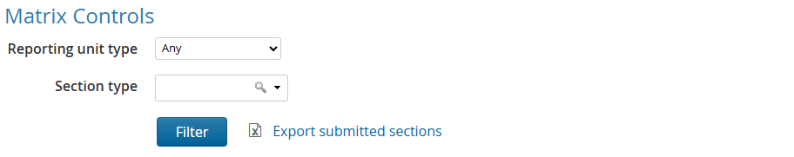
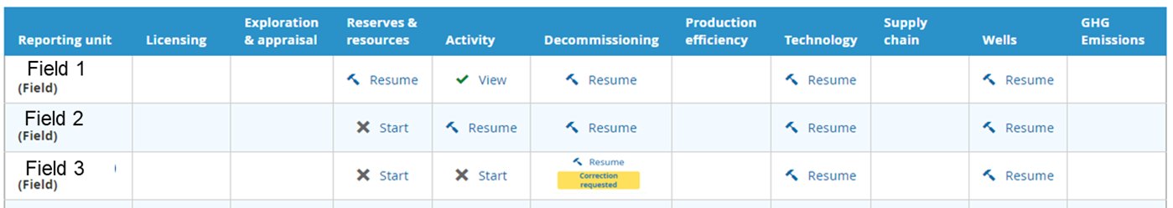
The status links will be available on the sections of the Survey that you have been assigned to complete.
Status Link | Description
 | Click on the Start link to access the Survey section for a specific Reporting Unit.
The Survey section has been started, however, the section is not complete.
Click on the Resume link to continue to enter the Survey responses.
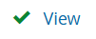 | The Survey section has been submitted.
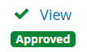 | The Survey section has been submitted and the NSTA has approved the data.
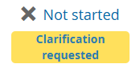 | The Survey has been submitted to the NSTA, it has been reviewed and there are some updates that have been identified (a clarification requested) with a need to be actioned and re-submitted.
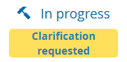 | A clarification requested has been viewed by the operator but has yet to be completed and the survey section re-submitted
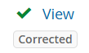 | The Survey section has been re-submitted and the NSTA has approved the updated data.

Export Submitted Sections
All sections will be downloaded to a ZIP file and will be opened as an Excel document.
This can be done for any survey submitted.

Survey Matrix – Reporting Units
Reporting units that have been allocated to you for completion will be listed on the left.
These units are assigned to your user account by your SPA. The units are:
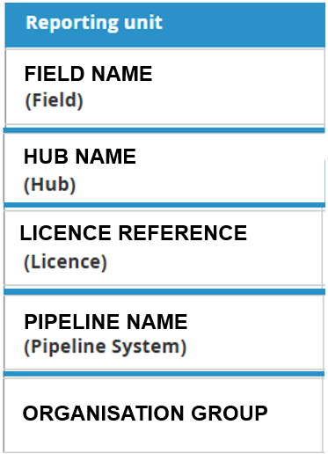

Field – For each field allocated to you there are up to five Survey sections to be completed:
- Reserves & Resources
- Activity
- Decommissioning
- Technology
- Wells

Hub – For each hub allocated to you there is one survey section to be completed:
- Production Efficiency

Licence – For each licence allocated to you there is one Survey section to be completed:
- Licensing (note: licence data requested is for the previous year, therefore a licence surrendered in the previous year will still appear in the survey for a final time)
- Wells

Pipeline – For each pipeline allocated to you there is one survey section to be completed:
- Activity

Organisational Group – there are five Survey sections to be completed:
- Exploration and Appraisal
- Decommissioning
- Technology
- Supply Chain
- GHG Emissions
  - Within this section, you will be asked for forecasted emissions data for any facilities, terminals, new developments and abatement projects.

SURVEY STATISTICS

Viewing Statistics
The survey has the ability to provide a view of your survey submission status graphically.
When hovering over the top ‘UKSS’ banner, you will be able to select the ‘Current survey statistics’ link.
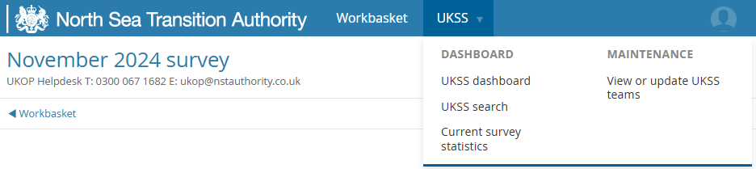

You can also find a link to this on the ‘UKSS Dashboard’.
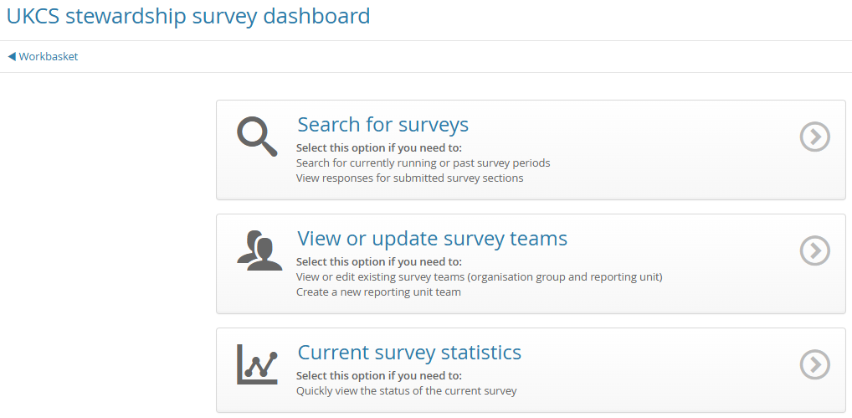

The initial pie chart will show the current status of the overall survey, while the bar chart and subsequent pie charts display the survey status broken down into each section.
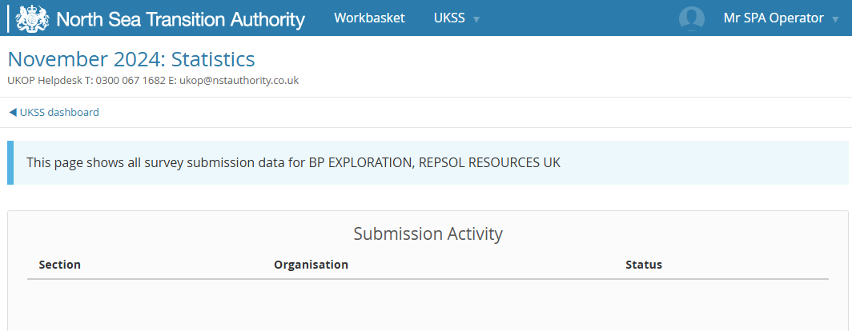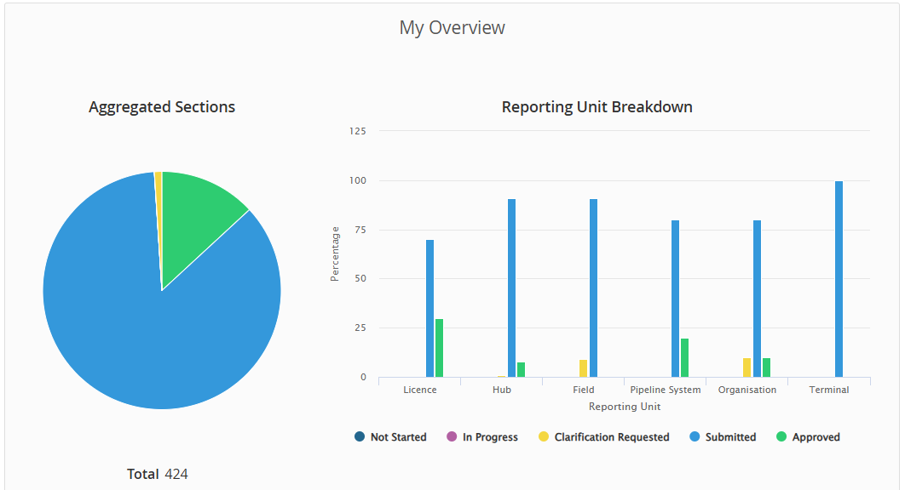

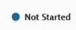 | The operator has not opened the section yet.
 | The operator has opened the section and has looked through/entering data into the section.
 | The operator has submitted the section, but during the QC process the NSTA have noticed an error/need for further clarification and a ‘correction request’ has been returned.
 | The operator has submitted the section.
 | The NSTA have reviewed the data and have approved the submission.

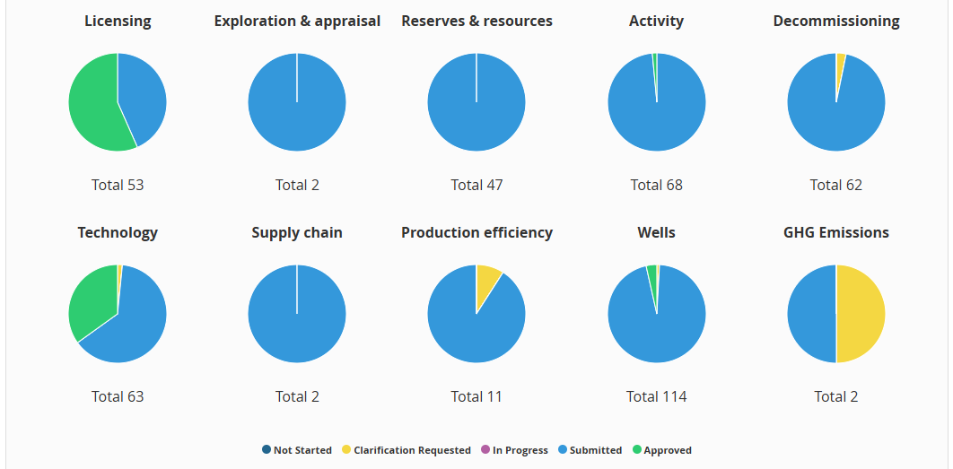
The area chart shows the daily progress of the overall survey.
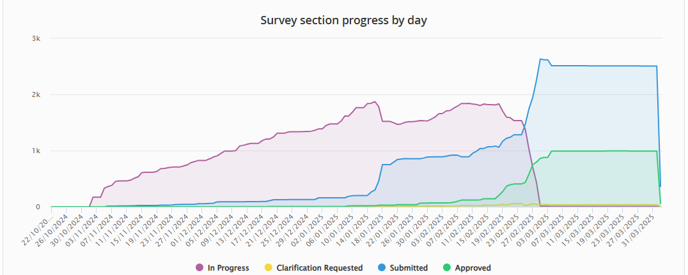
Please note:
All SPAs are automatically given permission to see this screen. Though you can assign this permission using the ‘View or update UKSS teams’ link in the top banner.

SURVEY TEAMS

View or Update
If you are the SPA for your organisation, or you have the ‘Maintain UKSS contacts’ role for your organisation’s user account, you are required to allocate sections of the Survey to relevant user accounts within your organisation. Different user accounts can be allocated single or multiple sections of the Survey to complete.
Once a Survey section is allocated to a user account, that user will be able to view that section in their Survey matrix. All nine sections of the Survey can be allocated to one user account, or individual sections can be allocated to different user accounts for completion.
To view the user accounts within an organisation that have been allocated Survey sections for completion (the Survey team) hover over the ‘UKSS’ banner at the top of the screen and select ‘View or update UKSS teams’.
You can also find a link to this on the ‘UKSS Dashboard’.

In the UKSS Organisation Group field, the name of your organisation will automatically be entered.
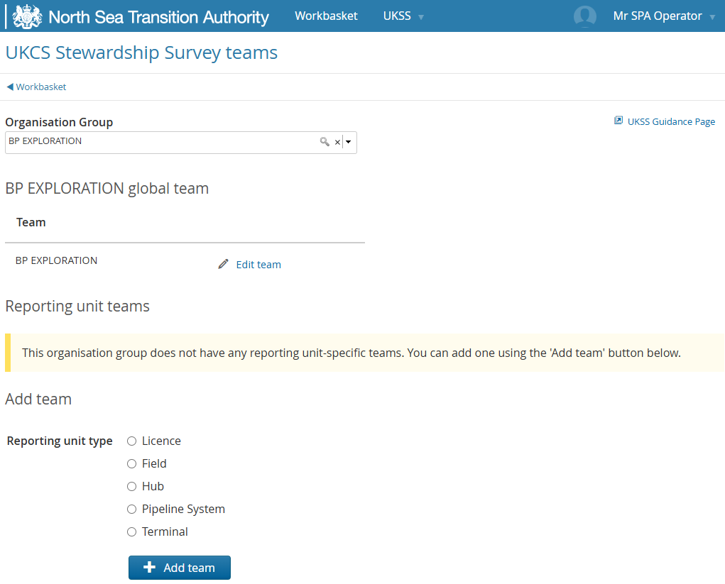
Three ‘team’ sections will be available:
- Global Team – where you can view and edit the central contact details of your organisation.
- Reporting Unit Teams – where you can view and edit the different Reporting Unit teams.
For example, a user may be responsible for reservoir management for one specific field.
By using a Reporting Unit team, you can specify what Survey section a user can see.

- Add Team – where you can add a new Reporting Unit type, which can be broken down into:
- Licence
- Field
- Hub

Click on the Edit team link 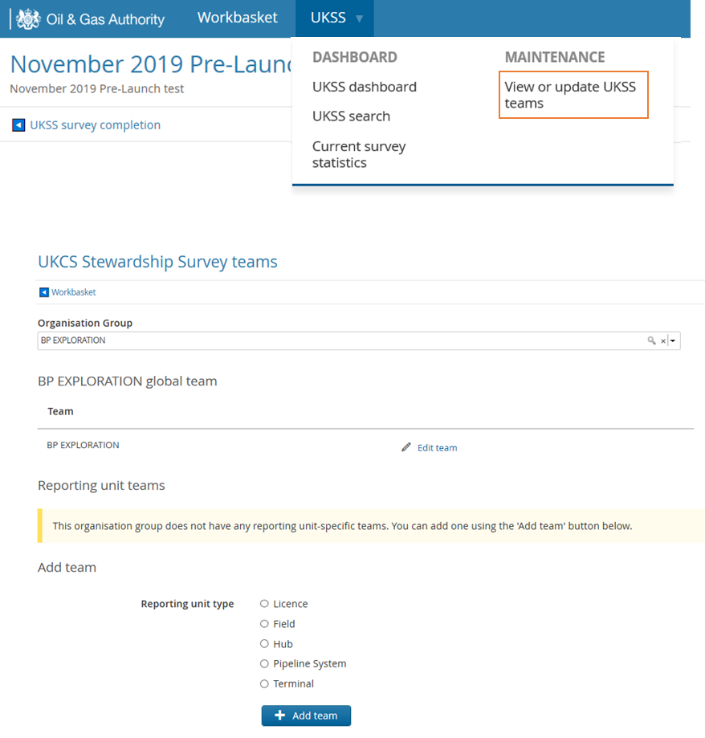to view the users in each team and see which survey sections they have been allocated.
The Global team has access to all Survey sections.
Different members of the Survey team can have access to different parts of the Survey, however all sections must be allocated to a user account.
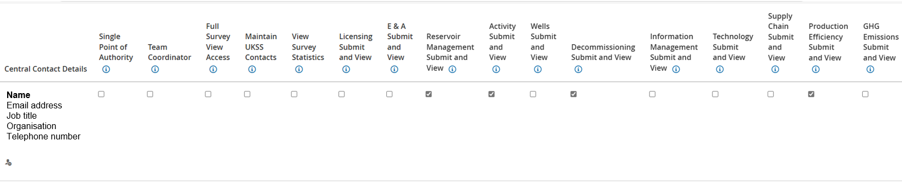
Single Point of Accountability (SPA):
The person who can modify Data Share Agreements and be the person who receives notifications from the NSTA.
- There is only one SPA per organisation and that team member will be assigned the Team Coordinator role. This role can maintain the Global and Reporting unit team’s roles as well as access Survey sections and receive Survey related emails,
for example when a Survey is open, when a section is sent back for correction and reminder emails if a Survey section has not been submitted.
- The SPA is the only team member who can tick the permissions boxes on the Matrix page.
Team Coordinator:
Someone who can manage the people in this team and membership.
Full Survey View Access:
Someone who can view responses for all sections.
Maintain UKSS Contacts:
Someone who can modify all UKSS teams for this organisational group.
- any team member assigned this role can update the Global team’s roles and Survey sections as well as maintaining the Reporting unit teams.
View Survey Statistics:
Someone who can view statistics related to the survey.
Submit and View:
Someone who can submit responses for their specific section of all stewardship surveys for operator.
- E.g. A team member with ‘Activity’ section Submit and View permissions will only see the Activity Section in their Matrix.
Please note:
Click on the ‘Save Team’ button to save any new members added to the global team. After which you will be taken back to the Survey teams screen.

There is the option to at the bottom of the page.

In the Select Person area, enter all the details of that user and click on the Add Person button, or click on the Add Me button to add yourself as the user.
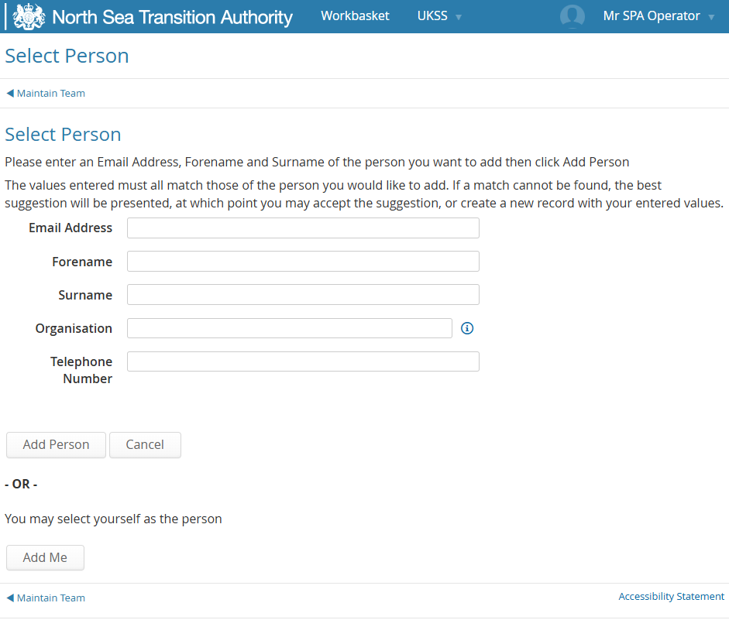

SURVEY REQUESTS

Section Re-open Request
A section re-open request can be made so you can make changes to the data you have submitted.
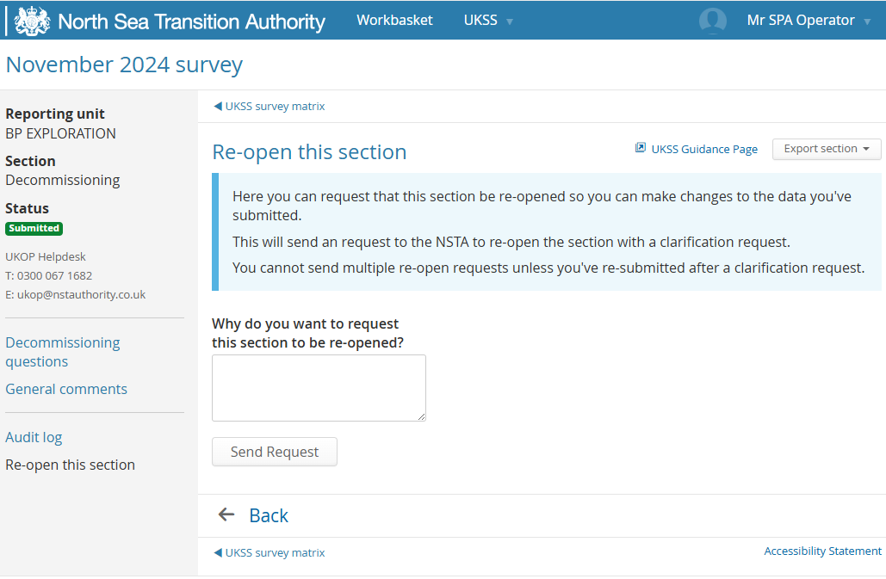
This will send a request to the NSTA to re-open a specific section via a correction request.
It is encouraged for operators to re-open sections if errors are spotted during the survey live period.
Note:
- You do not need to email the stewardship survey mailbox for a section re-open request.
- You cannot send multiple re-open requests, unless you have re-submitted following a previous correction request.
This option in the survey allows the section re-opening to be captured in the Audit log for operator and NSTA transparency.

Operator Clarification Requests
The link enables you to send a clarification request to the survey stewardship team.

Stewardship Clarification Requests
Once a section is submitted, if the NSTA has a query regarding an aspect of the data entered they will raise a Clarification request (Note: As of the UKSS 2024 Correction requests were renamed to Clarification requests.).
The number of clarification requests will be detailed in the survey matrix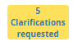.
Clicking on this will display a summary of all the clarifications being requested.
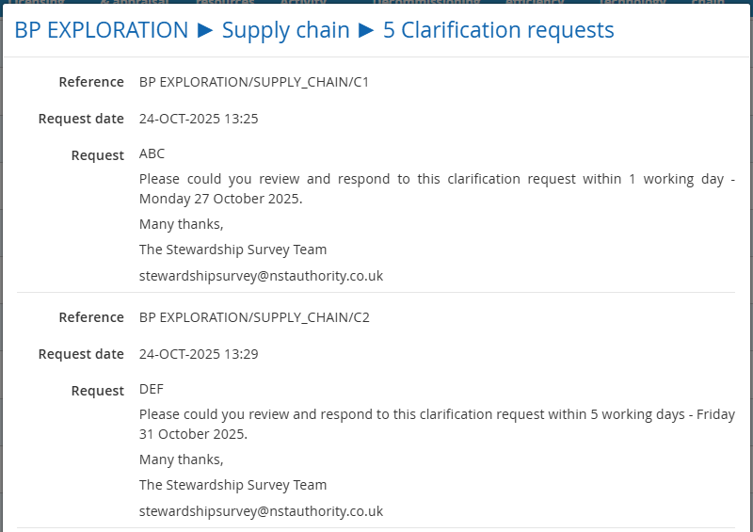
Multiple clarification requests may be made at the same time.
Each request will have a deadline for which the clarification is to be actioned and the section re-submitted to the NSTA by.

Cicking on Start will re-open the section and allow the operator to edit the data, or more commonly provide further clarification in the General Comments page that is in each section.
A section cannot be re-submitted until all the clarification requests have been marked as resolved. A warning message will be presented at the start of a section whilst there are unresolved clarification requests.
Clicking on within the warning message will display the list of raised clarification requests.
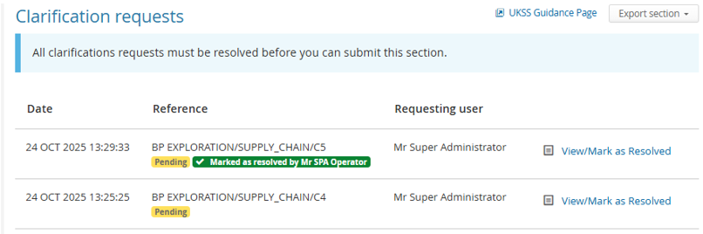
An individual clarification request can be viewed by clicking on .
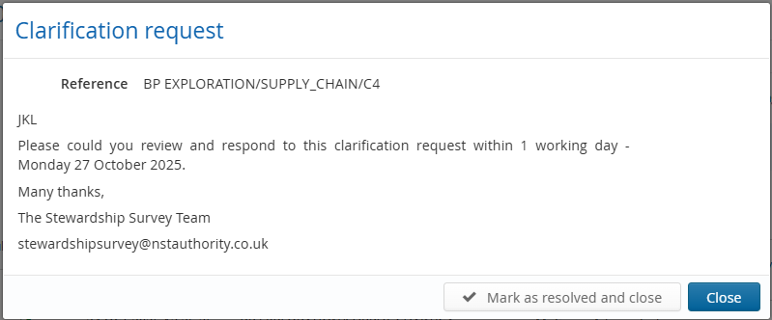
The name of the person resolving a clarification request will be recorded, and whom may be contacted should there be any futher discussion required.
A clarifiation request marked as resolved can be undone by clicking on to view it again, then clicking on 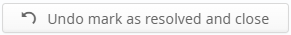.

Any other requests
If you have any issues when using the UKSS Stewardship Survey then please email stewardshipsurvey@nstauthority.co.uk and the stewardship team will respond as quick as possible.

COMMENTS, WARNINGS, SUPPLEMENTARY GUIDES

General comments
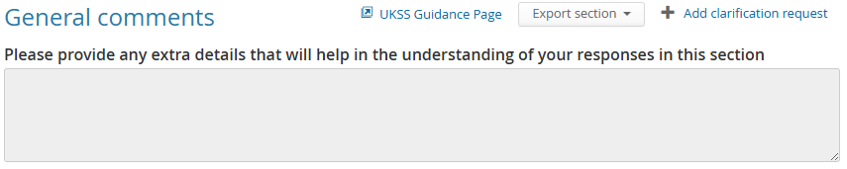
Please provide any extra details that will help in the understanding of your responses.

Warnings
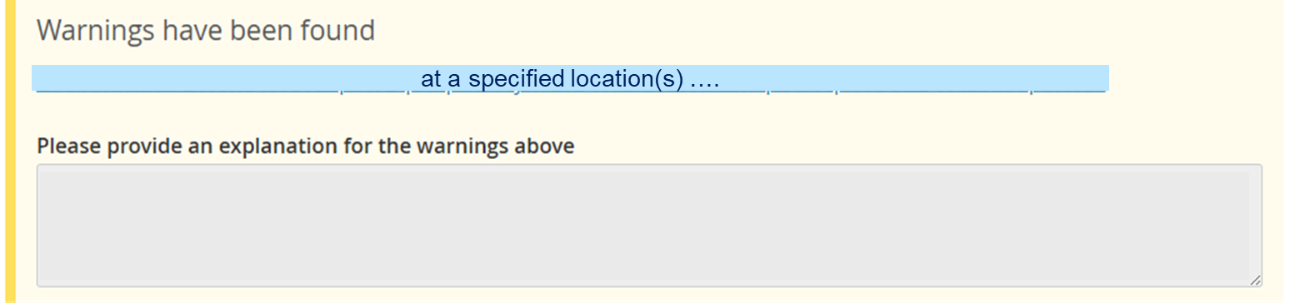
If a validation rule is broken, then a Warning window will appear at the bottom of a section, and an explanation must be provided for each of the warnings displayed.

Supporting guidance documentation
The link will take you to the Asset Stewardship Survey webpage where all the additional supporting documentation can be found.

SUBMIT SECTION

Autosave functionality
Data entered into the form is automatically saved. If you need more time to complete the form, you can return to the matrix or log off and any progress will be safe.

Submission
Prior to submitting the form, please ensure any data entered is correct. You will not be able to modify your responses until the NSTA have reviewed the submission and asked for a correction.
The section can be exported either via a spreadsheet or a PDF at any time during the survey live period.

