

UKSS SECTION GUIDE
PRODUCTION EFFICIENCY

This section will for all Hubs that you are operator of.

If you think there are any errors with allocation, please contact
stewardshipsurvey@nstauthority.co.uk

Date of publication 3/11/2025

The document can be found on the NSTAs website.

© NSTA Copyright 2025
URN

You may re-use this information free of charge in any format or medium, under the terms of the NSTA’s User Agreement. To view this, visit: https://www.nstauthority.co.uk/site-tools/access-to-information/ or email correspondence@nstauthority.co.uk

This document is available in large print,audio and braille on request.
Please email: correspondence@nstauthority.co.uk with the version you require.

Enquiries to:
North Sea Transition Authority
50 Broadway
London
SW1H 0DB

Email: correspondence@nstauthority.co.uk

Published by the North Sea Transition Authority

Contents
1. UKSS 2025 CHANGES 5
2. PE GUIDANCE NOTES 6
2.1 Terminology 6
2.2 Additional Information 6
2.3 Hub or Satellite 6
3. COVER SHEET AND ADDITIONAL DATA 8
3.1 Hub members 8
3.2 Duty holder 9
3.3 Development 9
3.4 Exports 9
3.5 Additional Production Information 11
4. PRODUCTION 13
4.1 Production – guidance notes 13
4.2 Production balance guidance 14
4.3 Production totals for year 15
4.4 Exported oil 15
4.5 Exported / Imported gas 15
4.6 Injected gas 16
4.7 Fuel gas 17
4.8 Flare and vent 18
4.9 Conversion factor 19
4.10 Produced water 20
4.11 Injected water 20
5. POTENTIAL 22
5.1 Potential – guidance notes 22
5.2 Choke model 23
5.3 Calculated Maximum Production Potential 24
5.3.1. Contributor to SMPP Economic Production Potential (EPP) 25
5.3.2. Contributor to SMPP Uneconomic Production Potential (UPP) 26
5.3.3. Contributor to SMPP Sanctioned Capital Project Delay 27
5.3.4. Contributor to SMPP Production Loss 27
5.4 Production choke 28
5.5 Uneconomic Production Potential 31
5.6 Capital Project Delays 32
5.7 Economic Production Potential 32
5.8 Production efficiency and losses 33
5.9 Injection potential 35
6. LOSSES 38
6.1 Losses – guidance notes 38
6.2 Combined losses (annual) 38
6.3 Wells losses (annual) 39
6.4 Plant losses (annual) 39
6.5 Export loses (annual) 43
6.6 Market losses (annual) 44
7. SUPPORTING INFORMATION 46
7.1 Infrastructure Connectivity Diagram 46
7.2 Topsides Process Flow Diagrams 46
7.3 Third Party Data Collection Template… 47
7.4 FAQs 47
8. CHECKLIST 49
9. CONTACT DETAILS 50

- UKSS 2025 CHANGES

No changes are being implemented in the Production Efficiency section of the survey:

- PE GUIDANCE NOTES

2.1 Terminology
REGULATOR - North Sea Transition Authority (NSTA)
The NSTA is the regulator for the Production Efficiency data collection & reporting process, which collects and reports the actual UKCS production information.

SPE (Society of Petroleum Engineers)
The Society of Petroleum Engineers (SPE) is the organisation that has documented the new basis for reporting UKCS production - in the (SPE's) 2016 draft white paper "Production Efficiency Reporting - Best Practice Guidelines".

Production Efficiency data collection & reporting process
The regulator has interpreted this best practice requirement & updated the Production Efficiency data collection template, reporting process definitions & guidelines accordingly.

2.2 Additional Information
The regulator will, on request, provide clarification of the Production Efficiency data collection & reporting process. This process is based upon the Production Efficiency best practice guidance (recommended by the SPE) that uses a 4-stage production choke model to evaluate the SMPP (per choke) and hence production loss per choke. The SPE shall be consulted on any technical / structural queries on the 4-stage production choke model.

The regulator will also, on request, provide additional interpretation of the Production Efficiency best practice guidance as used in this data collection template, these definitions and the supporting guidance notes.

2.3 Hub or Satellite
“Hub” definition
The Hub facility receives and processes all fields HC production to the required export spec.
Hub fields are those whose wellhead production is gathered and/or processed on the Hub facility.
“Satellite” definition
A field whose production is sent from a separate facility (where some level of processing may or may not have taken place) to the Hub facility, where additional processing occurs, prior to export.
Note: This excludes 3rd party production that is routed “up & over” with no processing involving a compositional change. (For example: oil export pressure boosting or gas export pressure boosting is not considered as ‘processing’ since there is no compositional change).

- COVER SHEET AND ADDITIONAL DATA

3.1 Hub members
Regulator will list all fields that feed to the Hub facility and will classify each field (i.e. hub field or satellite field).
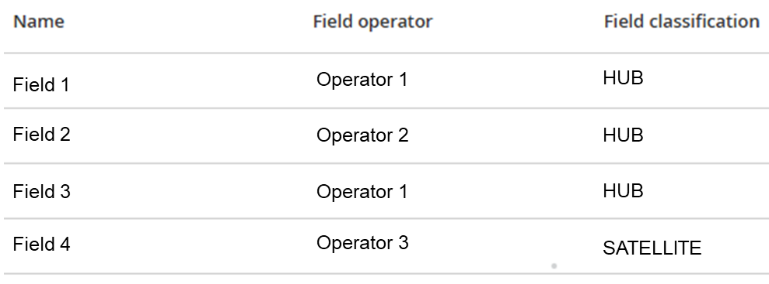
Field Type is selected from drop down menu (Oil, Gas, Condensate, Other).
Field Operator refers to the licenced UKCS Operator of the oil/gas field.
Hub fields are those whose wellhead production is gathered and processed on the Hub facility/platform referred to in this PE return.
Satellite fields are those whose production is routed to the facility covered by this PE return and requires some form of processing prior to export.
'Processing' refers to a process resulting in a compositional change.
Production that goes "up & over" with no processing to achieve a compositional change shall not be reported on this data collection template.
Pressure boosting is not considered as 'processing' if there is no compositional change.
Please check to ensure the correct Field and classification are listed as Hub members.
Contact the stewardship survey team if information is incorrect at stewardshipsurvey@nstauthority.co.uk
Questions asking for information on Satellite fields will only appear when there is a Satellite field listed in the Hub members.

3.2 Duty holder
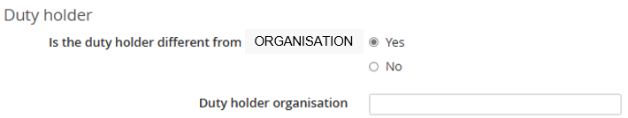
If the duty holder is different to the organisation specified, please enter the name of the duty holder organisation.

3.3 Development
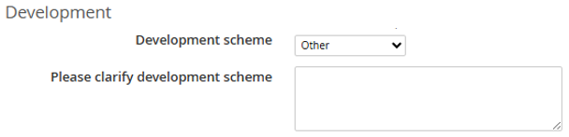
Development scheme options:
- Platform Manned
- Platform NUI
- FPSO / FPS
- Subsea Tieback
- Other
If the scheme is not available within the list, or a combination of options, please select ‘Other’ and provide further details in the comments box.

3.4 Exports
There are multiple questions based on the selections made.
Oil Export options:
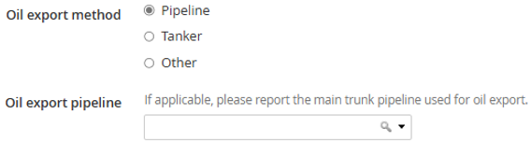
If you select ‘Pipeline’,
then you will be required to select the main trunk pipeline used for oil export, from a drop-down list.
If you select ‘Other’,
then you will be asked to clarify the oil export method scheme.
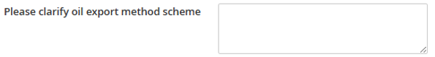
Gas export options:
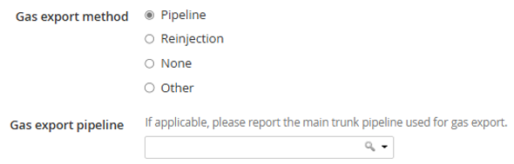
If you select ‘Pipeline’,
then you will be required to select the main trunk pipeline used for oil export, from a drop-down list.
If you select ‘Other’,
then you will be asked to clarify the gas export method scheme.

Gas contract type options: ● None
- Depletion contract
- Supply contract
- Spot market
- Hybrid
- Other
If a contract type exists,
then you will be required to specify if the contract was driven forward by the Buyer or the Seller.

If you select ‘Other’,
then you will be required to clarify the contract type.
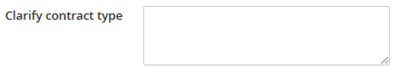

3.5 Additional Production Information
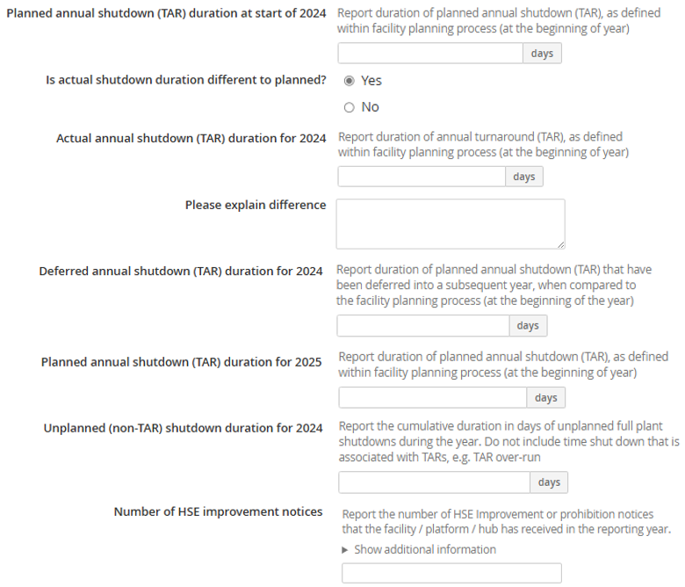
There is now a validation looking at the relationship between TAR days and TAR losses.
It is expected that Actual Annual shutdown (TAR) duration for the ‘survey year’ would equate to TAR losses of EMPP.

- PRODUCTION

4.1 Production – guidance notes
Calculated fields
This page contains fields whose value is calculated automatically. These fields are greyed out and unmodifiable.
Please note: 'mm' signifies 'millions'
e.g. mmboe

Data entry
 You can paste values into table directly from Excel:
- The page will map your pasted cell values to the table cells, ignoring any overflowing rows or columns
- Input fields which have been pasted to will be highlighted green to allow a visual check.

4.2 Production balance guidance
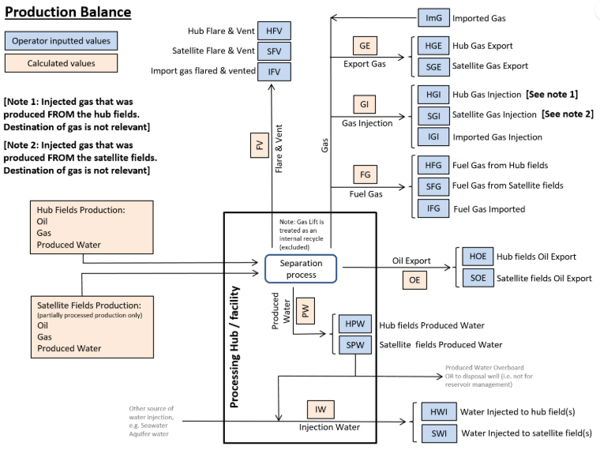
- Hub fields flow to the facility for processing. Well production is calculated in the balance.
- Satellite fields require a measure of pre-processing before flowing to the facility/hub for further processing.
- Fuel, flare & vent volumes now included in the Production balance calculation.
- Gas lift is not included as it is an internal process recycle.
- The Operator of the named facility is responsible for collecting & inputting data into the production balance sheet in the PE data collection template.

4.3 Production totals for year
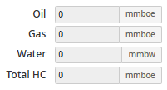
These are calculated values, detailing the total exiting the facility in the reporting year.

4.4 Exported oil
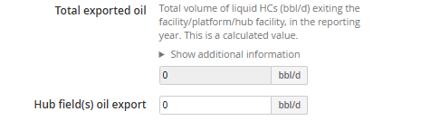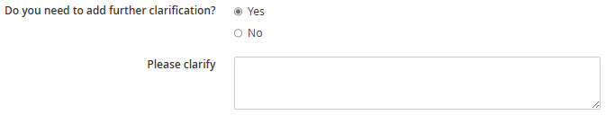
Figures are average per day over the reporting year.
The total exported oil is a calculated value. It is the sum of the hydrocarbon processed and exported by the facility including satellite field(s) hydrocarbons processed within the facility.

4.5 Exported / Imported gas
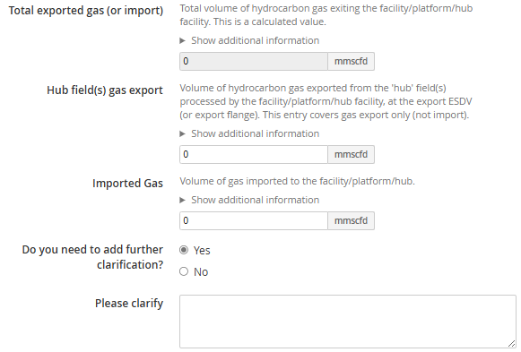
Input data must only contain up to 3 decimal places.
Sum of the hydrocarbon gas processed and exported by the facility including satellite field(s) gas processed within the facility
Excludes gas flows that simply go "up and over" the facility or receive pressure boosting.
Where possible use the metered and/or allocated facility export hydrocarbon gas value, adjusted to standard conditions.
Where possible use the metered and/or allocated facility import hydrocarbon gas value, adjusted to standard conditions.
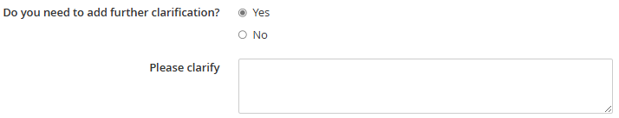

4.6 Injected gas
Input data must only contain up to 3 decimal places.
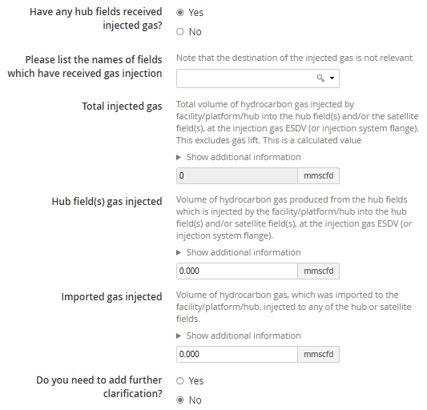
Total injected gas is the sum of hub field(s) injected gas volumes and satellite field(s) injected gas volumes, excluding gas lift.
Note that the destination of the injected gas is not relevant, but please indicate the fields that receive this injection from the drop down menu at the start of this section.


4.7 Fuel gas
Input data must only contain up to 3 decimal places.
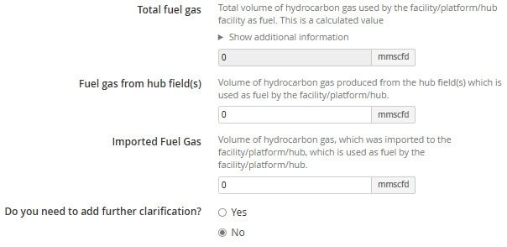
Total fuel gas is the sum of gas used as fuel, whether from hub or satellite fields or from import gas.

4.8 Flare and vent
This should be reported in a manner consistent with the issuing of flare and vent consents,
Note: Flare quantity should relate only to the hydrocarbon fraction (excludes inert fraction).
Input data must only contain up to 3 decimal places.
Cold flare is hydrocarbon gas emissions that should normally be combusted at the flare tip. This figure should not include volumes that are vented.
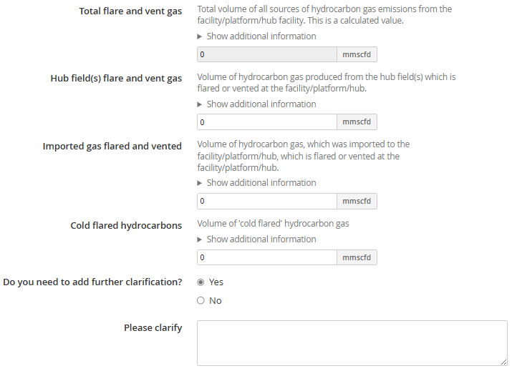
Total flare and vent gas is the sum of hub field(s) flare & vent volumes plus satellite field(s) flare and vent volumes, plus import gas that is flared (if applicable), at the facility.
In the current SPE model Flare & Vent are not logged as production losses.

Import gas flaring volumes are also reported as part of the calculation of this data entry value.

Cold flare is hydrocarbon gas emissions that should normally be combusted at the flare tip.
This figure should not include volumes that are vented via vent routes.
If not known, please leave this blank.

4.9 Conversion factor
Input data must only contain up to 4 decimal places.
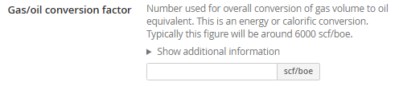
Gases of differing composition or molecular weight will have slightly differing gas/oil conversion factors. The figure entered here should represent a typical but generic factor for the types of gas typically processed.

4.10 Produced water
Input data must only contain up to 4 decimal places.
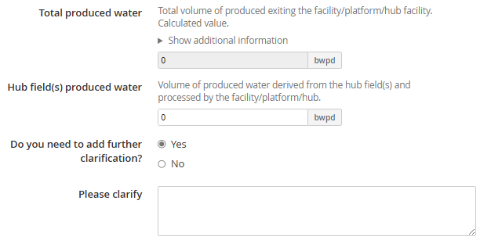
Total produced water is automatically calculated as the sum of all the facility’s produced water exit & discharge routes.
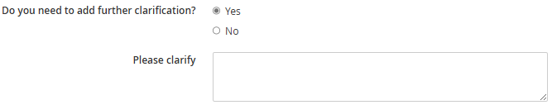

4.11 Injected water
Input data must only contain up to 4 decimal places.
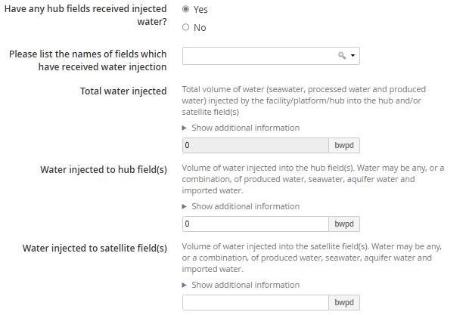
Please indicate the fields that receive water injection from the drop down menu, if you enter a value for Water injected to hub field(s) and/or Water injected to satellite fields.
Total water injected is automatically calculated as the sum of all water sources injected in the hub and/or satellite field(s) (sum of seawater, processed water (eg reduced sulphate) and produced water).


- POTENTIAL

5.1 Potential – guidance notes
Reference should be made to the SPE draft white paper "Production Efficiency Reporting - Best Practice Guidance (2016)" for supporting clarification of the PE choke model and loss process elements.
Calculated fields
This page contains fields whose value is calculated automatically. These fields are greyed out and unmodifiable.
Please note: 'mm' signifies 'millions'
e.g. mmboe

5.2 Choke model
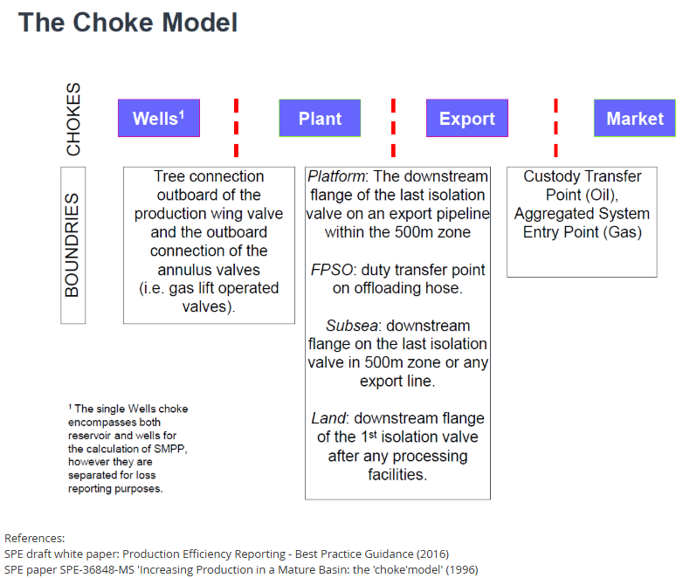
The Choke Model

The Production Efficiency (PE) Data Collection & Reporting process uses a 4-stage production choke model.
The 4 chokes in the production choke model are: Wells¹, Plant, Export & Market.
The production choke model evaluates MPP (per choke), production loss, production potential and hence the Production Efficiency (PE) of the complete process.
¹ The single Wells choke encompasses both reservoir and wells for the calculation of SMPP, however they are separated for loss reporting purposes.

5.3 Calculated Maximum Production Potential
Structural Maximum Production Potential (SMPP) is the lowest structural production potential of the well, plant, export & market systems including volumes processed from satellite fields.
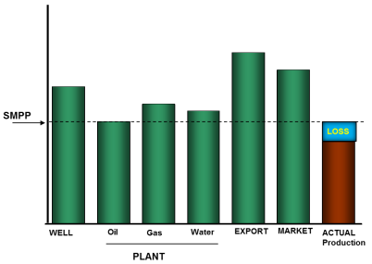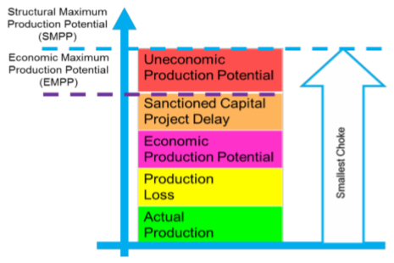

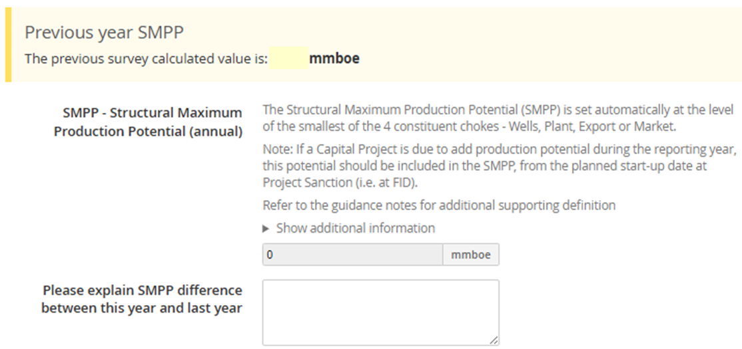

The Maximum Production Potential (MPP), per choke, is calculated as:
Uneconomic Production potential + Capital Project Delays + Economic Production Potential + Actual Production + Production losses
SMPP for the facility is the smallest MPP of the 4 chokes and is reported in mmboe.
Refer to SPE guidance notes for additional information on how these SMPP contributors are applied.

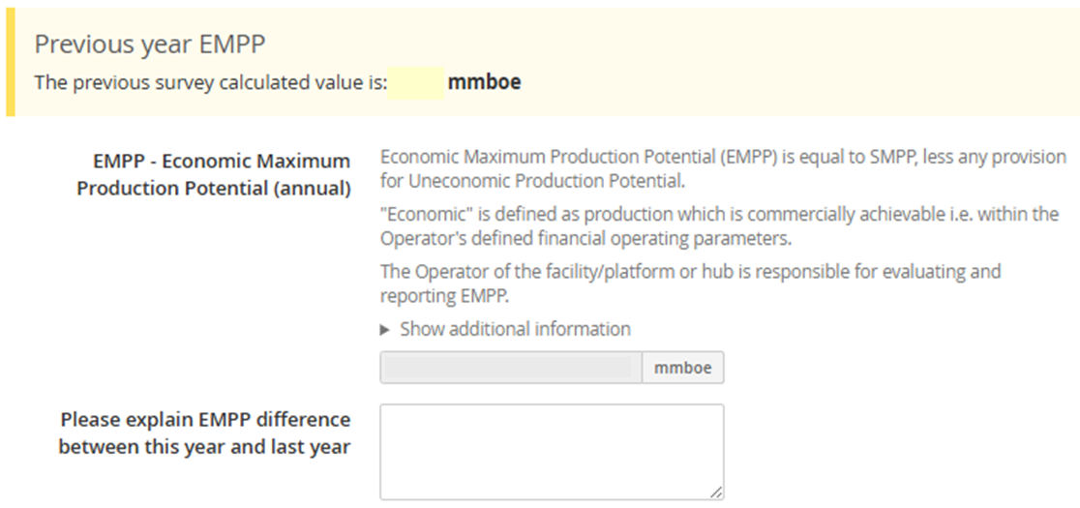
The Production Efficiency data capture process captures only the Operator advised production data for the various chokes and production categories.
The Operator is responsible for collating all hydrocarbon data required in this form, checking allocation into the correct category and using the relevant Operators Technical Authorities to assure data entry and allocation.
No economic data is to be submitted with the Production Efficiency return but the individual Field Operators have a responsibility to report separately to the regulator the basis, calculation and decision for any economic based decision / economic allocation of shut in production potential. This report will be subject to separate review between the Operator and regulator.

5.3.1. Contributor to SMPP Economic Production Potential (EPP)
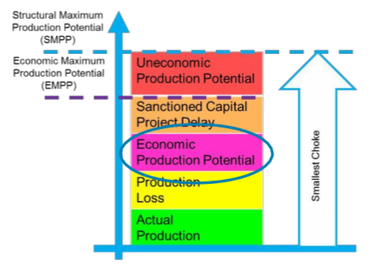
Production potential identified as realisable production potential in the reporting year:
- Made up of production potential which is economically achievable for the Operator through actions such as intervention, workover, repair, maintenance activity, etc.
- EPP is usually described in the Operators annual asset or field plan, for the reporting year.
- EPP can also be found in Operators commitments to the regulator (e.g. approved Field Development Plans (FDPs or FDP Addendum).
- The economic evaluation & justification of EPP shall be reported separately to the regulator (for review as part of the regulator's Asset Stewardship process).

5.3.2. Contributor to SMPP Uneconomic Production Potential (UPP)
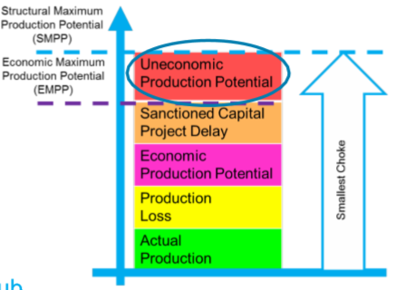
Production potential, which is not economically achievable for the Operator, in the reporting year. UPP is part of SMPP.
- This category can include Capital Project production potential that has met the Operators technical approval requirements but that has been put on hold (not meeting the Operators economic approval criteria).
- UPP can be Field or Facility specific. Hence both the field Operator and the facility/platform/hub Operator shall evaluate & report UPP.
  - The Facility/Platform/Hub Operator is responsible for collecting & reporting all advised UPP in the new data collection template.
  - The basis & economic evaluation of Field or Facility UPP shall be reported separately (for review as part of the regulator's Enhanced Asset Stewardship process).

5.3.3. Contributor to SMPP Sanctioned Capital Project Delay
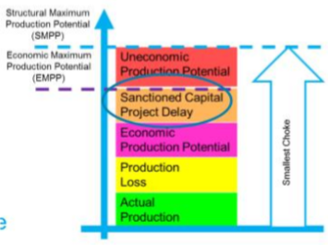
Sanctioned capital projects are defined as projects that have received the Operators Financial Investment Decision approval.
- The Sanctioned Capital Project Delay (SCPD) category identifies production potential loss in the reporting year, for Sanctioned Capital Projects which have reached their Original Scheduled Completion Date at FID but have yet to complete.
SCPD should be recorded as the total loss during the reporting year. i.e. if a project was delayed for 12 months from March then 8 months of SCPD are recorded for the current survey year with the remaining 4 months reported the following year.
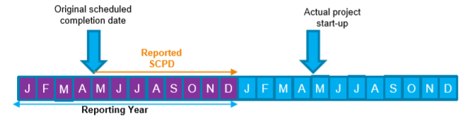

5.3.4. Contributor to SMPP Production Loss
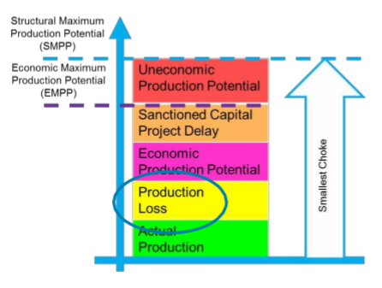
In the new SPE choke model, Production Loss has been redefined as:
Production Loss is calculated as:
- Production losses are allocated into defined “loss categories” designed by the SPE to provide a high-level approximation of where losses occur, per choke.
- The new template is based on SPE “source of loss” categories to record production loss. Individual choke production loss values are summed together to obtain the total production loss for the facility.

5.4 Production choke
Input data must only contain up to 3 decimal places.
Production values of 0 will be ignored when calculating the SMPP and Debottlenecking prize values.
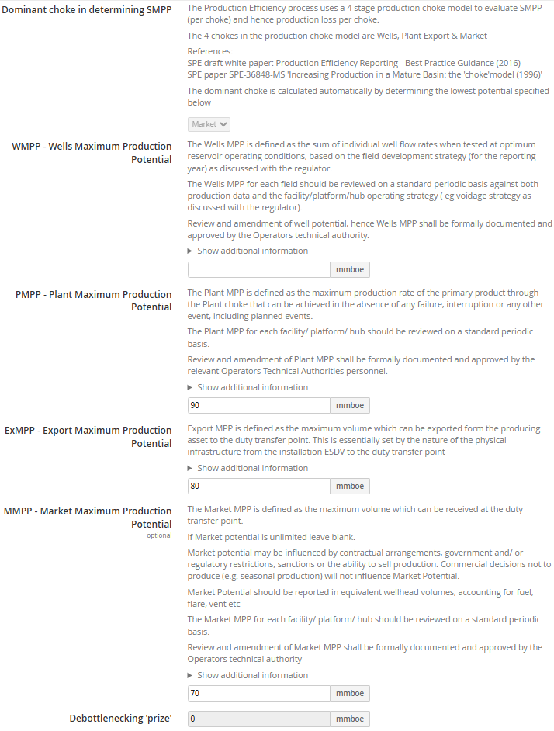
Note the Dominant choke is calculated automatically by determining the lower potential specified.
By design, no two potentials should be exactly the same. If they are you must provide an explanation.

The Wells MPP is the sum of the individual operating well flow rates tested at the optimum operating condition:
- The well potential is based on measured dry oil and gas flow rates corrected to export conditions, reviewed on a standard periodic basis.
- Flowing well rates may decline according to a reduction based on well test rate trend.
- Pseudo tests are acceptable in lieu of measured rate where the test separator is unavailable and there is no other means of establishing a measured rate.
- Where artificial lift is installed, the well potential shall be expressed as total potential inclusive of any uplift from artificial lift.
- Well is included as part of Wells MPP until it is unable to flow - either naturally or with artificial lift, where installed. Removal from Wells MPP requires regulator approval.
- Production potential as a result of a Capital Project (e.g. a new infill well), should be included from the planned start-up date at Project Sanction (i.e. at FID).
Any delay to planned start-up date will be recorded as a Capital Project Delay (CPD).
The Wells MPP for each field should be reviewed on a standard periodic basis against both production data and the facility/platform/hub operating strategy (e.g. voidage strategy as discussed with the regulator). Review and amendment of well potential, hence Wells MPP shall be formally documented and approved by the Operators technical authority.
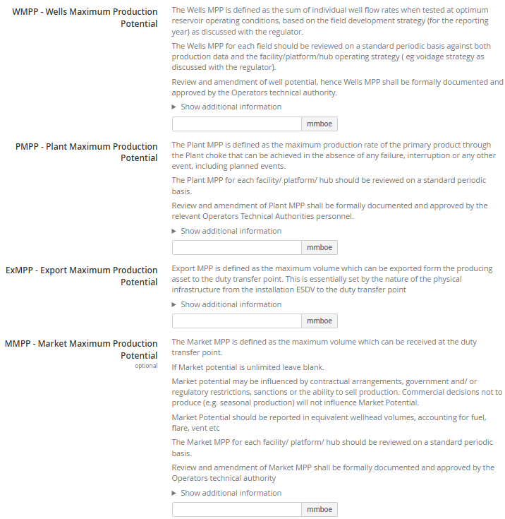
The Plant MPP is defined as the maximum production rate of the primary product through the Plant choke:
- The throughput potential is measured as the quantity of oil, gas, condensate and NGLs that could be processed over a set period of time when no interruptions occur.
- Throughput potential should include gas for re-injection, fuel or flare.
- The constraint on the throughput can be from any of the following; water, gas, oil processing, flare limits or water disposal limits.
- Plant potential should not be reduced for planned or unplanned shut-downs.
- Production potential as a result of a Capital Project (e.g. new or modified plant giving additional potential for processing), should be included from the planned start-up date at Project Sanction (i.e. at FID).
Any delay to planned start-up date will be recorded as a Capital Project Delay (CPD).
Export losses are due to factors outside the control of the Platform operations, and Market constraints should not reduce the Export potential.
The Export MPP for each facility should be reviewed on a standard periodic basis.
Review and amendment of Export MPP shall be formally documented and approved by the Operators technical authority.
The Market MPP is defined as the maximum volume which can be received at the duty transfer point:
- for some gas fields production is constrained by the type of gas contract that is in place, and this can be the overriding consideration when calculating the Market MPP.
The monthly volume should be the sum of the daily gas nominations for that month.
- Market potential should be reviewed on a standard periodic basis where buyer nominated contracts require it. Nominations do not include "best endeavours" element of contract, which means that fields can legitimately achieve over 100% MPP.
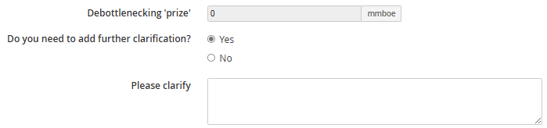
Debottlenecking ‘prize’ is automatically calculated.

5.5 Uneconomic Production Potential
If data is entered, you must provide descriptions.
Input data must only contain up to 3 decimal places.
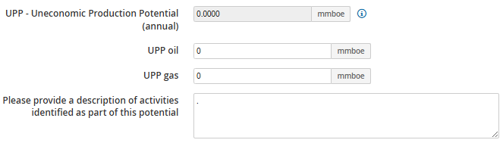
The Uneconomic Production Potential (UPP) category may only contain shut-in Production Potential that has previously been available. UPP should only be made up of Production potential which is not commercially achievable for the operator. UPP will remain part of SMPP.
"Economic" is defined as production which is commercially achievable i.e. within the Operator's defined financial operating parameters
The Operator of the facility/platform or hub for evaluating and reporting UPP for the reporting year.
The UPP loss value (per field) producing to the facility is to be provided in supporting documentation with this return.
Includes Capital Project production potential that has been put on hold due to economic assessment/ decisions.
No economic data supporting the UPP loss value is to be submitted with this Production Efficiency return. The Field Operator has a responsibility to report the economic basis / assessment, calculation and decision for such production potential loss. This will be subject to discussion as part of the regulators Enhanced Stewardship process.

5.6 Capital Project Delays
If data is entered, you must provide descriptions.
Input data must only contain up to 3 decimal places.
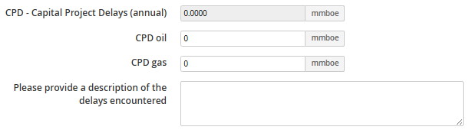
Capital Projects are projects which require investment to deliver benefit across multiple years, and may make available production potential which has not previously been available.
Sanctioned Capital Projects which have reached their Original Scheduled Completion Date but have not yet been completed should be included in the Capital Project Delays (CPD) category.
Note: production potential from such capital projects will be reflected in the SMPP, from the original start-up date specified at Project Sanction (FID).
The production loss associated with a capital project delay (per field) producing to the facility/platform/hub facility is to be provided in supporting documentation with this return.
The loss resulting from the delay could start in the reporting year or over-run from previous years.
No economic data supporting the CPD loss value is to be submitted with this Production Efficiency return. The Field Operator has a responsibility to report the economic basis / assessment, calculation and decision for such production potential loss. This will be subject to discussion as part of the regulators Enhanced Stewardship process.

5.7 Economic Production Potential
If data is entered, you must provide descriptions.
Input data must only contain up to 3 decimal places.
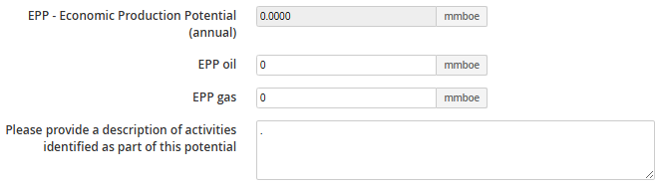
The Economic Production Potential (EPP) category may only contain production potential that has been identified as realisable production potential. Hence EPP shall only be made up of production potential which is commercially achievable for the Operator through actions such as intervention, workover, repair, maintenance activity, etc.
The Operator of the facility/platform or hub is responsible for evaluating and reporting EPP.

Includes all economic potential, including activities where the work plan is not yet set.
"Economic" is defined as production which is commercially achievable i.e. within the Operator' defined financial operating parameters.

5.8 Production efficiency and losses
The Actual Wellhead Production is defined as total hydrocarbon production volumes prior to any processing losses. AWP figures are automatically calculated and included from data entered on the Production page.
In the Production Efficiency data capture process, this hydrocarbon value is calculated from the volume (mass) balance across the facility.
Note that in the SPE guidelines, Flare & Vent volumes are not losses but part of the PE calculation.

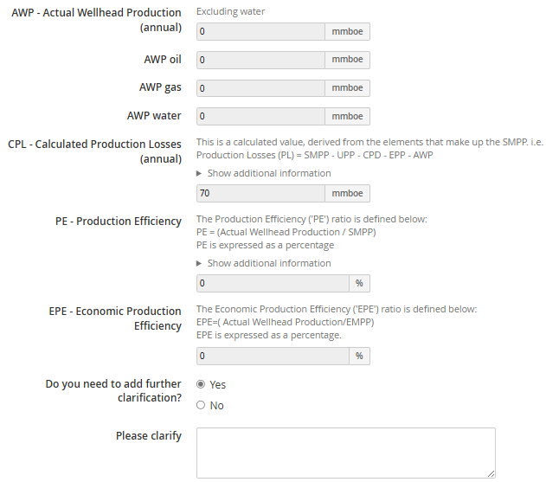
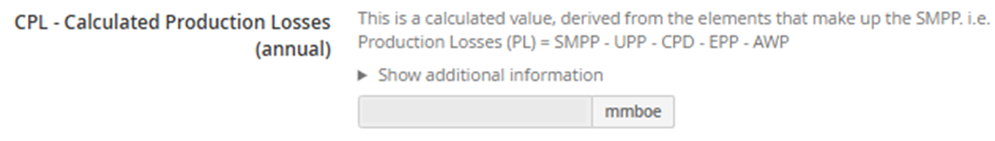
Production Losses are events which occur and prevent an asset achieving its SMPP and are not classified within other categories, i.e.
- Uneconomic Production Potential
- Capital Project Delays
- Economic Production Potential
Hence Production Losses (per choke) is calculated as:
SMPP
less Uneconomic Production potential
less Capital Project Delays
less Economic Production Potential
less Actual Production
Each choke production loss will be further split into the relevant source of loss category
Actual Wellhead Production is the total hydrocarbon value entering the facility, calculated from the volume balance across the facility.

5.9 Injection potential
Input data must only contain up to 4 decimal places.
Depending on the Voidage replacement / pressure maintenance strategy is selected various questions will appear below and on the Losses page.
Options for ‘Voidage replacement / pressure maintenance strategy?’:
- None
- Water injection
- Gas injection
- WAG (water alternating gas injection)
- SWAG (simultaneous water and gas injection)
- Other
- If ‘None’ or ‘Other’ is selected, you will not be able to enter any injection losses in the Losses page.
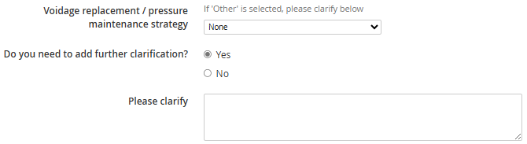
- If ‘Other’ is selected, you will be asked the full complement of injection potential questions:
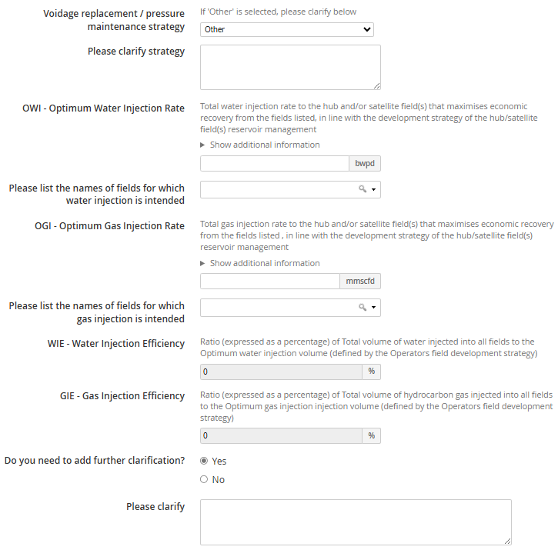
Both the OWI and OGI Values are to be determined by the relevant Operators Technical Authority and agreed with the regulator (asset stewardship review).

- If ‘Water injection’ is selected, you will be asked the following questions.
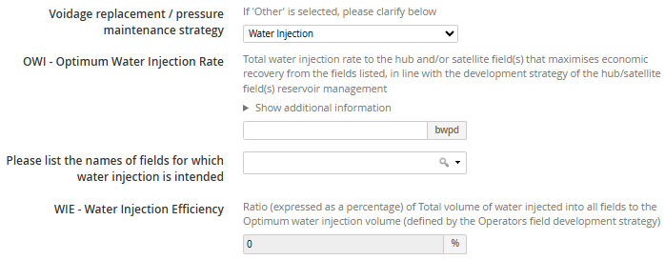
The OWI Value to be determined by the relevant Operators Technical Authority and agreed with the regulator (asset stewardship review).

- If ‘Gas injection’ is selected, you will be asked the following questions.
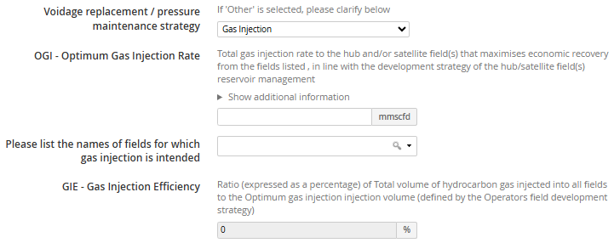
The OGI Value to be determined by the relevant Operators Technical Authority and agreed with the regulator (asset stewardship review).

- If ‘WAG (water alternating gas injection)’ is selected, you will be asked the following questions.
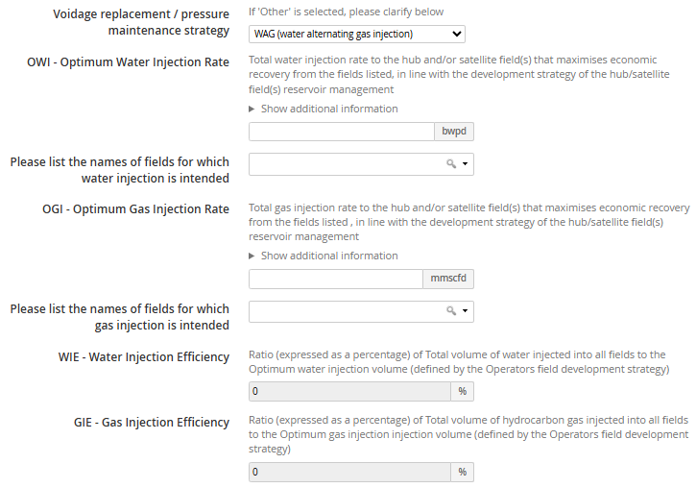
Both the OWI and OGI Values are to be determined by the relevant Operators Technical Authority and agreed with the regulator (asset stewardship review).

- LOSSES

6.1 Losses – guidance notes
Calculated fields
This page contains fields whose value is calculated automatically. These fields are greyed out and unmodifiable.
Please note: 'mm' signifies 'millions'
e.g. mmboe
Input data must be integer values.

6.2 Combined losses (annual)
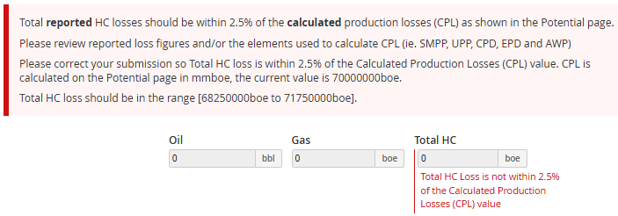
It is expected that reported HC losses should be within 2.5% of the calculated production losses shown on the Potential > Production efficiency and losses page:
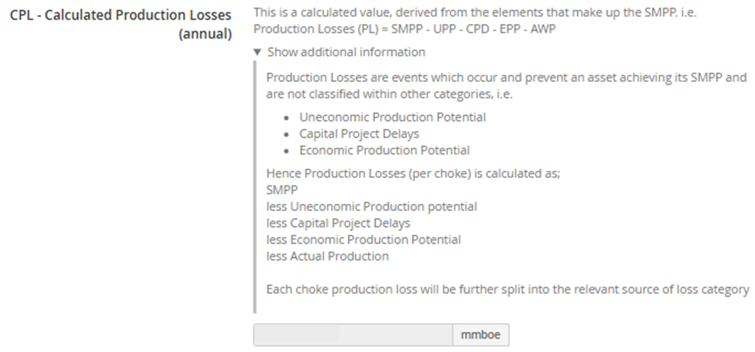

6.3 Wells losses (annual)
If there are well losses, please provide details about the main contributors in the text box at the end of the Wells losses (annual) section.
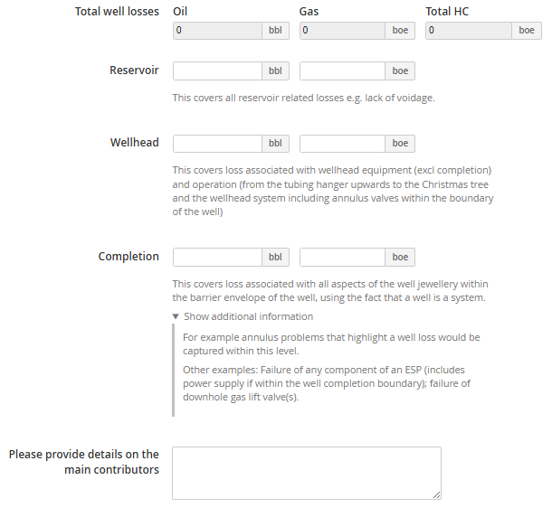

6.4 Plant losses (annual)
If there are plant losses, please provide details about the main contributors in the text box at the end of the Plant losses (annual) section.
Total plant losses is automatically calculated.
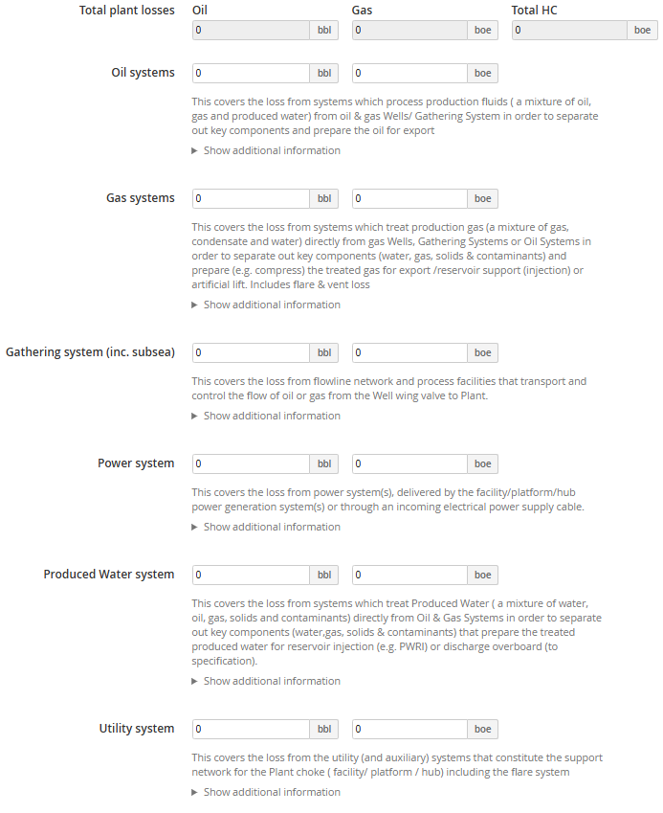
Includes reservoir fluid contaminants, artificial lift fluids and production chemicals injected into the reservoir and wells. Includes satellite and/or 3rd party oil system loss
Equipment includes separators, vessels, tanks, flowlines, manifolds, pipework, pumps, metering. Includes oil phase treatment systems that remove solids or other contaminants and oil metering systems.
Includes gas phase treatment systems that remove hydrocarbon liquids, water, solids or other contaminants (CO2, H2S etc), gas dehydration systems, gas to be processed for fuel, fuel gas distribution systems, gas metering systems, gas Import systems.
Equipment includes separators, vessels, pipework, manifolds, compressors, pumps, metering.
Includes fluids for Artificial Lift (e.g. supply for gas lift etc.).
Loss of Artificial lift will produce a Production Loss.
Includes all types (radial, trunk line, daisy chain) and all associated equipment (flowline, pipeline, manifold, inline equipment etc.). Also called the collecting system.
Includes all sources of electrical power generation on the facility and incoming power supplies.
Includes electrical distribution systems on the facility and electrical power distribution systems to artificial lift equipment in Wells and Gathering System (e.g. ESPs, subsea pumps / compressors etc).
Includes all electric drives supplied by the Power system(s).
Includes all produced water treatment systems that condition produced water for re-injection of discharge, remove solids or other contaminants, non HC drain systems, metering systems, discharge systems.
Includes all marine water systems (slops, machinery, drains) that result in a water discharge stream overboard (which has to meet specification).
Equipment includes tanks, separators, vessels, pipework, manifolds, pumps, metering, caissons etc.
Typically cover the following facility systems:
- Fresh, hot and sea water distribution
- Flare and vent systems
- Chemical injection
- Jet fuel and diesel oil system
- Air/ Nitrogen / Inert gas system
- Chemical bunkering, storage and distribution
- Lube oil, hydraulic oil and compressed air
- Heating and cooling medium
- HVAC
- (FPSO) Turret auxiliary systems
- Helideck support systems
- Safety systems (inc. firewater systems)
Also includes all mechanical lifting (cranes, winches etc.) and storage systems.
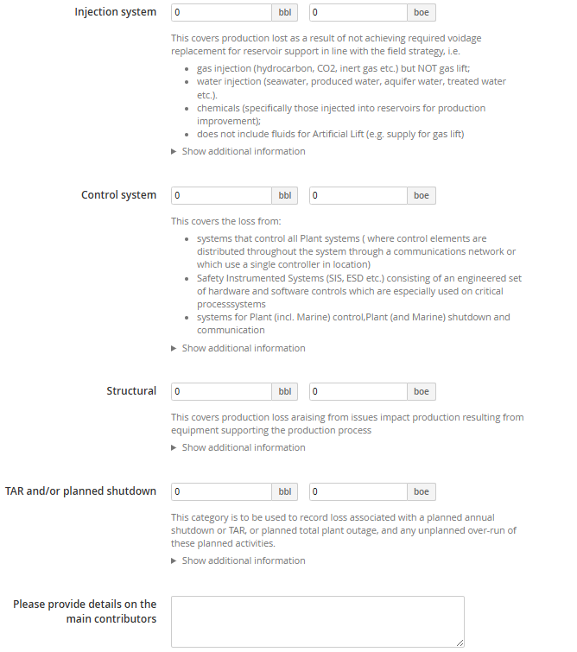
Covers injection of fluids that will produce (over time) a production loss from the reservoir if injection volumes cease or are not managed to optimum reservoir management guidance.
Hence loss of fluids for reservoir support does not immediately produce a production loss, but will over time, therefore a loss should be estimated by the relevant Operator Technical Authority and agreed with Regulator.
All production systems with Instrumented emergency shutdown, control and instrumented monitoring equipment, including hydraulic systems.
Includes equipment such as:
- Primary structure incl. jacket legs etc.
- FPSO moorings
- Midwater arches, J-Tubes.

Planned means that the activity is defined within the facility planning process (at the beginning of year).
This category includes unplanned over-runs of the planned activities (e.g. TAR exceeding the originally planned duration).

6.5 Export loses (annual)
If there are export losses, please provide details about the main contributors in the text box at the end of the Export losses (annual) section.
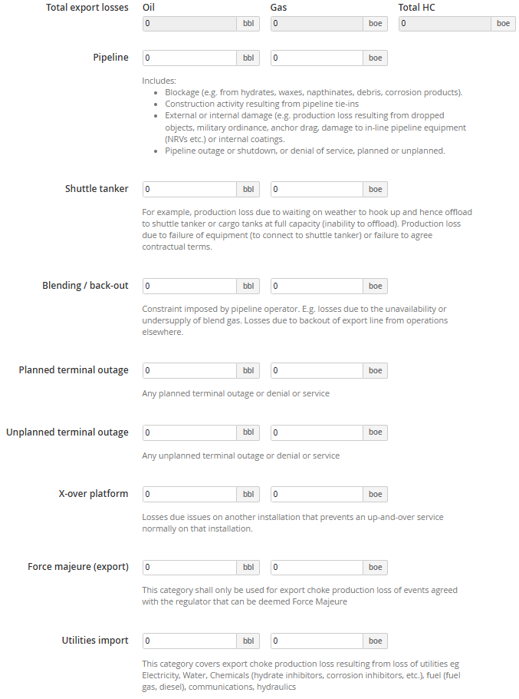


6.6 Market losses (annual)
If there are market losses, please provide details about the main contributors in the text box at the end of the Export losses (annual) section.
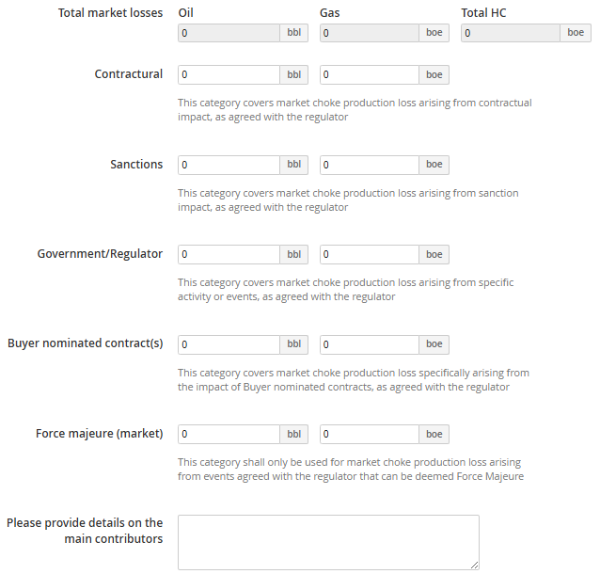

- SUPPORTING INFORMATION

7.1 Infrastructure Connectivity Diagram
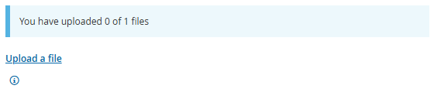
Please upload:
- 1 Infrastructure connectivity diagram.

The following file extension are not allowed:
bat, bin, com, dll, exe, msc, msi, msp ocx, scr, wsc, wsf, wsh.

Once a file has been uploaded,
you will be able to (i) add a description, (ii) delete the file, (iii) restore a deleted file (iv) upload a new version of a file.

Topsides Process Flow Diagrams
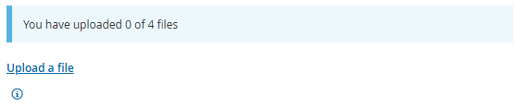
Please upload 4 Topsides process flow diagrams:
    - Separation systems.
    - Gas compression (inc. injection) systems.
    - Produced water systems.
    - Water injection systems.
You will no longer be made to upload 4 separate diagrams, but you must confirm all 4 flow diagrams are in the documents uploaded.

The following file extension are not allowed:
bat, bin, com, dll, exe, msc, msi, msp ocx, scr, wsc, wsf, wsh.

Once a file has been uploaded,
you will be able to (i) add a description, (ii) delete the file, (iii) restore a deleted file (iv) upload a new version of a file.

Third Party Data Collection Template…

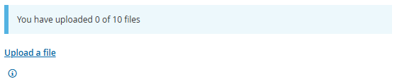
Please upload 1 Third part data collection template if necessary – 2017-pe-field-operator-data-request spreadsheet.

7.4 FAQs
- Wells MPP
Definition is the sum of the well tests …. But will this always be the case?
We could use the modelled potential of a well …
the issue is up for debate but in the end the Operators subsurface or wells TA will determine the potential ... and hence it is for the Operator to justify the value at the asset stewardship review with OGA.
- Sanctioned Capital Production Delay (SCPD) (no production in the year)
If the sanctioned capital project has a delay of more than 12 months (from sanctioned first oil date) and the delay has resulted in no production in the reporting year, then the whole of the estimated production in the reporting year will be logged as SCPD.
- Loss examples
  - Deman due to imminent extreme weather
Loss categorised as – Plant choke loss, full plant loss.
  - Production stopped due to regulatory action
Loss categorised as – Plant choke loss, full plant loss.
  - Well awaiting intervention (in asset work activity plan to do)
Loss categorised as – Wells choke loss, EPP loss. Well expected online in May but then comes online in Dec.
Loss categorised as – Well choke loss, SCPD loss from May to start-up date.
  - EPP (plant configuration N or N+1.
It could be argued that N+1 configuration had a potential to bring on additional plant capacity, but if the Operator can show the facility runs a maintenance strategy of N+1, the plant capacity (for loss calculation) is therefore based on N.
  - Strike action
Market losses → Force Majeure.

- CHECKLIST

Below are the some of the detailed QC steps that each section will go through. If you think your data will not pass these checks, please add as much information in the general comments section as possible to help us understand why.
- SMPP vs previous year(s). A comment will now be necessary if figure is different from previous year. (this includes EMPP).
- Production vs previous year(s).
- Production v PPRS.
- Sense check of third-party volumes.
- What determines the choke and does it make sense (i.e. versus previous years or field team knowledge).
- General field team intelligence versus input overall (i.e. water inj for winj fields).
- Check all producing fields/PPRS reporting units are allocated to a hub (possible exceptions are recent start ups or any fields/hubs deliberately excluded by the Area Teams).
- Check specified export routes and export methods are correct.
- Any cross reference to Wells section e.g. well losses?
- Dominant potential is now automatically populated as the lowest potential.
- There is now a flag when reported and calculated losses >2%.
- New validation rule where 2+ Potentials cannot be the same value.

- CONTACT DETAILS

If you have any issues when using the UKSS Stewardship Survey then please email stewardshipsurvey@nstauthority.co.uk and the stewardship team will respond as quick as possible.

If you find any errors with the data or question options presented on this survey form, then please report the error to the UK Energy Portal Service Desk by calling 0300 067 1682 or email ukop@nstauthority.co.uk.

