

UKSS SECTION GUIDE
TECHNOLOGY

This section will appear for all Fields that you operate and once at Organisational level.

If you think there are any errors with allocation, please contact
stewardshipsurvey@nstauthority.co.uk

Date of publication 31/10/2025

The document can be found on the NSTAs website.

© NSTA Copyright 2025
URN

You may re-use this information free of charge in any format or medium, under the terms of the NSTA’s User Agreement. To view this, visit: https://www.nstauthority.co.uk/site-tools/access-to-information/ or email correspondence@nstauthority.co.uk

This document is available in large print,audio and braille on request.
Please email: correspondence@nstauthority.co.uk with the version you require.

Enquiries to:
North Sea Transition Authority
50 Broadway
London
SW1H 0DB

Email: correspondence@nstauthority.co.uk

Published by the North Sea Transition Authority

Contents
1. UKSS 2025 CHANGES 5
2. FIELD – TECHNOLGY 6
2.1 Field – Technology Deployment Notes 6
2.2 Technology Deployment 7
2.2.1. Deployment Status 8
2.2.2. Development Plan 9
2.2.3. Technology sub-category 9
2.2.4. Digital and data sub-category 10
2.2.5. Maturity stage 10
2.2.6. Net Zero sub-category 11
2.2.7. Technology aims 11
2.3 Import a technology 12
2.4 Removal of Technology 13
3. ORGANSATION – TECHNOLOGY 15
3.1 UK Spend on Technology 15
3.1.1. Total Spend 15
3.1.2. Breakdown Spend 16
3.1.3. Validations 17
3.2 Licence – Technology deployment 18
3.2.1. Deployment Status 19
3.2.2. Development Plan 19
3.2.3. Technology sub-category 20
3.2.4. Digital and data sub-category 20
3.2.5. Net Zero sub-category 20
3.2.6. Maturity stage 20
3.2.7. Technology aims 21
3.3 Removal of Technology 21
3.4 Company technology plan 23
3.4.1. Technology Plan 23
3.4.2. Responsible Person 24
3.5 Company Technology Plan – Further guidance 25
3.5.1. Required Content 25
3.5.2. Additional Information 25
3.5.3. Technology Needs 26
3.5.4. Addressing the Identified Technology needs 26
3.5.5. NSTA Technology Needs spreadsheet contents 27
3.5.5.1. NSTA Sub-Categories 29
3.5.6. Timeline for Completion of the Technology Plan 31
3.5.7. Delivery of Expectation 31
4. CHECKLIST 32
5. CONTACT DETAILS 33

- UKSS 2025 CHANGES

The following changes are being implemented in the Technology section of the survey:

- If you do not have any technologies to report in a field, then you will be presented with a list to select from as well as the box to provide additional detail. A comment is only mandatory if ‘Other’ is selected.

- FIELD – TECHNOLGY

2.1 Field – Technology Deployment Notes
This section does not replace the Technology Plan
As part of the Stewardship Expectations, we aim to use this section to demonstrate that technologies are being deployed to optimum effect achieving net zero objectives and in maximising the value of economically recoverable petroleum from each field.
By requesting data on Technology Deployment on each field, the NSTA will increase the consistency of data collected across the UKCS. This will create a better understanding of the types and pace at which technologies are being deployed in addition to the detail provided in the Technology Plan.

Please add technologies to all fields that apply.
For each Field, you will initially be asked if you have any technologies to report on.

If ‘No’ is selected, and no technologies have been copied forward from last year,
you will be asked to select / provide a reason and then directed to the submit section page.
The reason options are:
- Asset for COP
- Asset in Decom
- No technologies to report
- Other
If ‘Other’ is selected then you must provide a reason in the designated comments box.
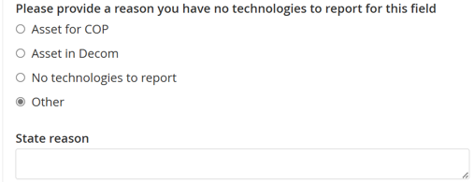
A warning will flag if you select no but there are technologies that were added in previous year.
If ‘Yes’ is selected,
then technologies are to be added under a life cycle Domain within each Field.
The following life cycle domains will appear for you to report on:
- Seismic and exploration
- Well drilling and completions
- Subsea systems
- Installations and topsides
- Reservoir and well management
- Facilities management
- Well P&A
- Facilities decommissioning

For each life cycle domain, the questions asked are the same, excluding the options for ‘Technology Category’.
Please ensure the technology is in the correct life cycle domain before selecting ‘Other’ in the sub-category.
You will not be able to edit the Technology name and Description from technologies copied from previous surveys.

2.2 Technology Deployment
Please provide details about technologies that have been deployed in the last 12 months.
These technologies should also feature in the Technology Plan alongside previous deployment of technologies and emerging technologies.
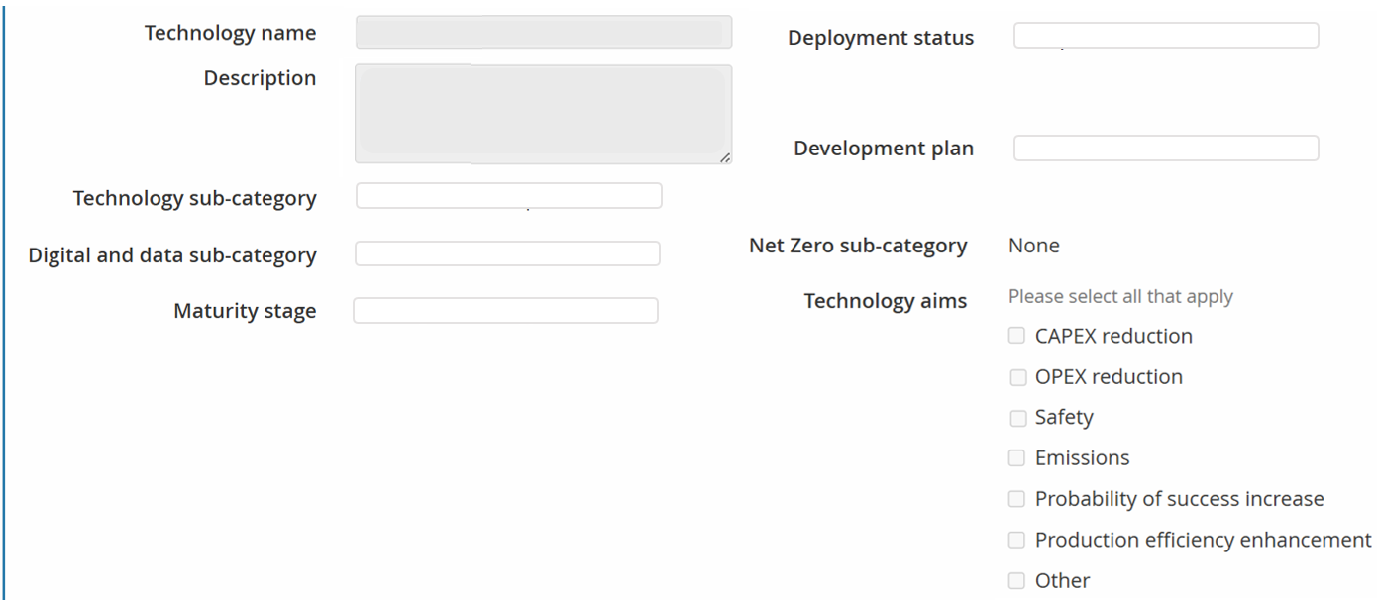
We want to gather data on where technologies are deployed, therefore if a technology is deployed over several fields, please add individually to each field.
If the same technology is deployed over multiple fields, please ensure the Field name is consistent. You can use the ‘import a technology’ button to achieve this (reference section 2.3 Import a technology), but only once the technology has been added to a field and the section has been submitted.
If you have no technology deployments to report in the first domain (Seismic and exploration), please progress on to report on the other domains.
Technologies added this year will auto populate into the following years survey.
Please note that from the 2023 survey, the "Technology category" in the form below was amended to "Technology sub-category".
If the technology being deployed has either Digital or Net Zero content, please select the appropriate sub-category or closest match.
Please refer to the Stewardship Expectation Number 8 (SE08) for guidance on this section.
If the technology is more relevant to a Licence level, please include this information within the
operator Level Technology Section
Please ensure Technologies are in the correct lifecycle domain.
Technology sub-categories are different for each lifecycle domain and ‘other’ should only be selected if the technology doesn't fit into any existing sub-category listed.

Deployment Status
Select one of the following options:
- Under Assessment - The technology has not yet been planned to be deployed but is being assessed at this time.
- Planned - Technology is available and is intended for deployment at a future date.
- In Progress - Technology is being developed and/or undergoing trials for future deployment.
- Parked - Not Progressing - The technology is not progressing at this time because it does not make a sufficient business case, or is no longer suitable.
- Completed - Technology is in use on the asset.
- Business As Usual - The technology has been deployed and has become standard practice to use, so it is considered business as usual.
- Unknown - Technology does not fit with the above options (operator to describe).

Development Plan
Select one of the following options:
- Vendor's solution - Technology developed by supply chain
- Partnership with suppliers - Technology developed in collaboration with supply chain
- Joint industry programme - Technology developed in collaboration with other operators/institutions/supply chain
- OGTC/NetZeroTC programme - Technology developed in collaboration with supply chain but with NetZeroTC funding
- In-house development - Technology developed by operator
- Other - Does not fit in above options (operator to describe)
If ‘Other’ is selected, then provide a description in the ‘other development plan’ comment box.

Please note in the general comments box if you use a different TRL scales and what this scale is.

Technology sub-category
For the ‘Technology sub-category’, the options are dependent on the domain (reference the table below). Select one of the sub-category options from the relevant list.
Please ensure the technology is in the correct domain before selecting ‘Other’ in the sub-category. If ‘Other’ is selected, then provide a description in the ‘other technology sub-category’ comment box.
Life cycle Domain | Technology Sub-Category
Seismic and exploration | Geophysical acquisition; Geology processing and imaging; Subsurface modelling; Other
Well drilling and completions | Well design and planning; High-angle and ERD; Drilling equipment; Drilling, casing and cementing operations; MWD, LWD and geosteering; Well equipment; Multilaterals; Completions and artificial lift; Stimulation; Other
Subsea systems | Subsea concept; Pipelines, risers, jumpers and connections; installations and construction; Manifolds, umbilicals and control systems; Power generation and hydraulic storage; Metering, flow assurance and chemicals; Processing, boosting and storage; Metering, flow assurance and chemicals; Processing, boosting and storage; Inspection and intervention systems; Other
Installations and topsides | Onshore terminals; Manned offshore platforms; Unmanned offshore platforms; Construction and installation; FPSOs and FSOs; Production and offloading buoys; Fluid separation, treatment and compression; Metering and monitoring; Control systems and automation; Fluid injection and reinjection; Power and utilities; Other
Reservoir and well management | Surveillance and inspection; Liquid loading and water production; Waxing, hydrates and scaling solutions; Sand and solids management; Intervention equipment; Well integrity repairs; Improved and enhanced recovery; Other
Facilities management | Maintenance and operations; Equipment monitoring and reliability; Integrity monitoring and inspections; Facility integrity repairs; Other
Well P&A | Data and planning; Well inspection and cement condition; Intervention equipment; Casing section removal; Conductor removal; Barriers, placement and verification; Other
Facilities decommissioning | Survey and planning; Data management; Site inspection and monitoring; Waste management and recycling; Late life management and equipment readiness; Preparation and removal; Cleaning and isolation; Other

Digital and data sub-category
Select one of the following options:
- None
- Connectivity
- Data acquisition
- Data systems
- Modelling & analytics
- Productivity & safety enhancements
- Visualisation & interfacing.

Maturity stage
Select one of the following options:
- Early development – TRL range 1-3
- Late development / pilot – TRL range 4-5
- Early commercialisation – TRL range 6-7
- Existing technology – TRL range 8-9.

Please note in the general comments box if you use a different TRL scale and what this scale is. The TRL definitions are:
- TRL 1 - Basic principles observed
- TRL 2 - Technology concept formulated
- TRL 3 - Experimental proof of concept
- TRL 4 - Technology validated in lab
- TRL 5 - Technology validated in relevant environment
- TRL 6 - Technology demonstrated in relevant environment
- TRL 7 - System prototype demonstration in operational environment
- TRL 8 - System complete and qualified
- TRL 9 - Actual system proven in operational environment

Net Zero sub-category
Select one of the following options:
- Low carbon power / electrification
- Energy efficiency
- Flaring venting, monitoring & reduction
- Hydrogen
- CCUS.

Technology aims
Select all the applicable options from the list:
- CAPEX reduction
- OPEX reduction
- Safety
- Emissions
- Probability of success increase
- Production efficiency enhancement
- Other
If ‘Other’ is selected, then provide a description in the ‘technology aims’ comment box.

2.3 Import a technology
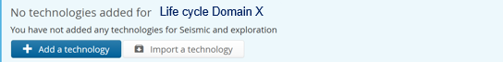
Click to import a Technology from another Field.
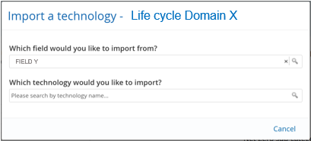
To import a previously submitted technology you will need to specify the Field the technology has previously been submitted for.
You can only import technologies from fields where the Technology section has been submitted.
You can only import technologies within the same life cycle domain, for example, you cannot import a technology from “Subsea systems” into the “Seismic and exploration” domain.

Once a technology has been added to a field and the section has been submitted, you can copy this Technology to another field with the ‘Import a technology’ button.
If the technology has been imported from another section, the Name, Description and Category cannot be edited.
Please note that updates to the source technology will not be reflected if the technology has been imported. You must remove and re-import if the source technology (name, description, category) has changed.

2.4 Removal of Technology
A technology can be removed by selecting the  icon. The following warning will appear.
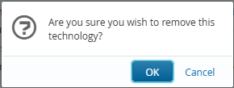
If the technology was added during the current survey year, the technology will just be removed.

If the technology was added during the previous survey and copied forward, you will see the following warning message
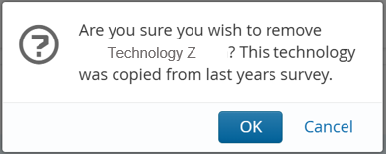
and requested to select a reason and explain why the technology is being removed.
The reason options are:
- Technology inconclusive
- Finance
- New technology superseded or taken over
- Technology failed to deliver expectation
- Other (please explain in the comments box).
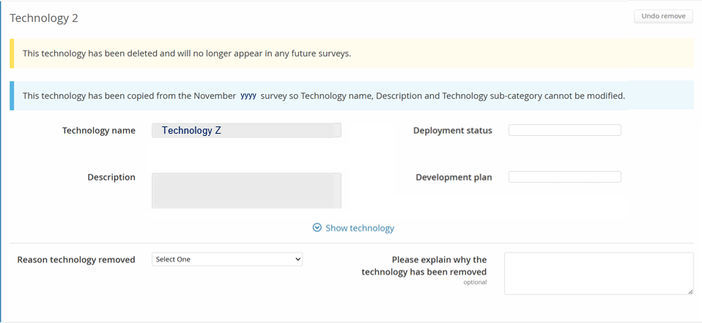

Select the button to undo the removal at any time before the section has been fully submitted.
Once the section has been submitted, the technology will be deleted and will no longer appear in any future surveys.

- ORGANSATION
– TECHNOLOGY

3.1 UK Spend on Technology
Please use actuals for the previous and current year and provide forecast spend/budget for the next 3 years of your company’s total technology spend in support of your UKCS business.
The value in the ‘Total’ column for Total spend (reference section 3.1.1) should equal the value in the ‘Total’ column for ‘Breakdown Spend’ (reference section 3.1.2).
Data entry
Entries should be whole numbers with no spaces, commas, or decimal points
e.g. £5m = 5000000.
 You can paste values into table directly from Excel:
- The page will map your pasted cell values to the table cells, ignoring any overflowing rows or columns
- Input fields which have been pasted to will be highlighted green to allow a visual check.

3.1.1. Total Spend
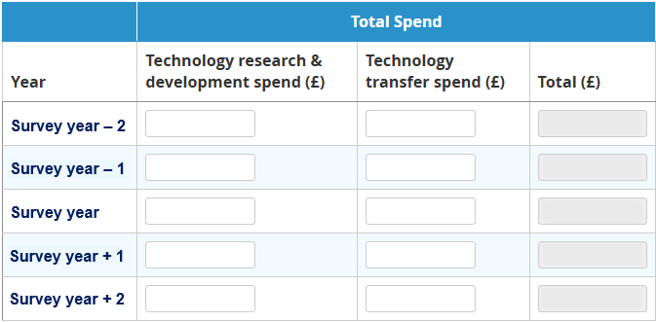

Technology Research & Development (R&D) Spend
Spend should include R&D activities undertaken by your UK business, corporate charges, as well as R&D activities outsourced to third-parties, memberships and contributions to joint industry projects.
Technology Transfer spend
Spend on the use of technologies, transferred to operators assets.
Total Spend
This section refers to your company's total technology spend in support of your UKCS business.
Please provide information on additional spend related to the testing, qualification, and deployment of advanced technologies, whether or not developed by your company, and in support of your UKCS business.
This spend category should include all costs (capex and opex) to undertake technology pilots, qualification work, design and implementation of advanced technologies, including activities outsourced to third-parties, and in collaboration with other companies.

3.1.2. Breakdown Spend
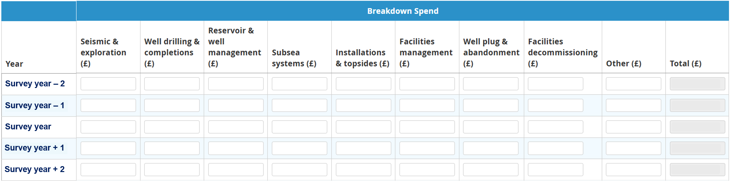
Please provide the breakdown of the Total Technology Spend reported in the previous section (i.e. the total of R&D and Technology Transfer) by the technologies categories indicated below:
- Seismic & exploration – e.g. to include technology related to Seismic acquisition, Geology, Seismic processing and imaging, Subsurface modelling and interpretation, etc.
- Well drilling & completions - e.g. to include technology related to Drilling equipment, Well design and planning, Well equipment, Drilling, casing and cementing operations, High-angle and ERD wells, Multilaterals, MWD, LWD and Geosteering, Well coring, logging and testing, Artificial lift, Reservoir stimulation, etc.
- Reservoir & well management - e.g. to include technology related to Well logging and inspection, Access and intervention equipment, Liquid loading and water production mitigations, Waxing, hydrates and scaling solutions, Sand and solids management, Integrity repairs, Perforating, etc.
- Subsea - e.g. to include technology related to Pipelines, Risers, Jumpers and Connection Systems, Manifolds, Umbilicals, Control systems and automation, Flow assurance, metering and monitoring, Subsea processing, boosting and storage, Subsea power generation, local chemical and hydraulic storage, Installation and construction methodologies (including lift and shift), Subsea inspection and intervention systems (excluding wells), etc.
- Installations & Topsides - e.g. to include technology related to Onshore terminals, Manned offshore platforms, Unmanned offshore platforms, FPSOs and FSOs, Production and Offloading Buoys, Fluid separation, treatment and compression, Power and utilities, Fluid injection and reinjection, Metering and monitoring, Control systems and automation, Construction and installation, etc.
- Facilities management - e.g. to include technology related to Integrity monitoring and inspections, Integrity repairs, Equipment monitoring and reliability, Maintenance and operations, etc.
- Well plug & abandonment - e.g. to include technology related to Data management, Well inspection and cement condition, Intervention equipment, Casing section removal, Barriers, placement and verification, Conductor removal, Site inspection and monitoring, etc.
- Facilities Decommissioning - e.g. to include technology related to Late life management and equipment readiness, Survey and planning, Data management, Cleaning and isolation, Preparation and removal, Waste management and recycling, Site inspection and monitoring, etc. but excluding wells P&A.
Additional categories can be added to the Breakdown Spend.
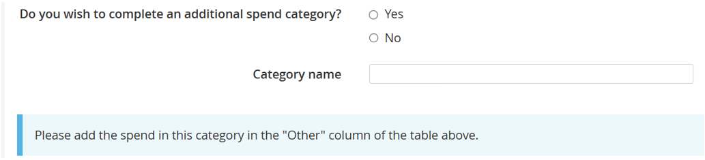

3.1.3. Validations
Explanations will be required in the comments box below the table of spend values for the following validations.
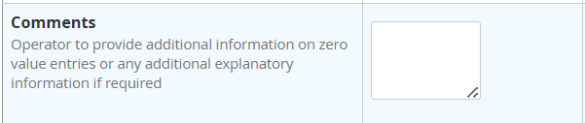
Validation 1: you must enter data for all years. If there is no spend, enter 0.
If 0 entered, please provide an explanation.
Validation 2: each years Total Breakdown Spend must be within +/- 10% of the Total Spend.
If out with the tolerance, please provide an explanation.
eg If year 2027 Total spend is £5MM and 2027 Breakdown Spend is £14MM. Why?
Validation 3: each years Total Spends must be within +/- 10% of the Total Spends from the previous survey.
If out with the tolerance, please provide an explanation.

3.2 Licence – Technology deployment
Select a licence you are providing details about technologies that have been deployed in the seismic and exploration category that are implemented across a licence in the last 12 months.
If these technologies apply to a field, then please add that to the associated field found in the operator matrix.
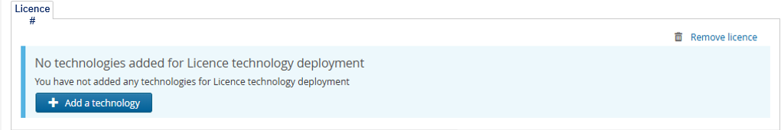
Only add licences where technologies have been deployed.
Technologies added this year will auto populate into the following years survey. Please note that from the 2023 survey, the "Technology category" in the form below is amended to "Technology sub-category". If a technology has been carried forward from a previous survey, then the following message will be displayed:

For each technology added, provide the following information:
- Technology name & a description
Note: You will not be able to edit the Technology name and Description from technologies copied from previous surveys.
- Deployment status
- Development plan
- Technology sub-category
- Digital and data sub-category
- Net Zero sub-category
- Maturity stage
- Technology aims.
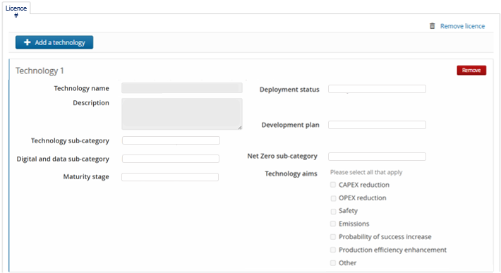

Deployment Status
Select one of the following options:
- Under Assessment - The technology has not yet been planned to be deployed but is being assessed at this time.
- Planned - Technology is available and is intended for deployment at a future date.
- In Progress - Technology is being developed and/or undergoing trials for future deployment.
- Parked - Not Progressing - The technology is not progressing at this time because it does not make a sufficient business case, or is no longer suitable.
- Completed - Technology is in use on the asset.
- Business As Usual - The technology has been deployed and has become standard practice to use, so it is considered business as usual.
- Unknown - Technology does not fit with the above options (operator to describe).

Development Plan
Select one of the following options:
- Vendor's solution - Technology developed by supply chain
- Partnership with suppliers - Technology developed in collaboration with supply chain
- Joint industry programme - Technology developed in collaboration with other operators/institutions/supply chain
- OGTC/NetZeroTC programme - Technology developed in collaboration with supply chain but with NetZeroTC funding
- In-house development - Technology developed by operator
- Other - Does not fit in above options (operator to describe)
If ‘Other’ is selected, then provide a description in the ‘other development plan’ comment box.

Technology sub-category
Select one of the following options:
- Geophysical acquisition
- Geology processing and imaging
- Subsurface modelling
- Other - Does not fit in above options (operator to describe)
If ‘Other’ is selected, then provide a description in the ‘other development plan’ comment box.

Digital and data sub-category
Select the appropriate sub-category or closest match from the following options:
- None
- Connectivity
- Data acquisition
- Data systems
- Modelling & analytics
- Productivity & safety enhancements
- Visualisation & interfacing.

Net Zero sub-category
Select the appropriate sub-category or closest match from the following options:
- None
- Low carbon power / electrification
- Energy efficiency
- Flaring venting, monitoring & reduction
- Hydrogen
- CCUS.

Maturity stage
Select one of the following options:
- Early development – TRL range 1-3
- Late development / pilot – TRL range 4-5
- Early commercialisation – TRL range 6-7
- Existing technology – TRL range 8-9.
The TRL definitions are:
- TRL 1 - Basic principles observed
- TRL 2 - Technology concept formulated
- TRL 3 - Experimental proof of concept
- TRL 4 - Technology validated in lab
- TRL 5 - Technology validated in relevant environment
- TRL 6 - Technology demonstrated in relevant environment
- TRL 7 - System prototype demonstration in operational environment
- TRL 8 - System complete and qualified
- TRL 9 - Actual system proven in operational environment
Please note in the general comments box if you use a different TRL scale and what this scale is.

Technology aims
Select all the applicable options from the list:
- CAPEX reduction
- OPEX reduction
- Safety
- Emissions
- Probability of success increase
- Production efficiency enhancement
- Other
If ‘Other’ is selected, then provide a description in the ‘technology aims’ comment box.

3.3 Removal of Technology
A technology can be removed by selecting the icon. The following warning will appear.
If the technology was added during the current survey year, the technology will just be removed.

If the technology was added during a previous survey and copied forward, you will see the following warning message
and be requested to select a reason and provide an explain why the technology is being removed.
The reason options are:
- Technology inconclusive
- Finance
- New technology superseded or taken over
- Technology failed to deliver expectation
- Other (please explain in the comments box).

Select the button to undo the removal at any time before the section has been fully submitted.

A licence that you no longer wish to report a technology on can be removed by selecting the icon. The following warning will appear.
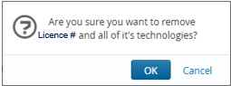

Once the section has been submitted, the technology will be deleted and will no longer appear in any future surveys.

3.4 Company technology plan
For the required content of a Company technology plan, including a minimum technology plan outline, please refer to the Stewardship Expectation Stewardship Expectation 8 and the Technology templates using the links below:
- Stewardship Expectations SE08
- NSTA Technology Plan Template
- NSTA Technology Needs Spreadsheet Master Template

Multiple Technology plans can be uploaded.

3.4.1. Technology Plan
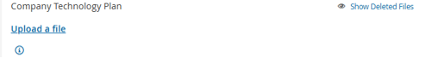
Select the icon to attach a copy of your Company Technology plan(s).
The following file extensions are not allowed: bat, bin, com, dll, exe, msc, msi, msp, ocx, scr, wsc, wsf, wsh.
The Technology Plan expectations are set out in the Asset Stewardship Expectations and are available on the NSTA’s website. The link to the expectations is also included in the Technology Plan section of the UKCS Asset Stewardship Survey.
A Technology Plan should indicate to the NSTA that an operator has a strategy for the appropriate development and/or deployment of existing, new and emerging technologies to their optimum effect for the benefit of its assets and in support of its MER UK obligations.

A Technology Plan should help to identify potential technology gaps, providing an operator and the NSTA with visibility of technology needs that, if addressed, would support the MER UK objectives. Therefore, a Technology Plan is also intended for the NSTA to assist an operator to identify technology solutions across its asset base and determine how best to deploy such technologies also collaborating with other companies.
A minimum technology plan template can be found on our website. This should be used as a guide to any word documentation you normally would provide and acts as a minimum expectation, there is no requirement for operators to modify their existing technology plan format. The template is only to be used for creating a new technology plan where none exists.

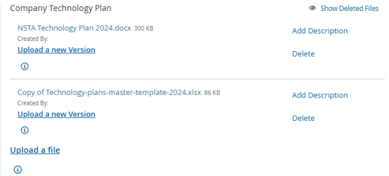
Select the icon to overwrite a previously uploaded file.
Select the icon to include a description for the uploaded file.
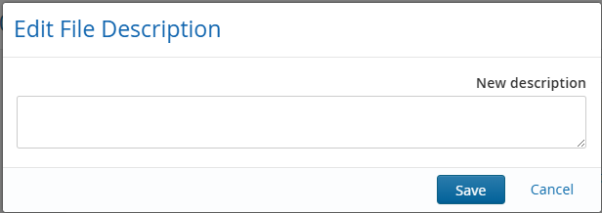
Select the icon to delete a previously uploaded file.

3.4.2. Responsible Person
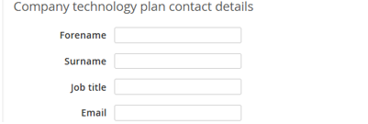
The NSTA requires a single point of contact if the NSTA requires to follow-up on any aspect of an operator’s Technology Plan or to engage with regarding technology subjects. Operators should nominate a Responsible Person in the UK as the single point of contact for each Technology Plan submitted. The Responsible Person may be the same individual as the Single Point of Accountability (SPA) for the Stewardship Survey.
The following information should be provided:
- Name of Responsible Person
- Job Title
- Email address

3.5 Company Technology Plan – Further guidance
For the purposes of this Guide, references to:
- ‘Operator’ means the operator (under a licence) of a UKCS exploration and/or production asset;
- ‘Technology’ includes technologies covering the whole asset lifecycle comprising the exploration, production, late-life, cessation of production and decommissioning phases.

3.5.1. Required Content
Operators are responsible for preparing and submitting the Technology Plan to the NSTA. Where an operator operates multiple assets in the UKCS, the operator is expected to submit a single Technology Plan covering the operated assets in the UKCS (business unit level consolidated plan).

The Technology Plan should specify:
- The key technology needs for each operated asset or a group of assets.
- How the operator proposes to address the technology needs it has identified.
- The proposed timeline for development and deployment of existing, new and emerging technologies.
- Any potential or recognised technology gaps.

3.5.2. Additional Information
It would be beneficial if an operator could provide details of any technology projects, JIPs, pilots or trials that they are involved in:
- information on any potential areas where the introduction of any future transformational technology would be of significant benefit.
- identification of any particular technologies that are not commonly used in the UKCS.
- identification of any first-time use, trial or piloting.
- This information could be provided by modifying any existing Technology Plan tables or by providing it as stand-alone information.

3.5.3. Technology Needs
Operators should identify the technology need associated with each of its operated assets. Such information should be clearly set-out in the technology needs spreadsheet - using the Technology Needs spreadsheet template.
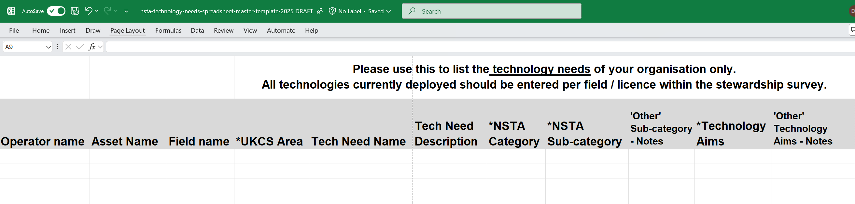
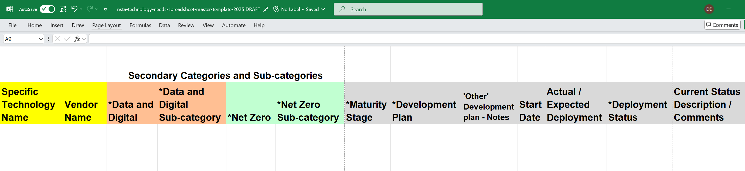
The spreadsheet template (contents detailed in section 3.5.7) contains lists of technologies to help you report on the technology needs of your organisation.
All technologies currently deployed should be entered per field / licence within the stewardship survey.
Where operators have multiple assets it may be preferable to add further asset columns to allow a matrix selection of assets and only list the technology need once.
Note:
- This is for technologies, or studies that enable the development of a technology, that are technology Gaps - not for technologies that are already identified and commercially available, or listing standard subsea facilities, topsides facilities or infrastructure installation methods.
- JIPS, University studies and Joint Ventures unless they are specific to a technology should not be included.

3.5.4. Addressing the Identified Technology needs
Operators should describe the consolidated need/s, associated with each of its operated assets or group of assets and identify potential technologies it proposes to use or develop to address those needs. Such information may be set out in the spreadsheet template in Table 1, however operators may use an alternative reporting format if it includes the requested information. If an operator is not aware of a specific technology opportunity available or under development to address a particular stated challenge, details should be provided, for example in the column titled “Current Status Description/Comments” or at some appropriate point in the Technology Plan.
The number of needs identified will vary per operator and therefore the number of rows in the table should be amended accordingly. Operators should include additional information on the technologies being considered to support the entries as applicable.
A proposed timeline that the technology is expected to be available for development and/or deployment should also be included.

3.5.5. NSTA Technology Needs spreadsheet contents
Within the spreadsheet template, the worksheet ‘Guidance’ provides similar information to that detailed below.
Columns where the heading starts with an asterisk (*) contain a drop-down list for the operator to select an appropriate response.
Column | Description
Operator name | Enter Asset operator’s name.
Asset Name | Enter Asset name.  Please list each technology once, add additional Asset Name columns for each Asset to allow a Matrix style selection of which assets apply to each technology need
Field name | Enter the Field name.
*UKCS Area | Select one of the five options from drop-down list:  - NNS, CNS, SNS, WOS, IS.
Tech Need Name | Enter a name / short descriptor  if there is a technology gap, or desire only for a technology.
Tech Needs Description | Enter a more detailed description of the named Technology need.
*NSTA Category | Select one of the eight categories from the drop-down list:  - Seismic & Exploration  - Well Drilling & Construction  - Subsea systems  - Installations & Topsides  - Reservoir management  - Facilities management  - Well P&A  - Facilities decommissioning
*NSTA Sub-category | For the selected Category,  select one of its sub-categories from the drop-down list:  Reference options listed in section 3.5.7.1 below.  Select ‘Other’ if none of the sub-categories suffice  and provide notes in the ‘‘Other’ Sub-category Notes’ column.
‘Other’ Sub-category - Notes | If ‘Other’ is selected for the NSTA Sub-category,  then enter notes to explain your ‘Other’ sub-category.
*Technology Aims | Select one of the seventeen Technology Aims options from the drop-down list.  - ABEX Efficiency  - Asset Management  - CAPEX Efficiency  - Development Complexity  - Emissions Reduction  - Enhanced Probability of Success  - Evaluation & Study  - Exploration & Subsurface Excellence  - GHG Reduction  - Increase Field Recovery  - Integrity  - Operational Excellence  - OPEX Efficiency  - Probability of Success Increase  - Production Efficiency Enhancement  - Safety Enhancements  - Other  If ‘Other’ is selected,  then notes are required in the ‘‘Other’ Technology Aims – Notes’ column
‘Other’ Technology Aims -Notes | If ‘Other’ is selected for the Technology Aim,  then notes are required in the ‘‘Other’ Technology Aims – Notes’ column
Specific Technology Name | Please enter where possible
Vendor Name | Please enter where possible
*Data and Digital | Select from the drop-down list either Yes or No.
*Data and Digital Sub-Category | Select one of the six Data and Digital Sub-categories from the drop-down list:  - Connectivity  - Data Acquisition  - Data Systems  - Modelling & Analytics  - Productivity & Safety Enhancements  - Visualisation & Interfacing
*Net Zero Sub-category | Select from the drop-down list either Yes or No.
*Net Zero Sub-category | Select one of the five Net Zero Sub-categories from the drop-down list:  - CCUS  - Flaring & Venting, Monitoring & Reduction  - Offshore Hydrogen  - Energy Efficiency  - Low Carbon Power/Electrification
*Maturity Stage | Select one of the four Maturity stage categories from the drop-down list:  - Early Development TRL 1-3  - Late Development/Pilot TRL 4-5  - Early Commercialisation TRL 6-7  - Existing Technology TRL 8-9
*Development Plan | Select one of the six Development Plan categories from the drop-down list:  - In-House Development  - Joint Industry Programme  - NetZeroTC Programme  - Vendor Solution  - Partnership with Suppliers  - Other
‘Other’ Development Plan - Notes | If ‘Other’ is selected for the Development Plan,  then notes are required in the ‘‘Other’ Development Plan – Notes’ column.
Start Date | Enter the expected start date for development, testing programme.
Actual / Expected Deployment | Enter the expected start date for offshore deployment.
*Deployment Status | Select one of the six Deployment Status categories from the drop-down list:  - Planned  - Under Assessment  - In-Progress  - Completed  - Business as Usual  - Parked not Progressing
Current Status Description / Comments | Enter a status update, notes on progress etc.

3.5.5.1. NSTA Sub-Categories
For each NSTA Category selected (for each named Tech Need, for each Asset) select one of the associated NSTA Sub-categories.
NSTA Category | NSTA Sub-category
Seismic & Exploration | - Geophysical Acquisition  - Geology Processing & Imaging  - Subsurface Modelling  - Other
Well Drilling & Construction | - Well Design & Planning  - Well Equipment  - Drilling Equipment  - Drilling, Casing & Cementing  - High Angle & ERD  - MWD, LWD & Geosteering  - Completions & Artificial Lift  - Stimulation  - Other
Subsea Systems | - Subsea Concepts  - Fluid Separation, Treatment & Compression  - Inspection & Intervention systems  - Pipelines, Risers, Jumpers & Connections  - Manifolds, Umbilicals & Control systems  - Power generation & Hydraulic Storage  - Processing, Boosting & Storage  - Other
Installations & Topsides | - Control Systems & Automation  - Fluid Injection & Re-injection  - Fluid Separation, Treatment & Compression  - FPSO's & FSO's  - Metering & Monitoring  - Power & Utilities  - Unmanned Offshore Platforms  - Other
Reservoir & Well Management | - Surveillance & Inspection  - Improved & Enhanced Recovery  - Intervention Equipment  - Well Integrity Repairs  - Waxing, Hydrates & Scaling Solutions  - Liquid Loading & Water Production  - Sands & Solids Management  - Other
Facilities Management | - Equipment Monitoring & Reliability  - Facilities Integrity Repairs  - Integrity Monitoring & Inspections  - Maintenance & Operations  - Other
Well Drilling & Completions | - Data & Planning  - Well Inspection & Cement Condition  - Conductor Removal  - Barriers, Placement & Verification  - Tubing & Casing Removal  - Intervention Equipment  - Other
Facilities Decommissioning | - Data & Planning  - Late life Management & Equipment Readiness  - Topsides/Jacket Decommissioning  - Subsea Equipment Decommissioning  - Site Inspection & Monitoring  - Waste Management & Recycling  - Other

3.5.6. Timeline for Completion of the Technology Plan
The Technology Plan should be submitted in accordance with the UKCS Asset Stewardship Survey timeline.

3.5.7. Delivery of Expectation
The following indicators will be used by the NSTA when assessing compliance with the Technology Plan Expectations:
- Technology Plan has been submitted to the NSTA as part of the Annual UKCS Stewardship Survey.
- The operator has listed the key technology needs faced by each asset, or group of assets, and identified the key challenges for such each asset, or group of assets.
- The operator has described how it proposes to address the technology needs and identified its timeline for doing so.
- Contact details have been provided for single point of contact for each Technology Plan submitted (see Responsible Person).

- CHECKLIST

Below are the some of the detailed QC steps that each section will go through. If you think your data will not pass these checks, please add as much information in the general comments section as possible to help us understand why.
- Technology Name – name of the technology or trade name
- Description - please ensure that the description is concise but describes the technology and enough information to help the reader understand its purpose/use (single word descriptions are not acceptable).
- Life cycle domain is correct and avoid use of “Other” where possible, this year we may be asking operators to change incorrectly categorised technologies.
- Technology status – please try to use a status from the list as close as possible, use of “Other” only where necessary.
- The value in the ‘Total’ column for Total spend (reference section 3.1.1) should equal the value in the ‘Total’ column for ‘Breakdown Spend’ (reference section 3.1.2).

- CONTACT DETAILS

If you have any issues when using the UKSS Stewardship Survey then please email stewardshipsurvey@nstauthority.co.uk and the stewardship team will respond as quick as possible.

If you find any errors with the data or question options presented on this survey form, then please report the error to the UK Energy Portal Service Desk by calling 0300 067 1682 or email ukop@nstauthority.co.uk.

