TI 24 – 12 Technology Example – EODev Hydrogen Fuel Cell for Offshore Applications
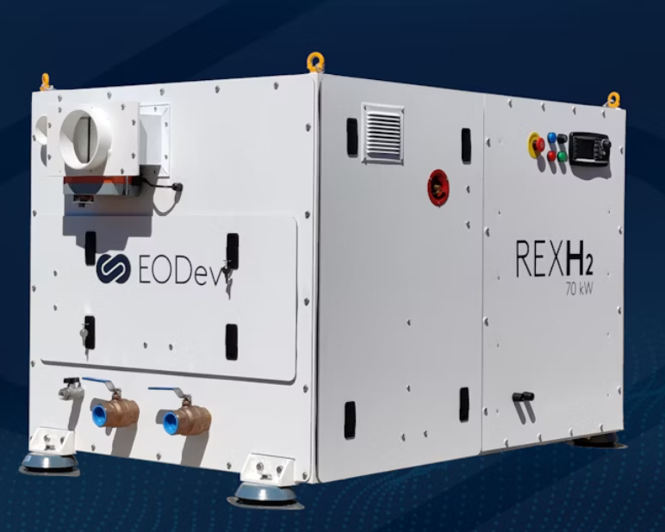
With a footprint of less than two cubic meters and a weight of 540 kilograms, the REXH2 equipped with the latest generation of Toyota fuel cells is today, in relation to the power delivered, the most compact and efficient Range Extender on the market.

The R&D carried out by the EODev and Toyota teams has enabled the REXH2 to be perfectly adapted to the extreme conditions of the marine environment, reaching power levels of 70 kW per unit, up to megawatts when stacked. It is this flexibility in implementation that makes REXH2 the ideal generator for tailor-made hydrogen solutions for propulsion and the supply of decarbonated energy at sea.

Vendors Website link: REXH2 | Hydrogen Range Extender for zero emission boat (eo-dev.com)

