TI 24 – 09 Technology Example – Baker Hughes Realtime Slickline system

Case Study
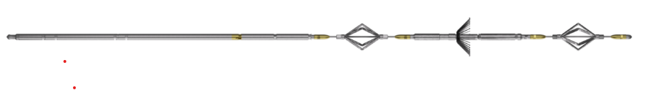
Realtime slickline system
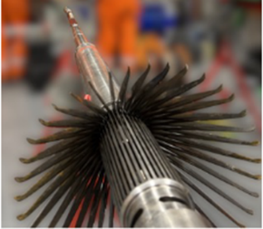
Multi finger calliper (MIT40)

CHALLENGES

As part of an abandonment campaign, a North Sea operator required logging across nine wells for both well integrity analysis and suitable joint selection for barrier placement •The full pre-abandonment phase involved mechanical wireline operations, data logging with Multi-Finger Caliper (MIT40) tool, and electro-mechanical punch and plug setting

SOLUTION

Digital Slickline was selected for this pre-abandonment phase versus a sequential slickline and electric line operation. This provided:

•Optimized POB with a multi-skilled crew
•Single rig-up of common unit and pressure control unit to carry out the full scope
•Bi-directional telemetry for real-time datacomms and in-well toolstring control throughout UK NORTH SEA

RESULTS

• Logged a world-record 10,800ft of continuous section using the multi finger caliper tool with real-time control and data read out
• Cumulatively, 19,920 ft of MIT40 data was logged during across all the wells from this phase of the campaign
• Reduced HSE risk and exposure to crew and operations
• Provided real-time quality control and data driven decisions across the entire operation

This is an example of this technology, Note: NSTA do not endorse or recommend specific technologies.
This is an extract from the Vendors website page for this product, the link for the full webpage is below for further information.

Vendors Website link: World record for the longest real-time acquisition of multi finger caliper data on digital slickline | Baker Hughes

