

UKSS SECTION GUIDE
GHG Emissions

This section will appear once at organisational level,
and will include any operated facilities, terminals, new developments and added abatement reduction projects.

If you think there are any errors with allocation, please contact
stewardshipsurvey@nstauthority.co.uk

Date of publication 29/10/2025

The document can be found on the NSTAs website.

© NSTA Copyright 2025
URN

You may re-use this information free of charge in any format or medium, under the terms of the NSTA’s User Agreement. To view this, visit: https://www.nstauthority.co.uk/site-tools/access-to-information/ or email correspondence@nstauthority.co.uk

This document is available in large print,audio and braille on request.
Please email: correspondence@nstauthority.co.uk with the version you require.

Enquiries to:
North Sea Transition Authority
50 Broadway
London
SW1H 0DB

Email: correspondence@nstauthority.co.uk

Published by the North Sea Transition Authority

Contents
1. UKSS 2025 CHANGES 4
2. MANAGE ASSETS AND ABATEMENT PROJECTS 5
2.1 Manage Assets, New Developments and Emissions Abatement Projects 5
3. ASSETS 9
3.1 Facilities / Terminals 9
3.1.1. Direct Emissions - Fuel Combustion 11
3.1.2. Direct Emissions - Flaring 12
3.1.3. Direct Emissions - Venting 12
3.1.4. Direct Emissions - Total 13
3.1.5. Indirect Energy Supply Emissions 13
4. NEW DEVELOPMENTS 15
4.1 New Developments 15
4.1.1. Direct Emissions - Fuel Combustion 18
4.1.2. Direct Emissions - Flaring 18
4.1.3. Direct Emissions - Venting 19
4.1.4. Direct Emissions - Total 19
4.1.5. Indirect Energy Supply Emissions 20
5. EMISSIONS ABATEMENT PROJECTS 21
5.1 Abatement Projects 21
5.1.1. Emissions Abatement 22
5.1.2. Abatement costs 24
6. CONTACT DETAILS 26

- UKSS 2025 CHANGES

The following changes are being implemented in the GHG Emissions section of the Survey:
- Updated guidance notes to reflect requesting mid-case technical profiles of the facility’s oil and/or gas production that extends at least 5 years beyond the Company CoP date (which is not expected to influence these technical profiles).
- To improve emissions data, ‘Survey year (estimated actuals)’ emissions data is now requested for asset-level emissions and abatement projects.
- Threshold for reporting abatement projects has been reduced to 1000 tCO₂e per annum.
- Abatement projects listed down the side bar now contain the name of the project as well as the project number.
- MANAGE ASSETS AND ABATEMENT PROJECTS

2.1 Manage Assets, New Developments and Emissions Abatement Projects
The NSTA is collecting data on future greenhouse gas (GHG) emissions which will facilitate the estimation of carbon costs to be included in the assessment of economic recoverability of existing and future oil and gas developments. The NSTA is also collecting these data to supplement emissions performance benchmarking to assist in Asset Stewardship engagements and also to monitor the industry's progress in reducing its GHG emissions.
It is expected that technical GHG emissions profiles will be provided for each facility, new development and abatement project.
These profiles should extend at least 5 years beyond the Company CoP date.
Company CoP date is not expected to influence these technical profiles.
i.e. the emissions profile should reflect what the emissions would be if CoP was deferred beyond the planned Company CoP, rather than showing 5 years of post CoP emissions.
Technical profiles should align to the mid-case technical profile of the facility’s oil and/or gas production.

On the Manage Assets page there should be a list of all your Facilities and Terminals, along with any New developments (FDP prior to NSTA consent) and Emissions Abatement projects recorded in a previous Survey. Any new developments that tie back to an existing host facility, and that have been granted consent since the last Survey should be incorporated into the forecast for that host facility e.g. Field A was a stand-alone entry in the Survey last year. Field A has recently been granted consent and will be developed via Facility X. The emissions forecast for Facility X should now incorporate the emissions associated with Field A.
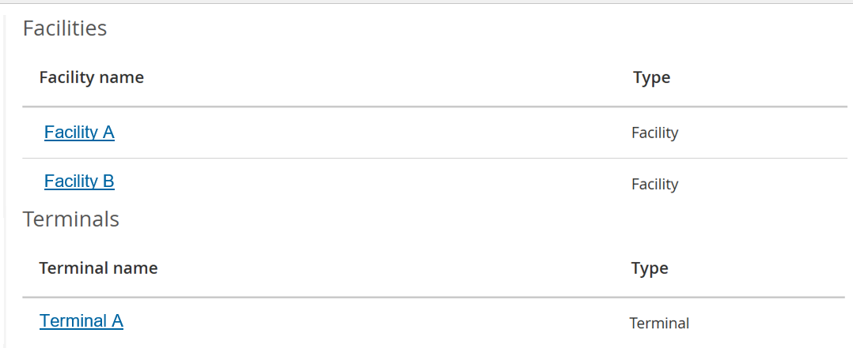
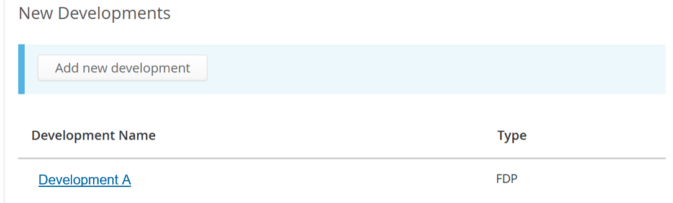
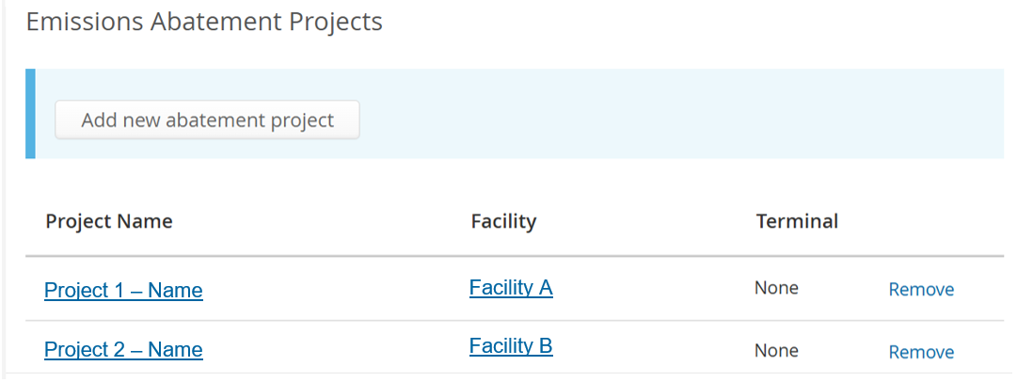
It may be the case that there are no terminals associated with your organisation, and so the following message will be presented:
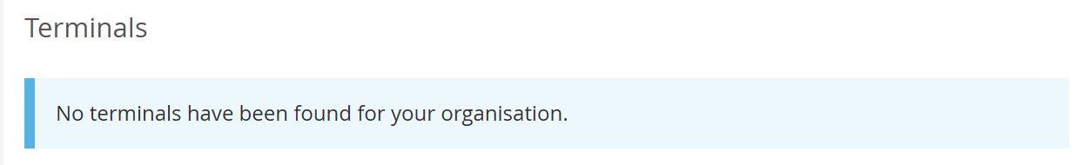
Please manually add any new incremental projects associated with fields that are already approved (FDPA prior to NSTA consent).
These new development projects should be reported separately by the operator of the project until consent has been granted by the NSTA. Once this occurs, the emissions profile should then be incorporated into the host facility's profile and submitted by the host facility operator.
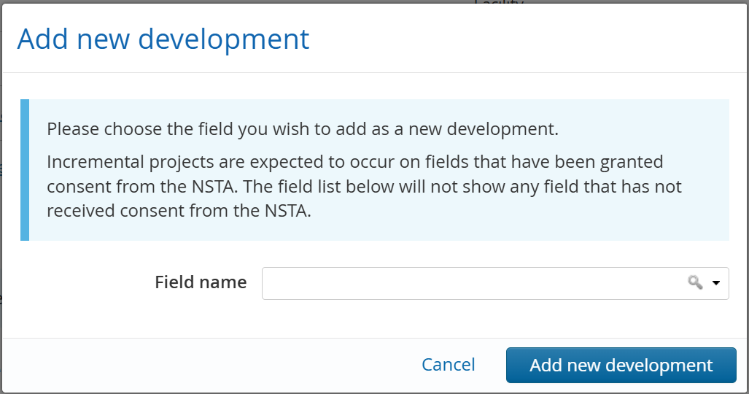
All GHG Emissions Abatement Projects which have an average GHG emissions abatement of greater than 1000 tonnes CO₂e per annum should be reported on. Any projects that were entered in the previous Survey will be automatically carried forward. The data for these projects should be checked and updated as required. Any projects that have been completed should be marked as such, and the abatement incorporated in the base forecast.
Any additional projects should be added using the ‘Add new abatement project’ function.
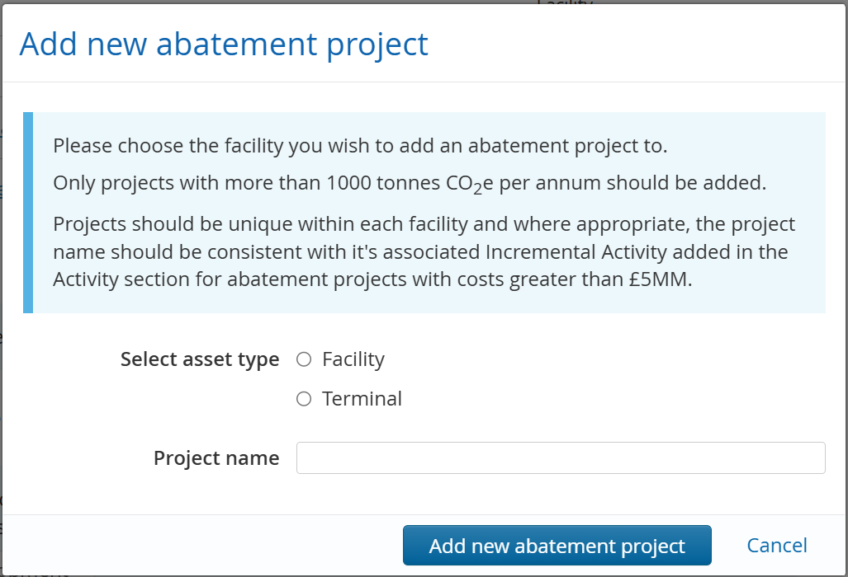
Note:
- It is expected that any project greater than £5MM should also be entered into the Activity section of the UK Stewardship Survey as an incremental project for the facility's host field.
e.g. If a project abates more than 1000 tonnes CO₂e per annum and costs greater than £5MM then it should appear in both the Activity and the GHG Emissions sections.
- All projects added in the Survey will be copied forward into future Surveys.

- ASSETS

3.1 Facilities / Terminals
Please report your best current estimate of forecasted GHG emissions per operated facility. This forecast profile should include:
- Your forecasted current baseline GHG emissions estimate.
This should include both GHG emissions associated with the installation's base case and direct incremental GHG emissions associated with any additional activities on the installation which do not require an FDPA (e.g. additional production from infill drilling, well intervention, enhanced recovery etc) with a greater than 50% chance of occurring.
- This should also be net of any applicable reductions in GHG emissions from emissions abatement projects that have a greater than 50% chance of occurring.
Therefore, please subtract emission avoided via abatement projects with a greater than 50% chance of occurring from the baseline profile to give your current estimate for forecasted GHGs.
Note: Any new development projects should be reported separately by the operator of the project until consent has been granted by the NSTA. Once this occurs, the emissions profile should then be incorporated into the host facility's profile and submitted by the host facility operator.
Direct Emission profiles should be split into the 3 categories:
- Fuel combustion – emissions resulting from the in-situ combustion of fuel gas, diesel or fuel oil. This will be split into Diesel Combustion and Fuel Gas Combustion.
- Flare – emissions from the combustion of waste gas at the flare stack.
- Vent – emissions from the controlled release of waste gas, includes gas vented via cold flaring (unignited flare).
The data on the total emissions tab will be automatically summed from the fuel, flare and vent tabs.
Indirect Energy Supply Emissions should be provided when you expect the facility will begin to import electricity. Emissions in this category should not include any generated during the construction or commissioning phase of an electrification project, rather, just the emissions generated to produce the electricity during the production phase of the electrification project.

Definitions:
- CO₂ within UK ETS scope (tonnes): Carbon Dioxide
Within scope of the UK ETS, i.e. CO₂ emissions resulting from the combustion of liquid fuels and flared gas from installations with combustion capacity greater than 20 MW thermal input, or venting of CO₂ above the ETS threshold.
- Total CO₂ (tonnes): Carbon Dioxide
Within scope of UK ETS (as above) in addition to CO₂ emissions out with scope of the UK ETS e.g. vented CO₂ and CO₂ emissions from installations with combustion capacity less than 20 MW thermal input.
- CH₄ (tonnes): Methane
Please report methane from all sources, for instance from venting, flaring and fugitives. The scope is equal to that of EEMS e.g. vented CO₂ below the ETS threshold.
- Other GHGs (tonnes):
Nitrous oxide (N₂O), hydro-fluorocarbons (HFC), perfluorocarbons (PFC), nitrogen trifluoride (NF₃), and sulphur hexafluoride (SF₆) using the 100 year time horizon global warming potential (GWP) factors reported in the relevant IPCC's AR report.
- CO₂e (tonnes):
Carbon Dioxide Equivalent
- Cold Flare: Gas passing through the flare without ignition
Effectively venting of gas through the flare system. This refers to a period of time where there is no combustion (or zero combustion efficiency) i.e. it is not the non-combusted component of a flare gas stream where combustion efficiency less than 100% but greater than 0%.

Data entry
- Please fill in as much detail as you can.
- Once data has been entered it is mandatory within each table to fill in the rest of the data for that year even if Zero please enter "0".
- The Total Emissions page contains values which are calculated automatically. These values will appear in the greyed out boxes when all required data has been inputted.
- It is expected that technical GHG emissions profiles will be provided for each facility, new development and abatement project.
These profiles should extend at least 5 years beyond the Company CoP date.
Company CoP date is not expected to influence these technical profiles i.e. the emissions profile should reflect what the emissions would be if CoP was deferred beyond the planned Company CoP, rather than showing 5 years of post CoP emissions.
Technical profiles should align to the mid-case technical profile of the facility’s oil and/or gas production.
- It is mandatory to complete GHG emissions profiles for at least the next 10 years. If there are zero emission in a year, then please enter "0".
- You are asked to provide the ‘estimated actuals’ for the ‘Survey Year’ i.e. the calendar year prior to the Survey deadline. Please provide the best estimate currently available for this row of data. The NSTA recognises that these figures may change once end of year reconciliation and validation has been completed. Once the Environmental and Emissions Monitoring System (EEMS) data becomes available, it will supersede the data provided for the ‘Survey Year’.

 You can paste values into table directly from Excel:
- The page will map your pasted cell values to the table cells, ignoring any overflowing rows or columns.
- Input fields which have been pasted to will be highlighted green to allow a visual check.

3.1.1. Direct Emissions - Fuel Combustion
Emissions resulting from diesel combustion and fuel gas combustion.
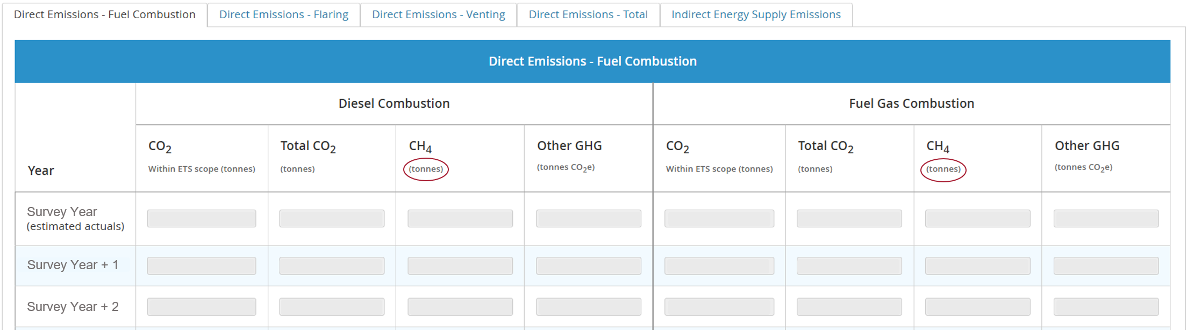
Please report your best current estimate of forecasted GHG emissions per operated facility. This forecast profile should include:
- Your forecasted current baseline GHG emissions estimate.
  - This should include both GHG emissions associated with the installation's base case and direct incremental GHG emissions associated with any additional activities on the installation which do not require an FDPA (e.g. additional production from infill drilling, well intervention, enhanced recovery etc) with a greater than 50% chance of occurring.
- This should also be net of any applicable reductions in GHG emissions from emissions abatement projects that have a greater than 50% chance of occurring.
Therefore, please subtract emissions avoided via abatement projects from the baseline profile to give your current estimate for forecasted GHGs.
Note: The units for Methane are tonnes of methane, not CO₂e.

3.1.2. Direct Emissions - Flaring
Routine flaring is equivalent to Category A, non-routine is equivalent to Category B+C. Please find definitions of these in the external guidance link.
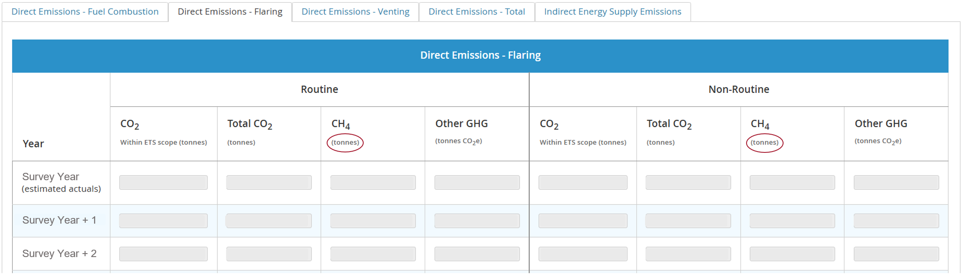
Note:
- Flaring is to be split into Routine and Non-routine.
- The units for Methane are tonnes of methane, not CO₂e.

3.1.3. Direct Emissions - Venting
Routine venting is equivalent to Category A, non-routine is equivalent to Category B+C. Please find definitions of these in the external guidance link.
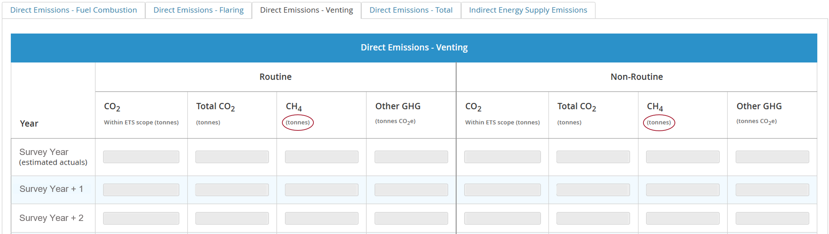
Note:
- Flaring is to be split into Routine and Non-routine.
- The units for Methane are tonnes of methane, not CO₂e.

3.1.4. Direct Emissions - Total
This table displays the total emissions resulting from fuel combustion, flaring, and venting.
The values are calculated automatically. They will appear in the greyed out boxes when all required data has been inputted.
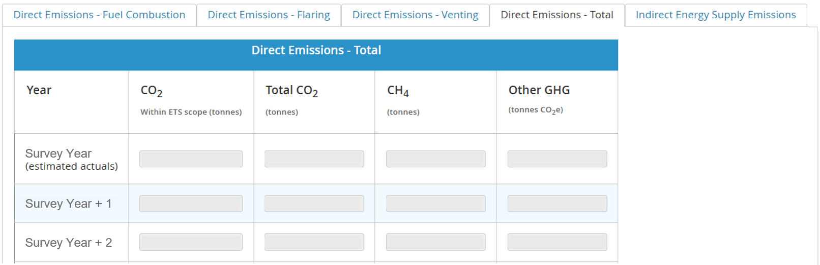
Previously, the NSTA asked operators to report abatement plans in this section.
Abatement projects should now be added to the Manage Assets page if over 1000 tonnes CO₂e abated per annum.
Operators should use this page as a general quality check of summed emissions from combustion, flaring and venting.

3.1.5. Indirect Energy Supply Emissions
Indirect Energy Supply Emissions should be provided when you expect the facility will begin to import electricity. Emission in this category should not include any generated during the construction or commissioning phase of an electrification project, rather, just the emissions generated to produce the electricity during the production phase of the electrification project.
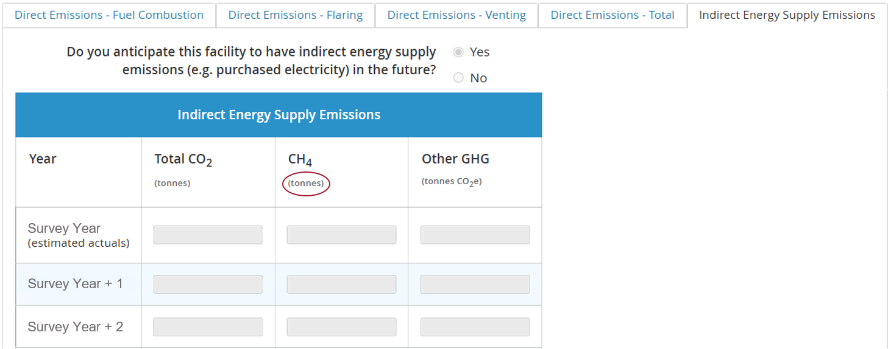
If it is expected that a facility will begin to import electricity during its future,
then please select ‘Yes’ for the question ‘Do you anticipate this facility to have indirect energy supply emissions in the future?’.
This will allow you to populate the GHG emissions forecast.
By selecting ‘No’, you will not have to populate any forecast for this tab.

Note:
- The units for Methane are tonnes of methane, not CO₂e.
- If Operators do not have their own project specific assumptions for emissions factors, the DESNZ Electricity Emissions Factors can be used - reference Table 1, Column E: 'Long-run marginal', consumption based, industrial. (Note, factors are provided in kgCO₂e/kWh so conversion to total CO₂e annual tonnes is required).

- NEW DEVELOPMENTS

4.1 New Developments


Please report your best current estimate of forecasted GHG emissions per operated new development. This forecast profile should include:
- Your forecasted current baseline GHG emissions estimate.
This should include both GHG emissions associated with the installation's base case and direct incremental GHG emissions associated with any additional activities on the installation which do not require an FDPA (e.g. additional production from infill drilling, well intervention, enhanced recovery etc) with a greater than 50% chance of occurring.
- Net of any applicable reductions in GHG emissions from emissions abatement projects that have a greater than 50% chance of occurring.
Therefore, please subtract emission avoided via abatement projects with a greater than 50% chance of occurring from the baseline profile to give your current estimate for forecasted GHGs.
Please provide emissions profiles only for any new developments that need consent from the NSTA (FDP/FDPA) and results in a GHG emission increase either outright or to the host installation.
A new field will appear automatically in this section. This normally occurs when a Concept Select Report has been approved by the NSTA.
Any incremental projects involving fields that are already online (FDPA) should be added on the Manage Asset page.
These projects should be reported separately by the operator of the project until consent has been granted by the NSTA. Once this occurs, the emissions profile should then be included in the host facility's profile and submitted by the host facility operator.
Note: Projects consented during Survey live period (November through to the end of February) should still complete a separate profile and be combined with the host facility profile in the next Survey.

For each new development, please report the most likely host facility of the new development via a drop-down selection and provide a % probability of proceedings for each new development.
- By reporting 100% probability of proceedings, this indicates the project has been consented by the NSTA and therefore should be included in the host facility profile. Only exception to this is if the project was consented during the Survey live period.
- 0% indicates the project is cancelled and is no longer a viable project. These cancelled projects will not copy forward into the Survey next year.
Direct Emission profiles should be split into the 3 categories:
- Fuel combustion – emissions resulting from the in-situ combustion of fuel gas, diesel or fuel oil. This will be split into Diesel Combustion and Fuel Gas Combustion.
- Flare – emissions from the combustion of waste gas at the flare stack.
- Vent – emissions from the controlled release of waste gas, includes gas vented via cold flaring (unignited flare).
The data on the total emissions tab will be automatically summed from the fuel, flare and vent tabs.

Indirect Energy Supply Emissions should be provided when you expect the facility will begin to import electricity. Emissions in this category should not include any generated during the construction or commissioning phase of an electrification project, rather, just the emissions generated to produce the electricity during the production phase of the electrification project.

Definitions:
- CO₂ within UK ETS scope (tonnes): Carbon Dioxide
Within scope of the UK ETS, i.e. CO₂ emissions resulting from the combustion of liquid fuels and flared gas from installations with combustion capacity greater than 20 MW thermal input, or venting of CO₂ above the ETS threshold.
- Total CO₂ (tonnes): Carbon Dioxide
Within scope of UK ETS (as above) in addition to CO2 emissions out with scope of the UK ETS e.g. vented CO₂ and CO₂ emissions from installations with combustion capacity less than 20 MW thermal input.
- CH₄ (tonnes): Methane
Please report methane from all sources, for instance from venting, flaring and fugitives. The scope is equal to that of EEMS e.g. vented CO₂ below the ETS threshold.
- Other GHGs (tonnes):
Nitrous oxide (N₂O), hydro-fluorocarbons (HFC), perfluorocarbons (PFC), nitrogen trifluoride (NF₃), and sulphur hexafluoride (SF₆) using the 100 year time horizon global warming potential (GWP) factors reported in the relevant IPCC's AR report.
- CO₂e (tonnes):
Carbon Dioxide Equivalent
- Cold Flare: Gas passing through the flare without ignition
Effectively venting of gas through the flare system. This refers to a period of time where there is no combustion (or zero combustion efficiency) i.e. it is not the non-combusted component of a flare gas stream where combustion efficiency less than 100% but greater than 0%.

Data entry
- Please fill in as much detail as you can.
- Once data has been entered it is mandatory within each table to fill in the rest of the data for that year even if Zero please enter "0".
- The Total Emissions page contains values which are calculated automatically. These values will appear in the greyed out boxes when all required data has been inputted.
- It is expected that technical GHG emissions profiles will be provided for each facility, new development and abatement project.
These profiles should extend at least 5 years beyond the Company CoP date.
Company CoP date is not expected to influence these technical profiles i.e. the emissions profile should reflect what the emissions would be if CoP was deferred beyond the planned Company CoP, rather than showing 5 years of post CoP emissions.
Technical profiles should align to the mid-case technical profile of the facility’s oil and/or gas production.
- It is mandatory to complete GHG emissions profiles for at least the next 10 years. If there are zero emission in a year, then please enter "0".
- You are asked to provide the ‘estimated actuals’ for the ‘Survey Year’ i.e. the calendar year prior to the Survey deadline. Please provide the best estimate currently available for this row of data. The NSTA recognises that these figures may change once end of year reconciliation and validation has been completed.
Once the Environmental and Emissions Monitoring System (EEMS) data becomes available, it will supersede the data provided for the ‘Survey Year’.

You can paste values into table directly from Excel:
- The page will map your pasted cell values to the table cells, ignoring any overflowing rows or columns
- Input fields which have been pasted to will be highlighted green to allow a visual check.

4.1.1. Direct Emissions - Fuel Combustion
Emissions resulting from diesel combustion and fuel gas combustion.
Please report your best current estimate of forecasted GHG emissions per operated facility. This forecast profile should include:
- Your forecasted current baseline GHG emissions estimate.
  - This should include both GHG emissions associated with the installation's base case and direct incremental GHG emissions associated with any additional activities on the installation which do not require an FDPA (e.g. additional production from infill drilling, well intervention, enhanced recovery etc) with a greater than 50% chance of occurring.
- This should also be net of any applicable reductions in GHG emissions from emissions abatement projects that have a greater than 50% chance of occurring.
Therefore, please subtract emissions avoided via abatement projects from the baseline profile to give your current estimate for forecasted GHGs.
Note: The units for Methane are tonnes of methane, not CO₂e.

4.1.2. Direct Emissions - Flaring
Routine flaring is equivalent to Category A, non-routine is equivalent to Category B+C. Please find definitions of these in the external guidance link.
Note:
- Flaring is to be split into Routine and Non-routine.
- The units for Methane are tonnes of methane, not CO₂e.

4.1.3. Direct Emissions - Venting
Routine venting is equivalent to Category A, non-routine is equivalent to Category B+C. Please find definitions of these in the external guidance link.
Note:
- Flaring is to be split into Routine and Non-routine.
- The units for Methane are tonnes of methane, not CO₂e.

4.1.4. Direct Emissions - Total
This table displays the total emissions resulting from fuel combustion, flaring, and venting.
Previously, the NSTA asked operators to report abatement plans in this section.
Abatement projects should now be added to the Manage Assets page if over 1000 tonnes CO₂e abated per annum
Operators should use this page as a general quality check of summed emissions from combustion, flaring and venting.

4.1.5. Indirect Energy Supply Emissions
Indirect Energy Supply Emissions should be provided when you expect the facility will begin to import electricity. Emission in this category should not include any generated during the construction or commissioning phase of an electrification project, rather, just the emissions generated to produce the electricity during the production phase of the electrification project.

If it is expected a facility will begin to import electricity during its future, please select ‘Yes’, this will allow you to populate the GHG emissions forecast.
By selecting ‘No’, you will not have to populate any forecast for this tab.
Note:
- The units for Methane are tonnes of methane, not CO₂e.
- If Operators do not have their own project specific assumptions for emissions factors, the DESNZ Electricity Emissions Factors can be used - reference Table 1, Column E: 'Long-run marginal', consumption based, industrial. (Note, factors are provided in kgCO₂e/kWh so conversion to total CO₂e annual tonnes is required).
- EMISSIONS ABATEMENT PROJECTS

5.1 Abatement Projects
Abatement project data should only be provided for any emisssions reduction projects that exceed 1000 tonnes CO₂e per annum.
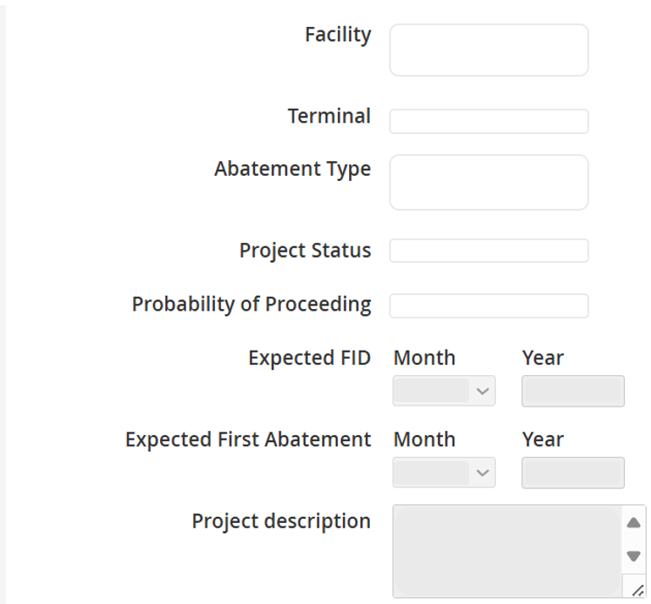
Please provide the probability of the emissions abatement project proceeding. It is expected that any project that is set to 100% has been sanctioned so therefore has a status of 'completed', 'under execution' or 'planned', 99-50% has a status of 'under evaluation' and 49-1% has a status of 'under scoping'. Any project set to 0% is assumed to be cancelled and will not be copied forward to the next Survey.
Note:
- Data for projects entered in the previous Survey Year will be pre-populated – you must review this data and update as required.
- It is expected that any project greater than £5MM should also be entered into the Activity section of the UK Stewardship Survey as an incremental project for the facility's host field.
e.g. If a project abates more than 1000 tonnes CO₂e per annum and costs greater than £5 million then it should appear in both the Activity and the GHG Emissions sections.
Project Status definitions:
Completed: the Project has been completed on the offshore asset/onshore terminal, and the actual emissions reduction impact is embedded in the asset's latest carbon forecast.
Under Execution: the Project's execution has commenced and is in progress on the offshore asset/onshore terminal, with the planned (i.e. expected) emissions reduction impact embedded in the asset's latest carbon forecast pending any actual reduction adjustments.
Planned: the Project is included in the asset's business plan (i.e. activity in the 8Q schedule, costs allocated in budget and onshore/offshore resources committed to deliver); site execution not yet commenced, with the planned emissions reduction impact embedded in the asset's latest carbon forecast.
Under Evaluation: the identified opportunity may be a formally defined early-stage Project however further technical/economic work is required in order to decide inclusion in the asset business plan. Not currently included in the asset's business plan and the emissions reduction impact not embedded in the carbon forecast.
Under Scoping: the identified opportunity is at idea/immature stage of definition.

It is recognised that for some abatement projects there will be an overlap in the emissions that will be abated and/or project costs.
e.g. the emissions abated by a project that reduces power consumption may be the same emissions that would ultimately be abated by electrification.
The costs and emissions abatement profiles should be entered for each project in it’s own right.
It is recognised that this introduces the potential for double counting, and that the sum of all the abatement projects identified therefore will not reflect the maximum emissions abatement potential for an asset.
It is also recognised that there are project options where only one out of two (or more) projects will be progressed, particularly in the earlier screening phases. Where these projects meet the threshold for the Survey, they should all be included in the Survey return with an appropriate project phase and likelihood of progression.
Where there are areas of overlap, this should be identified in the ‘Project description’ box for the relevant projects.

5.1.1. Emissions Abatement
Profile of emissions saved. It is expected all figures would be positive.
Reminder – anything over 50% likelihood of going ahead should also be reflected in the forward emissions profile entered into the Survey.
It is mandatory to complete GHG emissions profiles for at least the next 10 years. If there are zero emissions in a year, then please enter “0”.
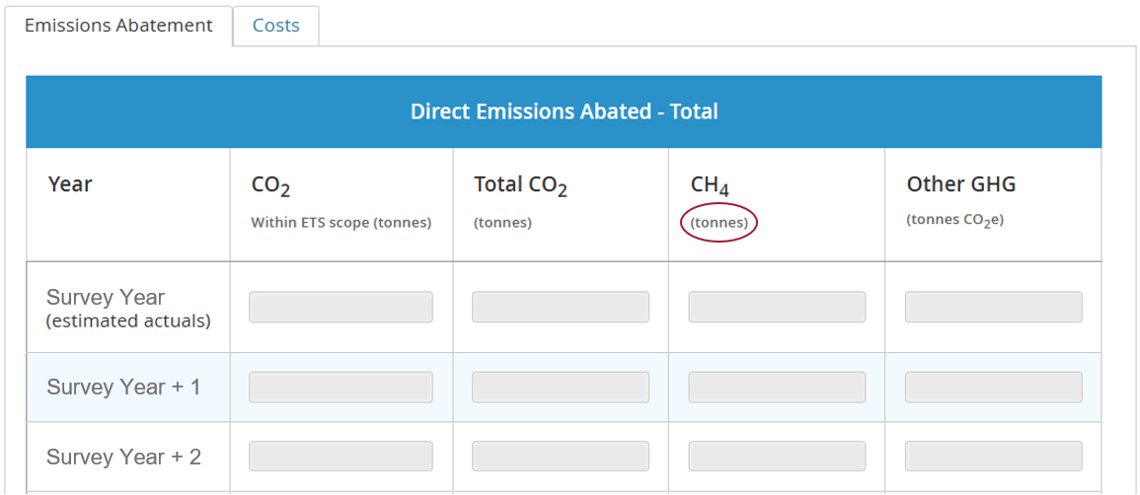

Data Entry
- Please fill in as much detail as you can.
- Once data has been entered it is mandatory within each table to fill in the rest of the data for that year even if Zero please enter "0“.
- It is expected that technical GHG emissions profiles will be provided for each facility, new development and abatement project.
These profiles should extend at least 5 years beyond the Company CoP date.
Company CoP date is not expected to influence these technical profiles i.e. the emissions profile should reflect what the emissions would be if CoP was deferred beyond the planned Company CoP, rather than showing 5 years of post CoP emissions. Technical profiles should align to the mid-case technical profile of the facility’s oil and/or gas production.
- You are asked to provide the ‘estimated actuals’ for the ‘Survey Year’ i.e. the calendar year prior to the Survey deadline. Please provide the best estimate currently available for this row of data. The NSTA recognises that these figures may change once end of year reconciliation and validation has been completed.

You can paste values into table directly from Excel:
- The page will map your pasted cell values to the table cells, ignoring any overflowing rows or columns
- Input fields which have been pasted to will be highlighted green to allow a visual check.

5.1.2. Abatement costs

Not all abatement projects will have an associated cost, though where possible please split into CAPEX and OPEX.
It is expected that reported CAPEX will be positive, however, it is possible for OPEX to be negative.
CAPEX: the capital investment cost of the project.
OPEX: the impact on asset OPEX as a result of implementing the decarbonisation project
e.g. a decrease/increase in maintenance cost or labour and the expected reduction in
UK-ETS costs as a result of the reduced emissions.
Any Emissions Abatement Project with CAPEX greater than £5 million is expected to also be entered into the Activity section as an incremental project for the host field of the facility.
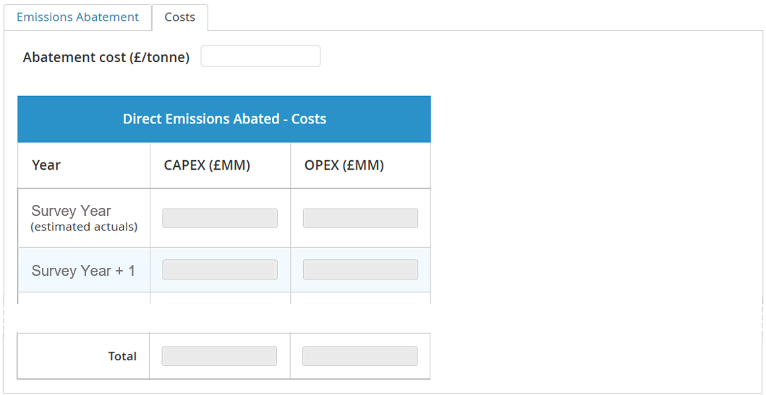
$$Abatement Cost (£/t{CO}_{2}e)= \frac{- \left(NPV of project \left(£\right)- PV of UK ETS cost savings \left(£\right)\right) }{Total emissions abatement ({tCO}_{2}e)}$$
Purpose:
The abatement cost calculation is intended to provide comparable data to the NSTA. We recognise there will be different approaches used across industry to calculate abatement cost.
Calculation components explained:
Negative signage
- A positive abatement cost represents a net cost per tonne whilst a negative cost represents a net benefit.
NPV of Project (£)
- Net Present Value (NPV) of project is the incremental project NPV. It should capture both cost (i.e. CAPEX and OPEX) and revenue drivers (e.g. fuel/flared gas savings converted to incremental gas sales, any production loss) and other OPEX benefits (e.g. reduced maintenance and UK ETS costs) where relevant and proportionate.
- A Real terms 10% discount rate to calculate NPV and PV estimates (consistent with the OGA Strategy).
PV of UK ETS cost savings (£)
- Present Value (PV) of UK ETS cost savings should capture the value of the project in reducing GHG emissions over asset life (e.g. the reduced UK ETS costs).
- A Real terms 10% discount rate to calculate NPV and PV estimates (consistent with the OGA Strategy).
Total emissions abatement (tCO₂e)
- The total expected emissions avoided as a result of the Emissions Abatement Project.
- No discounting to be applied.
Time period
- All data used in determining the abatement cost should be truncated at the estimated CoP date.

Example
Asset A plans to optimise gas compressor processes
NPV of project = - £5 million (discounted CAPEX and OPEX increment)
PV of UK ETS savings = £1 million (discounted UK ETS savings)
Total emissions abatement = 50,000 tCO₂e (lifetime abatement to CoP)
$$⇒Abatement Cost= \frac{-\left(-5 000 000- 1 000 000\right) }{50 000} \frac{£}{t{CO}_{2}e}$$
⇒ Abatement cost = £ 120 per tonne CO₂e

- CONTACT DETAILS

If you have any issues when using the UKSS Stewardship Survey then please email stewardshipsurvey@nstauthority.co.uk and the stewardship team will respond as quick as possible.

If you find any errors with the data or question options presented on this Survey form, then please report the error to the UK Energy Portal Service Desk by calling 0300 067 1682 or email ukop@nstauthority.co.uk.

