TI 22 – 55. Technology Example – Aptera CoMic Micelle Analysis system

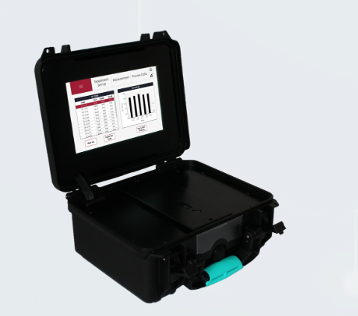
The Three components

Anpera Technologies are proud to introduce our third generations of CoMic™ Analysers micelle analysis software and reagent kits

The latest iteration of CoMic™ is driven by our Analyser hardware design to provide the user with a simple to operate and rapid test platform. Powered by and intuitive user interface the, the Analyser not only allows the operator to easily measure water samples in the filed but also provides results within two minutes. Combined with data that is easily integrated into databases, archives and visualisation software, Generation III CoMic™ is a powerful addition to your corrosion management system.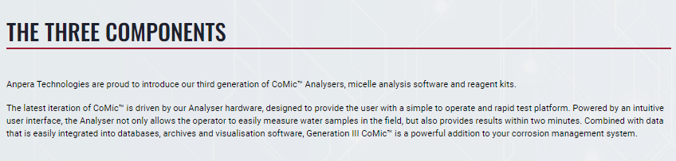
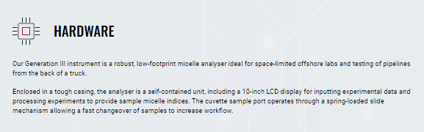
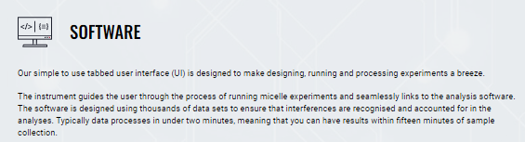

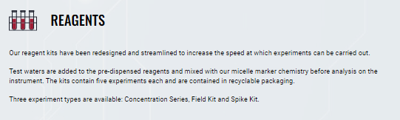
This is an extract from the vendors webpage and is an example of Field analysis kits for further information see the full website using the link below
Link: CoMic Platform | Anpera Technolgies

