TI 25 – 09 Technology Example – NZTC Wells Colab

NZTC Multi-Operator collaboration accelerating the rate in which technology is developed, tested and piloted for well decommissioning.

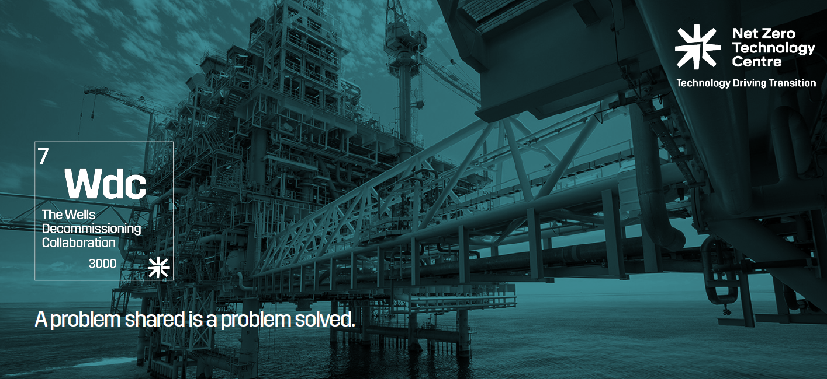

Global TQ Framework

To streamline the acceptance and use of alternative materials for use in the permanent plugging and abandonment of oil and gas wells

Applies principles and processes from established Technology Qualification Processes such as DNV-RP-A203.

- Incorporates requirements from regulations and standards around the globe such as OEUK and Offshore Norge.
- Bespoke to unique application of Alternative Materials for Well P&A.

Standardised framework across multiple operators and regions, applicable to all material and barrier types which enables early engagement with regulators and similar bodies.

1.0 Alternative Barrier Materials

Alternative materials used solely or in composite barriers have potential to provide more reliable and resistant isolation compared to cement.
- CRIN Alternative Products JIP
  - The objectives of the project were to deliver products that had a performance superior to cement, reduce greenhouse gas emissions from leaking wells by decreasing the number of inactive wells and overall reduce financial liabilities whilst creating business opportunities for Alberta and Canadian companies.

- Wellstrom T1000 Bismuth Plug
  - Electrically run bismuth plug than enables abandonments offline and CAN HALVE THE COSTS OF P&A in comparison to section milling and cement remediation.ug
2.0 Inspection and Verification
In recent years there has been a technology race between several vendors in the Through Tubing Cement Logging (TTL) space, with significantly different approaches taken.
- Thru Tubing Logging
  - In recent years there has been a technology race between several vendors in the Through Tubing Cement Logging (TTL) space, with significantly different approaches taken. As one would expect, with different Research and Development budgets, different resources allocated, and manner in which the vendors have approached both tool design and processing, the race has not been equal!
3.0 Enabling Technologies
Enabling technologies provides through tubing services to perform a wide range of task to support barrier placement.
From cutters to slotters and everything in-between
- Axter Retrieve
  - The enabler for permanently leaving the tubing string in the wellbore by removing the control line outside the tubing string to permit cementing/plugging the tubing in place.
- Exedra Balder Tracer Gas Tool
  - Tracer-gas-based verification method for P&A operations jointly funded by NZTC, NORCE and The Norwegian Research Council.
- AAI Hydrate Melter Petrobras Pilot
  - Removing the plugs before setting the plugs –
    - When a hydrate plug is discovered within the Christmas tree or production string.
    - a thermal tool could be employed to melt the hydrate plug after a glycol slug has been positioned above it.
    - The desirable solution comprehends a tool that could be continuously fed by the standard wireline cables.
.
Link to NZTC pdf document containing all case studies in full:
The Wells Decommissioning Collab Overview.pdf

