

UKSS SECTION GUIDE
DECOMMISSIONING

This section will
- appear once at an organisational level, and
- appear for all Fields, except for when both of the following conditions are met:
- No forecast decommissioning costs left to report (including post monitoring costs).
- AND an approved Close Out Report from OPRED.

If you think there are any errors with allocation, please contact
stewardshipsurvey@nstauthority.co.uk

Date of publication 03/11/2025

The document can be found on the NSTAs website.

© NSTA Copyright 2025
URN

You may re-use this information free of charge in any format or medium, under the terms of the NSTA’s User Agreement. To view this, visit: https://www.nstauthority.co.uk/site-tools/access-to-information/ or email correspondence@nstauthority.co.uk

This document is available in large print,audio and braille on request.
Please email: correspondence@nstauthority.co.uk with the version you require.

Enquiries to:
North Sea Transition Authority
50 Broadway
London
SW1H 0DB

Email: correspondence@nstauthority.co.uk

Published by the North Sea Transition Authority

Contents
1. UKSS 2025 CHANGES… 4
2. FIELD – DECOMMISSIONING 5
2.1 Manage Assets 5
2.2 CoP Cessation dates 7
2.3 CoP Schedule 7
2.4 Campaign decommissioning 9
2.5 Estimates, forecasts and actuals 10
2.5.1. Cost estimates 11
2.5.2 Quantities and Weights 27
2.5.3. ‘Survey year’ Well P and A actuals 33
2.5.4. ‘Survey year’ Removals actuals – recent removal projects 38
2.5.5 ‘Survey year’ Subsea infrastructure actuals 40
2.6 Cost Review 41
3. ORGANISATION – DECOMMISSIONING 43
3.1 Decommissioning questions 43
4. CHECKLIST 45
5. CONTACT DETAILS 46

- UKSS 2025 CHANGES

The following changes are being implemented in the Decommissioning section of the survey:
- Additional guidance has been included to provide further clarity.
- ‘Starting mechanical status’ and ‘New mechanical status’ have been relocated within the same page (it is now directly below the WONS wellbore registration number).
- Updated selection lists for ‘New mechanical status’, and the rig/unit types within the Well P and A data requests.
- Amended well type categories, and the licence number will automatically appear for an E&A well.
- Adjusted the well status code description to align with OEUK guidelines.
- Question added to state whether a well has been abandoned to high pressure and/or high temperature specification.
- In the ‘Estimates, forecasts and actuals’ section,
  - additional questions have been incorporated for operators to provide greater detail about planned activities,
  - a mandatory checkbox for operators to confirm that they have reviewed data that has been copied forward and that it is correct.
- For subsea infrastructure only, there are now validation checks in place to ensure that if data is entered for a specific year in the Quantity/Weight tab then there must also be data entered for the same specific year in the Cost estimate tab (and vice versa).
- In the ‘Decommissioning questions’ section, additional information will be requested should there be a ‘Scope change’.

- FIELD
– DECOMMISSIONING

2.1 Manage Assets
The Objective of the Decommissioning section is to collect consistent information on decommissioning activity from operators to allow meaningful analysis resulting in valuable outputs back to the industry at large.
Please provide the best current estimates and identified actual costs where available. Data should be filled in for all assets.
Within each field, please select "Add asset" or if necessary "Add custom asset" and provide direct costs and quantities under each asset.
An exception to this is where wells are drilled to multiple fields from a single platform. In this case, the wells should be counted under the platform and a note confirming this should be added to relevant field submissions.
Where appropriate, please add brief commentary to individual field submissions stating the host infrastructure back to which the field ties. Direct post-CoP running costs (e.g. inspection costs) for subsea fields should be defined and inputted. However, a subsea field’s share of host installation costs should not be allocated to the subsea field in the Stewardship Survey – the operator of the host installation is expected to provide these costs on a 100% basis elsewhere in the Stewardship Survey. Please use the comments box to provide narrative where helpful. Following these principles allows data to be gathered consistently in line with OEUK Guidelines and improves the quality and usefulness of the resultant benchmarks.
Where a platform or FPSO (used throughout this survey to denote any floating installation such as an FSU or FPF) acts as host to multiple fields, please add the host asset under one field only and provide host-related costs and quantities in this one place only. Please do not distribute host costs among user fields.

All assets within a Field should be listed on the screen.
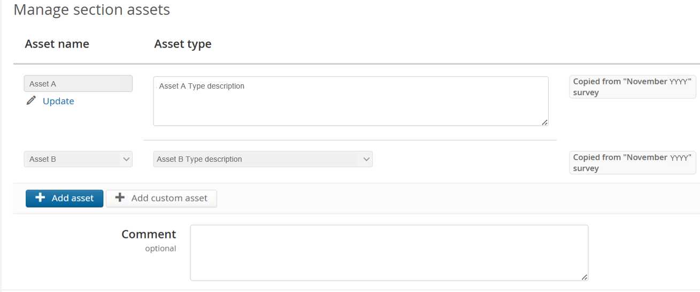
Use the Comment box to state any relevant information regarding the submission.

Should you need to report data on any additional facility, click the  icon , or if necessary add custom asset.

The ‘advanced search’ option opens the ‘Facilities Picker’ window that helps to source a facility.
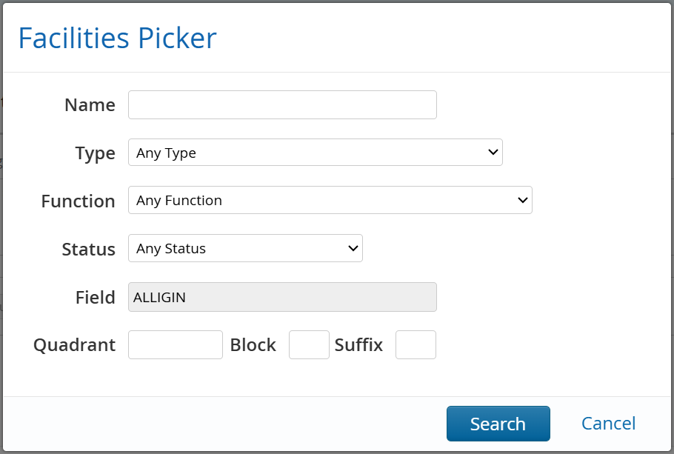

2.2 CoP Cessation dates
The NSTA requires operators to submit the following 3 cessation dates estimates/actuals where relevant.
These dates support an effective transition from asset late life operations to CoP and subsequent decommissioning, as well as supporting the implementation of the OGA Plan for Emissions Reduction.
- Company CoP date
Defined as the asset base case CoP date i.e. the date which the asset is expected to, or has already, permanently ceased production of native oil and gas. Likely based on an operator’s economic P50 estimate or when the host facility is expected to cease operations/exporting. Date should exclude any potential field life extension impact from unsanctioned projects, and should not consider any future third party processing dates.
- Early CoP date
Defined as the earliest credible CoP date based on asset risk register i.e. the earliest, credible CoP date based on asset risk register. CoP date could be driven by asset integrity risks, production decline or other such factors. This should be an operational risk date, not driven solely by economic factors.
- Emissions backstop date
Defined as the date in which host post-CoP running costs and routine GHG emissions cease permanently. This is very likely linked to final platform disembarkation for manned installations once the topsides are hydrocarbon free and the platform wells are decommissioned (likely to AB2 status) or vessel sail away in the case of FPSOs. The Emissions Backstop date and Company CoP date are therefore inherently linked.
Please provide a brief comment as to the basis of the three dates in the ‘General Comments’ section.
All cost and quantities & weights profiles provided should be based on the "Company CoP date", not the "Early CoP date"

2.3 CoP Schedule
Click on the icon to set the Company CoP date and decommissioning cost profile. Reference section 2.2 for Company CoP date definition.
The cost profile will be used to populate the cost and quantities data tables. The default setting will be from ‘Company CoP date – 5 years’ and to ‘Company CoP date + 10 years’, but please choose the cost profile timespan that you would like the cost and quantities data tables populated with.
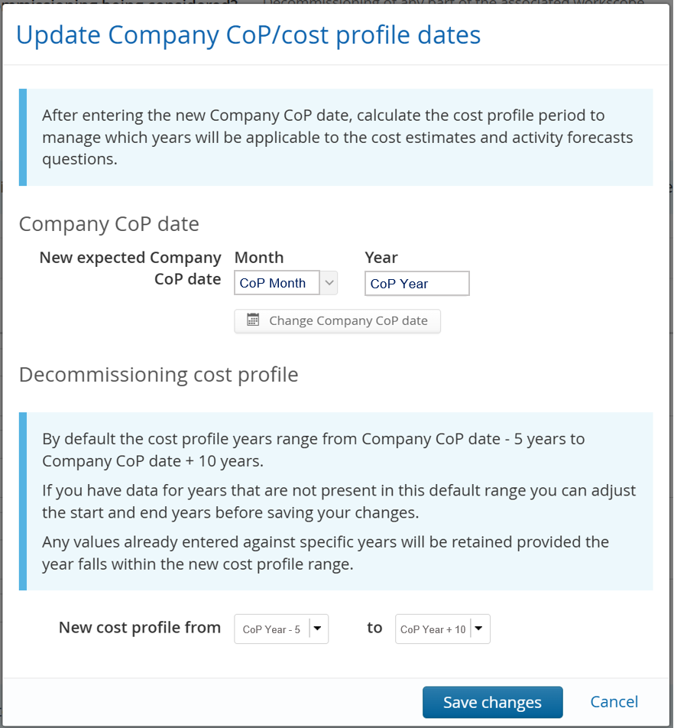

Once the Company CoP date is set, the following data request will be displayed:
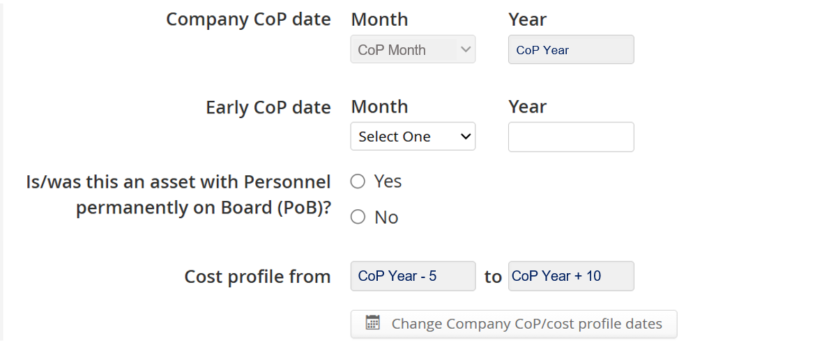
If ‘yes’ is selected for the question, ‘Is/was this an asset with Personnel permanently on Board (PB)?’, then you will be requested to enter an Emissions backstop date.

The Company CoP date can be edited by clicking on the icon, and the ‘Update Company CoP/cost profile dates’ windows will appear again.
After entering the new Company CoP date, calculate the cost profile period to manage which years will be applicable to the cost estimates and activity forecast questions.
By default, the cost profile years will range from Company CoP date - 5 years to Company CoP date + 10 years.
Note:
- To retain costs and quantities entered in pervious surveys against specific years, the new profile range must include those years, otherwise those values will be deleted.
- If you have data for years that are not present in the default range, you can adjust the start and end years before saving your changes.

2.4 Campaign decommissioning
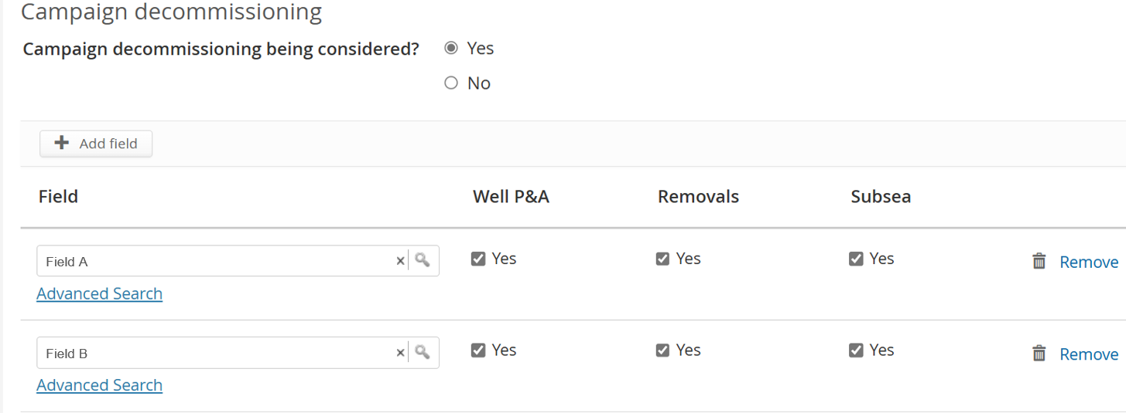
This section aims to capture whether any part of the listed decommissioning activities are being considered for aggregation/campaign approach either within company portfolio or with other operators in region.
Please indicate which elements of the work are being considered for a campaign approach and if known please state the other fields this is with.
The campaign decommissioning selection will be copied forward from previous years submission.
Please use the  icon to detail all the fields that are in the work campaign.
The ‘advanced search’ option opens the ‘Field Picker’ window that helps the user to find and select an existing facility.
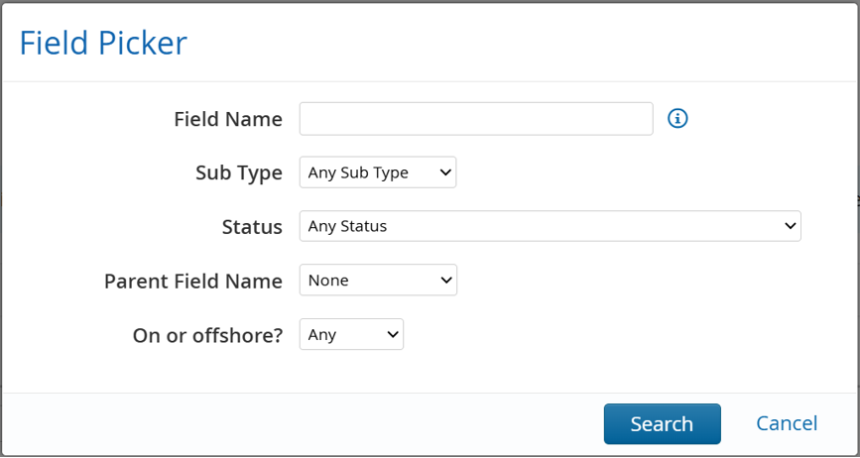
Please note there is an additional question in the well P&A actual section which asks if the well P&A work was part of a campaign and what sort of campaign: Single Operator, Multi-Operator, Operator led or Supply chain led.

2.5 Estimates, forecasts and actuals
For the aspects of decommissioning listed in the table of contents below,
Table of contents
Operator project management
Post CoP running costs
Well decommissioning
Facilities & pipelines permanent isolation & cleaning
Topsides preparation
Removal
Subsea infrastructure
Topsides and substructure onshore disposal
Site remediation
Post Decommissioning Monitoring
Total expenditure
Other relevant information
a table of costs and the following data request will be presented for completion:
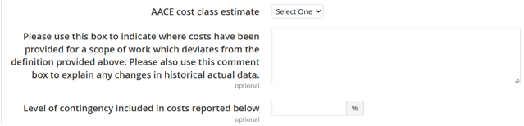
With reference to the Estimate class and characteristic table below, select a classification of estimate for the AACE cost class estimate question and the associated contingency level (if any) included in the costs reported question.
Estimate class | Secondary characteristic
Expected accuracy range
Typical variation in low and high ranges at an 80% confidence interval
Class 5 | L: -20% to -50%  H: +30% to +100%
Class 4 | L: -15% to -30%  H: +20% to +50%
Class 3 | L: -10% to -20%  H: +10% to +30%
Class 2 | L: -5% to -15%  H: +5% to +20%
Class 1 | L: -3% to -10%  H: +3% to +15%

2.5.1. Cost estimates
MM ≡ million.
Please complete the Cost Estimate with the operator's actual and best available forecasted spend under each of the Work Breakdown Structure (WBS) categories. Forecasted costs are required in £MM in ‘survey year’ money. Actual costs are required in the year of money spent.
The expectation is that the next 10 years of estimates are entered as a profile across the 11 WBS categories. Beyond ‘survey year + 10 years’, if cost estimates are available as a profile and/or per WBS category then please enter as so. Otherwise, enter estimates beyond ‘survey year + 10 years’ as aggregated below:
- Owners Cost (Project Management, Post CoP Running Costs) into the Operator project management section
- Well Decommissioning into the Well Decommissioning section.
This includes well costs incurred as pre work for plug and abandonment operations, such as P&L, wellbore surveys etc.
- Topside Removal (Permanent Isolation & Cleaning, Topside Prep, Topside Removal) entered into Removal - Topside section and separately including Substructure Removal into the Removal - Sub-structure/Jacket section.
- Subsea Infrastructure into the Subsea infrastructure - Other section
- Onshore Recycling & Disposal (Site Remediation, Monitoring) into the Topsides and substructure onshore disposal section

FPSO Guidance:
- Engineering down, emptying tanks, cleaning down and flushing of risers - costs to go in Permanent Isolation & Cleaning.
- Disconnection costs, riser disconnection and recovery, mooring leg disconnection and recovery, anchor removal, tugs for heading control, towing to port etc. in Substructure Removals.
- Marker buoy or Guard vessel hire should go under post CoP running costs.
Where a basis may not be available to readily split into WBS Categories, please be pragmatic in the methodology of doing so. Leave a brief comment in the ‘Other relevant information’ or General comments box detailing what was done.

Please indicate, using the text boxes provided, where the figures entered within a category deviate from the OEUK WBS definition.
Actual costs from the previous survey have been copied across for your convenience into this survey.
Historic data is locked to prevent unnecessary edits to actual costs. Please only unlock and edit when there is a genuine error or a significant update in the actual costs previously provided as in most instances, it would be expected that actuals would remain consistent with prior year surveys. If a change is necessary, please enter a comment into the individual comment box above for the reason for the change.
Notes:
- The decommissioning survey cost should include "full life cycle cost", i.e. including wells yet to be drilled or infrastructure yet to be installed which has been sanctioned.
- The total estimate in the Decommissioning survey should agree to the Activity Survey.
- Please indicate if contracts have been placed for each of the forecasted tasks or activities; this is valuable information for the supply chain.

 You can paste values into table directly from Excel:
- The page will map your pasted cell values to the table cells, ignoring any overflowing rows or columns
- Input fields which have been pasted to will be highlighted green to allow a visual check.

2.5.1.1. Operator project management
The owner's direct costs for management and engineering, preparation of documentation, presentation and related, including:
- Project Management Core Team
- Stakeholder engagement
- Studies to support Decommissioning Programmes and scope definition/ method development
- Decommissioning programme preparation and decommissioning programme reporting / close out (admiralty charts, fish safe etc)
The contractors awarded scopes of work throughout a decommissioning project will have project management with their associated activities. This "contractor project management" should be included in each respective WBS element as necessary.
Costs associated with operators core decommissioning team (project management team) should be included under operator project management.
Operator project management costs are expected to be incurred throughout the full lifecycle of a decommissioning project.
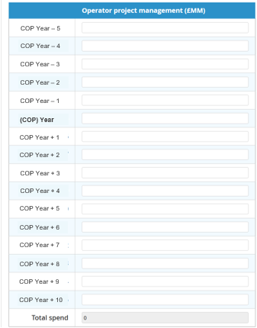

2.5.1.2. Post CoP running costs
Post CoP running costs as they refer to the management and operation of the installation (platform or FPSO only). Where relevant this includes:
- Logistics (aviation & marine)
- Operations Team
- Deck Crew
- Power Generation
- Platform Services
- Integrity management (Inspection and maintenance)
- Operations specialists services e.g. waste management
- Guard vessel costs should also be included here
For FPSO removal projects please insert costs from the CoP date to the date of handover (i.e. at port or other).
Note: If ‘Yes’ is selected for the question “Is/was this an asset with Personnel on Board (PoB)?” in the CoP schedule section, then the “Actual/Forecast date for the final disembarkation” question will appear.
Please provide actual/anticipated core crew* PoB (average per annum). For platforms which had PoB but which have now been disembarked, please still submit the historical PoB data. Do not enter zero PoB.
For bridge-linked platforms with PoB, please apportion total PoB under the platform where post-CoP running costs have been apportioned.
This should be only one platform. Insert zero PoB for the other platforms.
*Core crew: e.g., operations and maintenance team, catering, medic, heliops etc. plus topside preparation team and well decommissioning team.
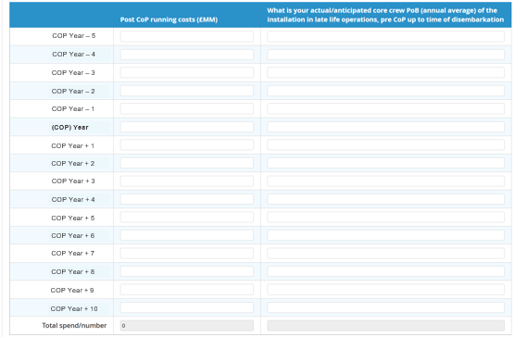

2.5.1.3. Well decommissioning
The costs for well P&A (both platform and subsea) include:
- Facilities Upgrade
- Studies to support well programmes
- Well suspension (spread rate/duration)
- Wells project management
- Operations support
- Specialist services e.g. Wireline
- Conductor recovery
- Cleaning and recycling
- Vessel costs

Subsea development wells
Subsea development wells only, please exclude any E&A well costs.
These will feature in the Wells section of the survey only.
Contract in place
Please indicate if contracts have been placed for each of the forecasted tasks or activities; this is valuable information for the supply chain.
Contract selection will be copied forward from previous years submission.
There is an additional question about forecast date of completion for well P&A work

Facilities Upgrade
Examples of facilities upgrade may include, but not limited to rig reactivation, modular unit, Hydraulic Workover Unit installation, procurement of special equipment, recertification, platform upgrades, rig upgrades, others. (please provide a description of these costs using the comment box above).
Mechanical Status (please ensure you add the costs in the correct column)
AB1: A wellbore where the reservoir has been permanently isolated. The wellbore below the barrier is no longer accessible.
AB2: All required permanent isolation barriers have been installed and verified (including environmental barriers). No “in-well” work is required to fully decommission the well. The well origin and conductor above the well origin may still require to be removed.
AB3: The well origin and all conductor above the well origin have been removed.
AB1, AB2, AB3
Please record the platform and subsea wells forecasted cost by mechanical status. If well decommissioning is phased over multiple years identify costs in the correct mechanical status. As a minimum, costs to AB2 status and costs from AB2 to final decommissioned status are expected to be estimated separately.
e.g., if the platform well decommissioning programme is £10MM total, see examples and table below to illustrate how to record the forecasted cost
Example 1 – all phases of abandonment are completed in 2025. How to record: split cost by mechanical status to reach the total
Example 2 – all phases of abandonment up to final abandonment status are completed in 2026, and costs are NOT able to be reported per mechanical status. How to record: put all cost into final mechanical status (e.g., AB3)
Example 3 – AB2 complete in 2027 and AB3 completed in 2028. How to record: split total cost by mechanical status and year.
Also, where activities span multiple calendar years report the cost proportionally e.g., if AB2 abandonment is phased across 2027 and 2028 proportion well costs across the two years.
Example |  | Platform P&A
 | Year | AB1 | AB2 | AB3
1 | 2025 | £ 5 MM | £ 3 MM | £ 2 MM
2 | 2026 |  |  | £10 MM
3 | 2027 |  | £ 8 MM
 | 2028 |  |  | £ 2 MM


If ‘yes’ is selected for the question, ‘Do you have Platform Wells to decommission?’, then you will be requested to enter a forecast date for completion of Platform Well P and A.
If ‘yes’ is selected for the question, ‘Do you have Subsea Wells to decommission?’, then you will be requested to enter a forecast date for completion of Subsea Well P and A.
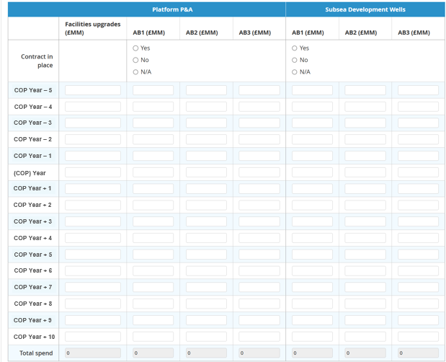

2.5.1.4. Facilities & pipeline permanent isolation & cleaning
This includes costs for the permanent isolation & cleaning of facility and pipelines such as:
- Operations drain, flush, purge & vent
- Engineering down including: physical isolation, de-energise, vent & drain.
- All cleaning costs (including removal of hazardous wastes, hydrocarbon freeing of equipment, pipeline pigging etc)
- Waste Management
Please indicate if contracts have been placed for each of the forecasted tasks or activities; this is valuable information for the supply chain.
Contract selection will be copied forward from previous years submission.
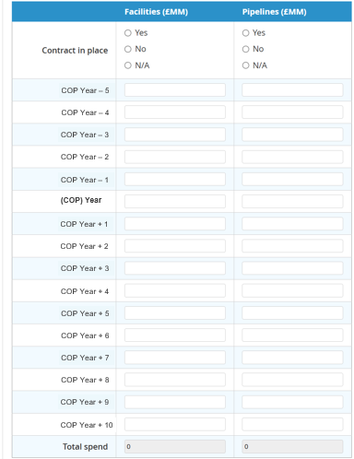

2.5.1.5. Topside preparation
This includes costs for preparing the topsides to be managed in its interim status prior to removal:
- Engineering up of temporary utilities e.g., power, air and water.
- Module process & utilities separation
- Dropped object surveys and subsequent remedial actions
Topsides removal preparation costs must not be included here, please record under Topsides Removal WBS instead.
Please indicate if contracts have been placed for each of the forecasted tasks or activities; this is valuable information for the supply chain.
Contract selection will be copied forward from previous years submission.
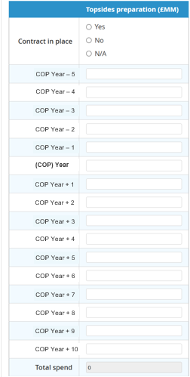

2.5.1.6. Removal
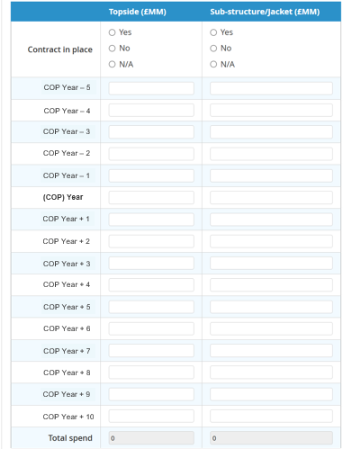

Topside Removal cost includes activities such as:
- Removal preparation (reinforcements and structural separation for removal).
These costs must be provided here and not under the earlier section 'topsides preparation'. Topsides removal benchmarking is calculated using costs provided in this section only and should include all topsides removal-related costs
- Major lift operations
- Vessel operations
- Sea-fastening
- Transportation and load-in
- Logistics and management associated with topsides removals
If there is only a total value for topside and jacket removal combined please place the cost in the Topsides column and place a comment to this effect in the ‘Other relevant information’ comment box at the bottom of the page.

Substructure Removal costs include activities such as:
- Removal preparation
- Removal
- Vessel
- Sea-fastening
- Transportation and load-in
- Logistics and management associated with substructure removals
- FPSO disconnection & removal cost (Riser cutting etc. included in Subsea)

Please indicate if contracts have been placed for each of the forecasted tasks or activities; this is valuable information for the supply chain.
Contract selection will be copied forward from previous years submission.

2.5.1.7. Subsea infrastructure
This includes costs associated with the decommissioning of subsea infrastructure including:
- Vessel preparation for subsea end-state (remove, trench, rock-dump)
- Sea fastening & transportation
- Load-in
- Subsea project management
- Waste management accounting (traceability of all streams)
- Removal: subsea structures, umbilicals, mattresses
- Logistics and management associated with subsea decommissioning
Subsea infrastructure lump sums should be added to "Other (Manifolds/SSIV/Christmas trees etc.)". If used - please include a high-level note in the ‘Other relevant information’ comment box at the end of the page to explain the expected content of the lump sum e.g., pipelines, umbilicals, jumpers, manifolds, mattresses etc.
Please indicate if contracts have been placed for each of the forecasted tasks or activities; this is valuable information for the supply chain.
Contract selection will be copied forward from previous years submission.
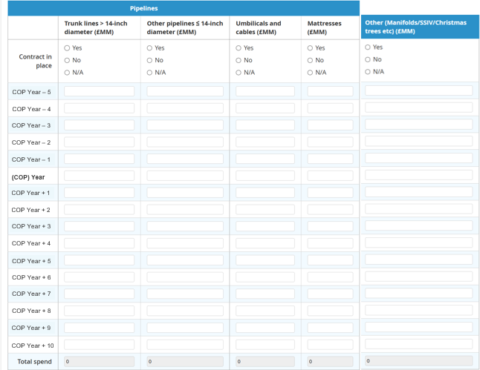
Note: Numerical data can only be submitted to a maximum of 3 decimal places in the cost estimate subsea infrastructure section.

2.5.1.8. Topsides and substructure onshore disposal
Activities include:
- Onshore cleaning and handling of hazardous waste
- Onshore deconstruction
- Re-use, recycle, and final disposal
- Transportation to point of sale and/or onshore disposal
- Waste management accounting (traceability of all streams)

Onshore disposal volumes should include marine growth.
Where relevant and known or estimated, please indicate scrap values for onshore disposal by doing all the following:
- add as a negative value,
- select "yes" to the question “Is scrap value included in onshore disposal costs?”.
Scrap value should not be provided anywhere else
e.g. added as a negative value under “Topsides removal" or "Substructure removal”. 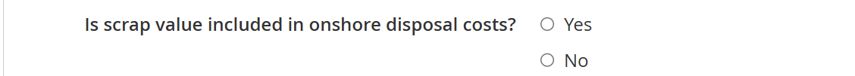
Please indicate if contracts have been placed for each of the forecasted tasks or activities; this is valuable information for the supply chain.
Contract selection will be copied forward from previous years submission.
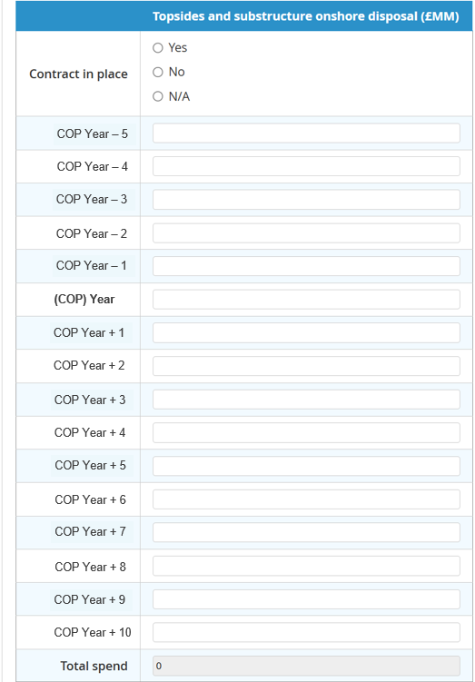

2.5.1.9. Site remediation
This includes:
- Pile management
- Oil field debris clearance (500 metre zone)
- Over-trawl surveys
Please indicate if contracts have been placed for each of the forecasted tasks or activities; this is valuable information for the supply chain.
Contract selection will be copied forward from previous years submission.

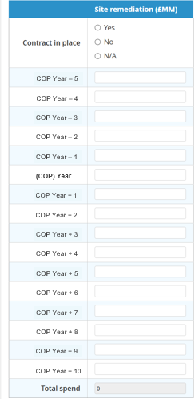

2.5.1.10. Post Decommissioning Monitoring
Post decommissioning monitoring programme as agreed with DESNZ. This includes the immediate post decommissioning survey and subsequent survey and monitoring costs including:
- Navigation aids maintenance
- Monitoring program for any facilities that remain
Please indicate if contracts have been placed for each of the forecasted tasks or activities; this is valuable information for the supply chain.
Contract selection will be copied forward from previous years submission.
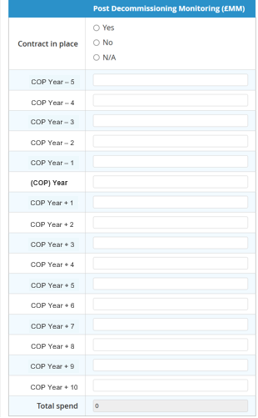

2.5.1.11. Total expenditure
The Total expenditure is auto calculated from the data entered in the sections above.
It is expected that the estimate and phasing (previous survey year, actual survey year, forecasted future years) of Total expenditure entered will match the decommissioning estimate provided in the ACTIVITY section of the survey (aside from onshore terminal decommissioning and unsanctioned project costs).
Note: the DECOMMISSIONING section is at Asset level, and therefore the addition of all assets' Total expenditure (from the previous survey year onwards) should equate to the Total expenditure in the ACTIVITY section of the survey.
If there is an error in the ACTIVITY section of the survey, you can revisit the ACTIVITY section and amend. If the ACTIVITY section is already submitted, please contact stewardshipsurvey@nstauthority.co.uk who will reopen the section for you to allow you to amend.
If there is a discrepancy between the ACTIVITY survey and the estimate and phasing, please clarify the reason(s) in the ‘Other relevant information’ comment box at the bottom of the page. This will remove the requirement for a query being raised during the NSTA survey QC process.
You will be able to check estimates and phasing in the Cost Review page (reference section 2.6 of this document).

2.5.1.12. Other relevant information
Please use this comments box to provide additional information that may be of value to analysts. This may include:
- a description of facilities upgrade costs.
- explain why there is only a total value for topside and jacket removal combined.
- explain the content of any subsea infrastructure lump sums added to the "Other (Manifolds / SSIV / Christmas trees etc.)" e.g., pipelines, umbilicals, jumpers, manifolds, mattresses etc.
- a discrepancy between the ACTIVITY survey and the below estimate and phasing.

2.5.2 Quantities and Weights
Unless otherwise stipulated, all weights are to be entered in metric tonnes.
For the wells and infrastructure to be decommissioned, the corresponding well numbers and weights / quantities should be listed in this section.
EXAMPLE:
For well quantity, if the example data in section 2.5.1.3. of this document was entered into the cost estimate section, then red text would appear for years 2025, 2026, 2027 & 2028. However, as the data in year 2027 relates to the well that will reach final status in 2028 you would count this as 0 in 2027. All other years would be counted as 1 as they are the final mechanical statuses for those wells.

We ask for data on:
- Well P&A
- Making safe, topsides preparation and removal
- FPSO removal, subsea infrastructure, topsides and substructure onshore recycling
- Subsea Infrastructure including pipeline details.
Note: All historic actuals and forecast data will be copied from the previous year’s survey,
but if the new profile range excludes any years that contained previously entered data, then that data will have been deleted.

2.5.2.1. Well P & A
Where there are costs quoted in the Cost of Well Decommissioning section, the corresponding scope / number of wells decommissioned to their final mechanical status per year should be provided here.
If any value was inserted into the AB1, AB2 or AB3 columns in the cost estimate section you will be prompted via red text to enter a value. Please only count the wells that have reached or are anticipated to reach their final mechanical status for that year, count as 0 if no wells reached or are anticipated to reach the final mechanical status that year.
The total number should equal the total number of wells to be decommissioned for that asset, please double check that the total matches your records.
Subsea wells data should include subsea development wells only, please exclude any E&A well data. These will feature in the Wells section of the survey only.

Rig/Unit Type Definitions (also applies to Well P&A Actuals section, if applicable):
- Integral rig - Platform rig with full derrick (would have been used to drill the wells)
- Modular Rig – Temporary rig
- Stand-alone jack-up –Standard or heavy duty
- Stand-alone semi-sub – Drilling rig or intervention unit
- Other rigless:
  - HWU – Hydraulic workover unit
  - LWIV – Light well intervention vessel
  - DSV – Dive support vessel
  - MSV/CSV – Multipurpose support vessel/construction support vessel
  - AHTS – Anchor handling tug supply vessel
- Unknown

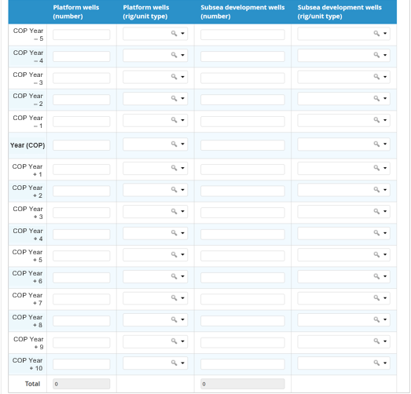

2.5.2.2. Facilities & pipelines permanent isolation & cleaning, topsides preparation and removal

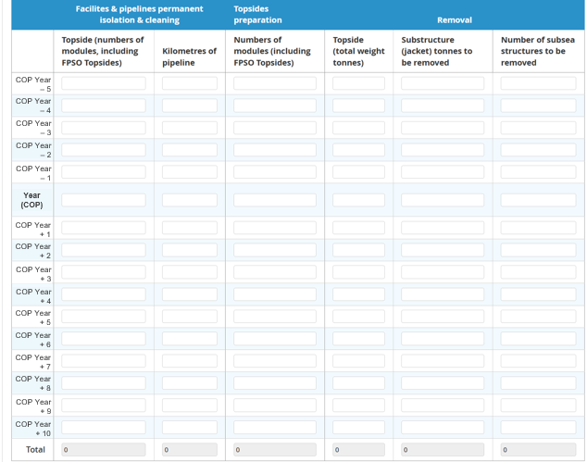

2.5.2.3. FPSO, subsea infrastructure, topsides and substructure onshore recycling
Please indicate the total steel weight of FPSOs to be decommissioned. This should be the weight of the vessel and not the displacement weight.
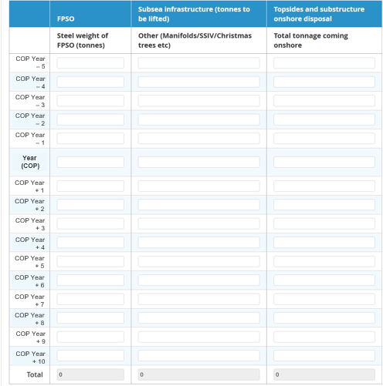

2.5.2.4. Subsea infrastructure
Subsea Infrastructure includes:
- Pipelines
  - Trunk Lines (note 1)
  - Other Pipelines (note 2)
- Umbilicals and cables (note 3)
- Mattresses
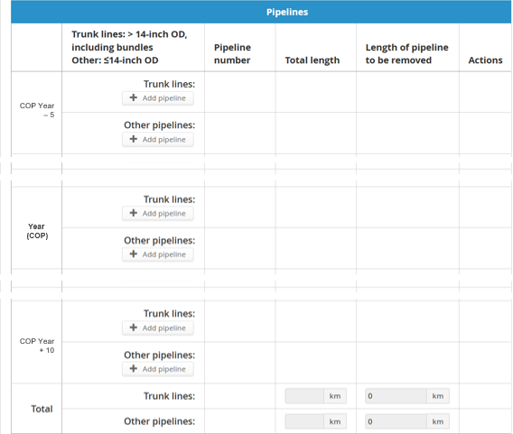
Pipelines are defined as a pipe or system of pipes (excluding a drain or sewer) for the conveyance of any fluid, together with any apparatus and works associated with such a pipe or system. Pipelines include flexible pipelines and bundles.
Note 1. Trunk lines are defined as pipelines with a diameter greater than 14-inches and a length in excess of 18km.
Note 2. Other Pipelines should include pipelines out with the trunk line classification.
This includes tie backs, short flow lines and bundles.
If this includes bundles of pipelines, please indicate in the ‘Other useful information’ comments box at the end of the page.
Umbilicals and cables have been given their own category.
Note 3. Umbilicals and cables are defined as utility support pipes
Please also indicate the length of pipeline expected to be removed in kilometres.
The pipeline dropdown list is now connected to the new Pipeline Works Authorisations (PWA) service.
Note: Numerical data can only be submitted to a maximum of 3 decimal places in the quantities and weights subsea infrastructure section and text entries will not be accepted.
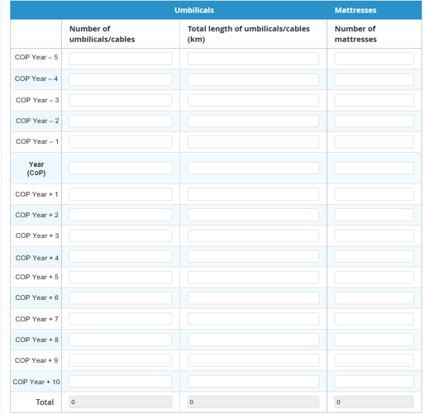

2.5.2.5. Other information
Please use this comments box to provide additional information that may be of value to analysts. This may include:
- Details on rig/ unit type if ‘Other’ has been selected for any of the platform or subsea well quantities.
- Details of any bundles of pipelines.

2.5.3. ‘Survey year’ Well P and A actuals

2.5.3.1 Well Decommissioning
This section is seeking the out-turn costs from well decommissioning works where a well has attained a new mechanical status in the ‘survey year’. This data will be collected annually and used as input to NSTA well decommissioning benchmarks.
Please only include if final costs to attain the new mechanical status are known or have a high degree of certainty.
Notes:
- For each WONS well number please select from the dropdown the starting mechanical status and the new mechanical status, either attained or believed to have been attained for which the well actual is being provided.
- Please provide the direct and indirect costs of taking the well from ‘starting mechanical status’ to ‘new mechanical status’.
- Only identify facilities upgrade costs in the 'Facilities Upgrade' field.
Please average the cost across the associated wells in the 'Facilities Upgrade' line.
- When entering details of Well P&A, the well type will default to “Platform” unless the WONS number is attributed to “Subsea”.
Please double check the Well Type is correct and if it is incorrect, you can change this.


If ‘Yes’ is selected for the question ‘Do you have ‘survey year’ Wells P and A actuals?’
then you will be:
- requested to add a well using the icon,
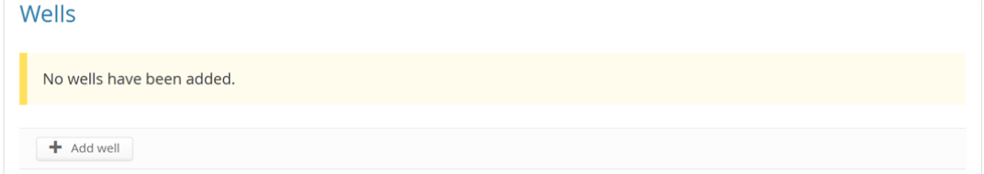
- informed to include the original costs and durations if the submission is a continuation of, or a correction to, a previously submitted actual,
- required to answer additional questions.

Multiple wells can be added using the button and deleted using the button.

2.5.3.1.1. WONS wellbore registration number
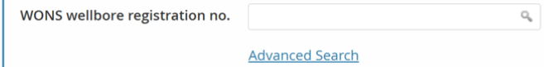
Search and select the relevant wellbore number as listed in WONS.
The option enables you to search using the following options:
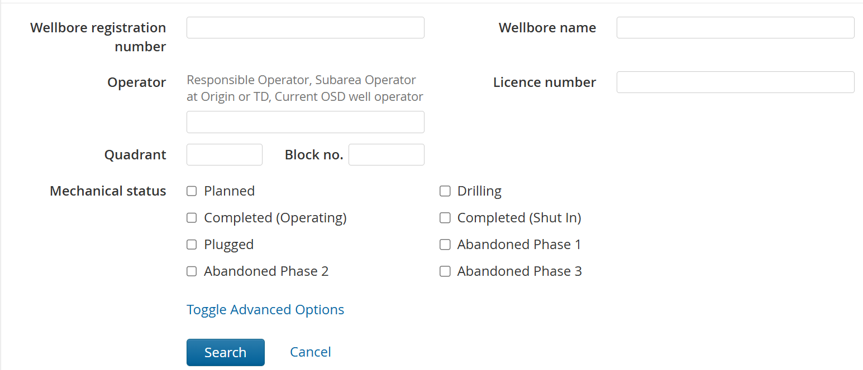

2.5.3.1.2 Mechanical status
The well decommissioning costs are expected to be the actual costs incurred when a well changes mechanical status during the ‘survey year’ and not just the actual costs incurred in the ‘survey year’.
Therefore, for each well, please provide both the starting mechanical status and new mechanical status for which these costs are associated.
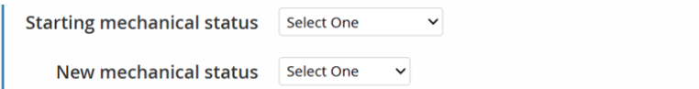
Mechanical Status Definitions:
Completed (Shut In): Completed wellbore that is shut in either at the tree values or subsurface safety value. Normally this status will only be applied if the wellbore is intended to be shut in for 90 days or more.
Plugged: A wellbore that has been temporarily plugged with a plug rather than a permanent isolation barrier. This includes inactive wells where the control system has been disconnected so the well is effectively plugged with the subsurface safety valve and tree valves.
Note that licence clauses refer to “plugging” and “plugged and abandoned”, “plugged and sealed”, “plugging or sealing”, these should be interpreted in context of the licence and clause in question.
AB1: A wellbore where the reservoir has been permanently isolated. The wellbore below the barrier is no longer accessible.
AB2: All required permanent isolation barriers have been installed and verified (including environmental barriers). No “in-well” work is required to fully decommission the well. The well origin and conductor above the well origin may still require to be removed.
AB2 Derogated: All “in-well” isolation work is complete. Derogation to leave the well origin or well equipment, e.g. conductor, above the well origin has been granted by OPRED.
In instances where derogation has not been granted by OPRED or where a derogation decision is pending or where a derogation application is intended to be submitted please also select 'AB2 Derogated'.
AB3: The well origin and all conductor above the well origin have been removed.

Notes:
- Data related to works up to AB2 mechanical status should be provided in the "Well decommissioning" section
Data related to going from AB2 to AB2 Derogated or AB3 should be provided in "Wellhead removal" section, which allows data entry for conductor removal or wellhead removal as appropriate.
Data inputted to the "Well decommissioning" section should not overlap with data inputted to the "Wellhead removal" section and vice-versa i.e. downhole costs and durations should be provided exclusively in the "Well decommissioning" section, whilst AB2 to AB2 Derogated or AB3 costs and durations should be provided exclusively in the "Wellhead removal" section.
- Please also use this box to state the kind of unit used to perform AB2 to AB2 Derogated or AB3 work if this is different to the unit used to perform the downhole work, e.g. where a conductor pulling unit has been used on a platform following downhole work using an integral rig.

2.5.3.1.3 Well type

Select one of the four options,
and state whether the well abandonment was to HP and/or HT specification.
If either of the ‘E&A’ options is selected, then the associated licence number will appear.

2.5.3.1.4 OEUK Well Status Code Description
As defined in the OEUK Well Decommissioning Guidelines (Issue 7), please state the status code for the well.

2.5.3.1.5 Other Well decommissioning data requests
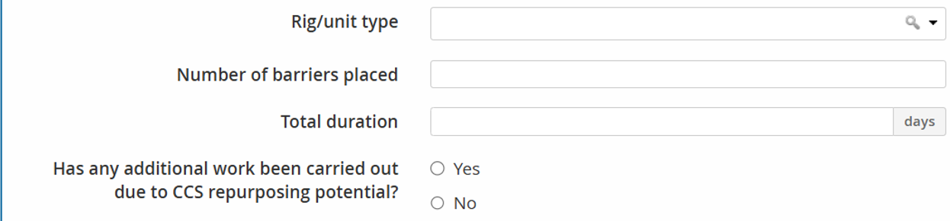
Rig/unit type: category of rig/unit used to carry out the decommissioning work.
Number of barriers placed: the number of permanent or environmental barriers placed in the well.
Total Duration: Cumulative time (days) spent on any aspects of well decommissioning. Duration reported should disregard any large breaks of time without active work on the well (such as rig recertification, however, periods of NPT rig time during execution should be reported).
State whether any additional work has been carried out due to Carbon Capture and Storage repurposing potential.

2.5.3.2 Cost of well decommissioning
All direct well P&A costs including upfront plugging, plus allocation of any indirect costs.
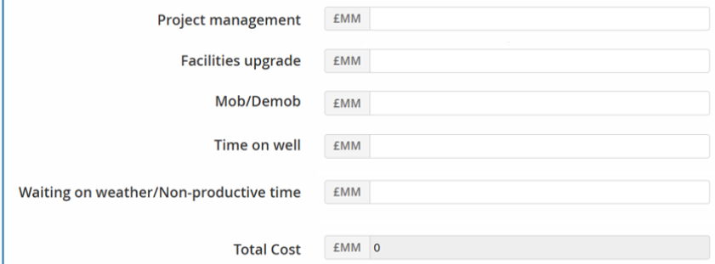
The cost of “in well” decommissioning is split out into the following categories:
- Project Management - Include all time writing, pre-engineering work
- Facilities upgrade - Rig reactivation, HWU installation, procurement of special equipment, platform upgrades, others (please provide a description of these costs using the 'Other Information' comment box at the end of the page).
- Mob/Demob - Vessel / jack-up / rig(mobile) mob demob time.
- Time on well - Actual work on well and ancillary costs (e.g standby boat).
- Waiting on weather / Non-productive time - Items such as waiting for permits, equipment failure, etc.
The total cost is auto calculated.

2.5.3.3 Conductor removal
The Conductor / Wellhead Removal section will only be displayed when AB2 (derogated) and AB3 is selected as the latest mechanical status.
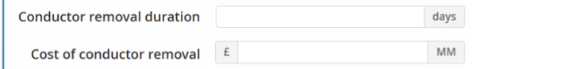
Only include duration associated with conductor/wellhead removal if it is part of the well abandonment programme. Conductor removal being executed as part of the jacket removal (e.g., Heavy lift) should not be included.

2.5.3.4 Campaign
Campaign Definition: A "campaign" is where any more than one well is worked on in a single mobilisation. Recognising that sub-scopes of well decommissioning may be campaigned,
e.g. downhole scopes in one campaign and conductor or wellhead removal in another,
please briefly detail the nature of the campaign(s) in the "Other information" comment box at the end of the page.
Please indicate whether the well was part of a campaign.

If ‘Yes’ is selected for the question ‘Was this part of a campaign?’
then use the dropdown list to detail the type of campaign.
The options are:
- Single Operator
The well has been decommissioned as part of an aggregated programme of activity across the portfolio of a single operator (i.e., multiple fields/licence areas). The campaign could be a designated decommissioning campaign or may include drilling/well intervention scopes.
- Multi-Operator, Operator led
The well has been decommissioned as part of an aggregated programme of activity across the portfolio of multiple operators. The combined scopes were tendered as one programme of activity, and the preferred contractor was agreed by all parties (Note: operators may secure services of the contractor under 1 contract or individual contracts). The campaign could be a designated decommissioning campaign or may include drilling/well intervention scopes.
- Supply chain led
The well has been decommissioned as part of an aggregated programme of activity across the portfolio of multiple operators. The campaign was formed by the contractor who aggregated multiple scopes of work from various operators into one programme of activity. The campaign could be a designated decommissioning campaign or may include drilling/well intervention scopes.

2.5.4. ‘Survey year’ Removals actuals – recent removal projects
This section is seeking the out-turn costs from decommissioning works performed in the year prior to the ‘survey year’. This data will be collected annually so that a suitable number of data points are compiled and benchmarking data can be developed over time.
Please only include if final costs are known.

If you selected ‘Yes’ to the question ‘Do you have ‘survey year’ removal actuals …?’
then you must answer additional questions regarding Topside and Substructure / FPSO.

2.5.4.1 Topside
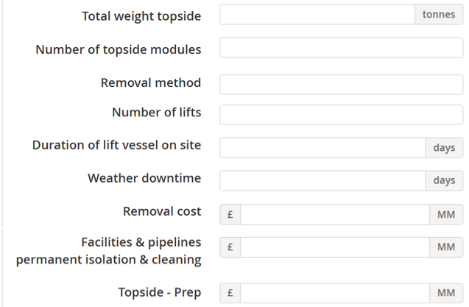
Note:
- Removal method examples include single lift, piece small, heavy lift vessel.
- The removal cost should include all costs to land the topsides at the disposal yard onshore (i.e. WBS 6 only).

2.5.4.2. Substructure / FPSO
For FPSOs, please enter the Time from CoP to Sail-away in days.
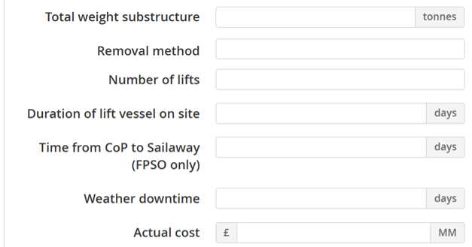
Note:
- Removal method examples include single lift, piece small, heavy lift vessel.
- The actual cost should include all costs to land the substructure at the disposal yard onshore (i.e. WBS 7 only).

2.5.5 ‘Survey year’ Subsea infrastructure actuals
This section is seeking the out-turn costs from decommissioning works performed in year prior to the ‘survey year’. This data will be collected annually so that a suitable number of data points are compiled and benchmarking data can be developed over time.
Please only include if final costs are known.
It is mandatory that all categories with zero values be reported, i.e. state as ‘0’.
Please note the units in this section.

If you selected ‘Yes’ to the question ‘Do you have subsea infrastructure actuals?’
then you must answer the following additional questions:
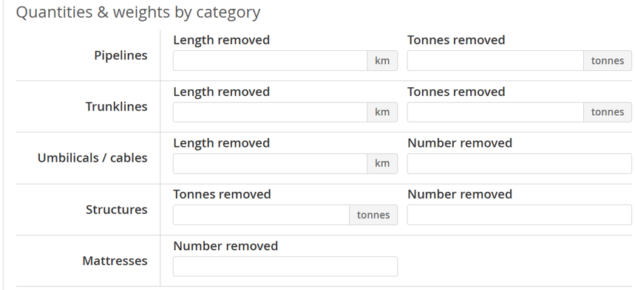
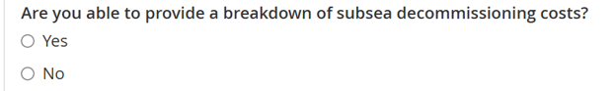
If you selected ‘No’ to the question ‘Are you able to provide a breakdown of subsea decommissioning costs?’
then you will be asked for a lump sum and for further details of this contract.
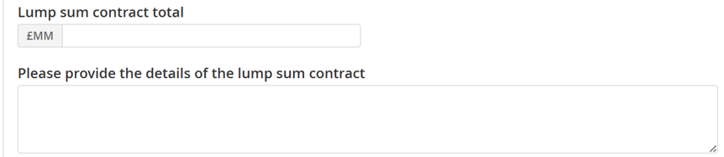
If you selected ‘Yes’ to the question ‘Are you able to provide a breakdown of subsea decommissioning costs?’
then you will be asked to provide a breakdown of costs:
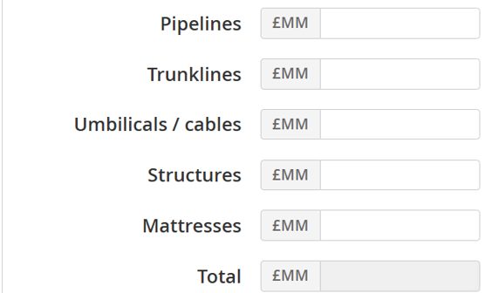

2.6 Cost Review
Background
Decommissioning cost data is currently asked for in both the Activity and Decommissioning sections of the survey.
In the Activity section, high level forecasted cost data per field is asked for and is due earlier than the rest of the survey sections. This is so that the data can be used to inform the NSTA’s estimates and projections of expenditure and production which is provided to the Office of Budget Responsibility ahead of the Spring Statement.
The Decommissioning section asks for costs, along with other information, at a more granular asset level which is due later than the Activity section to provide more time to submit this data.

How to use the cost review page:
The chart has been designed to help ensure that the decommissioning cost profiles entered in the Decommissioning section of the survey are consistent with the decommissioning cost data entered in the Activity section.
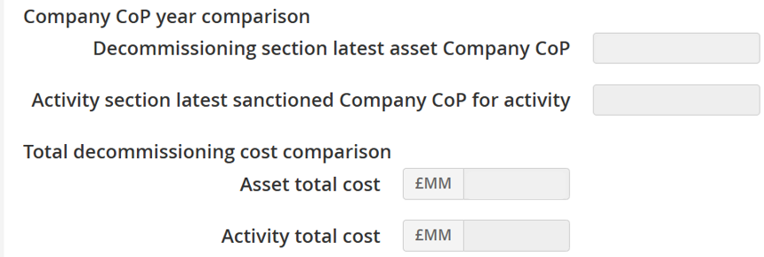
Total decommissioning spend is expected to be within 5% and less than £20MM. A warning will appear when spend is not within 5% and more than £20MM. Please use the graph and data table to identify where the discrepancies lie.
Example chart
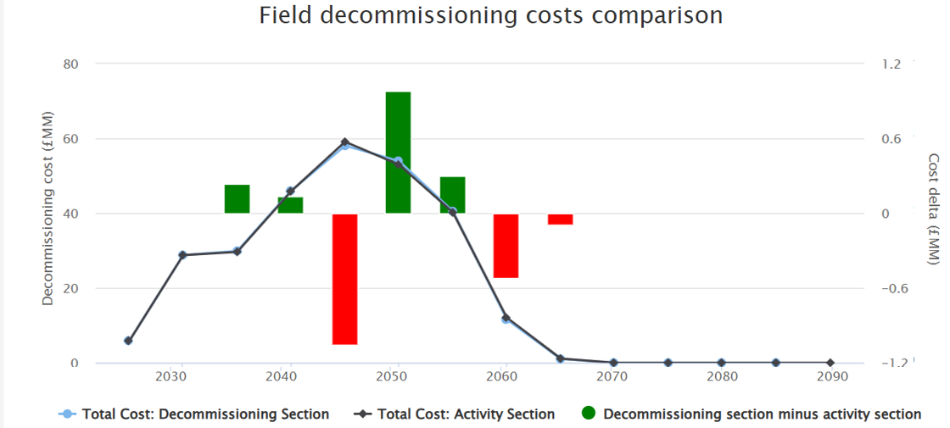
For more information you can hover over a year to see the data,
or click on the icon to view the raw data used to create the chart.
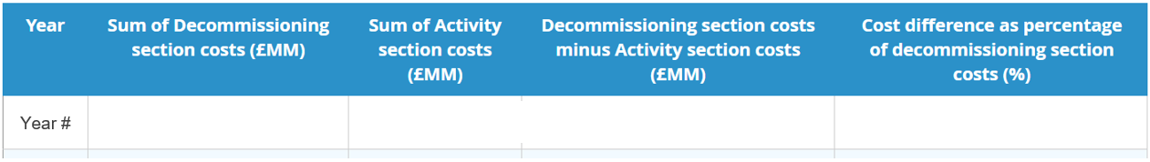
The table can be hidden from view by clicking on the icon.

If the Activity section has yet to be completed, then the following message will be presented:
No Activity section
No Activity section is available for this reporting unit. The graph will only show Decommissioning section data.

The Activity section must be submitted before the graph can pull through the decom data.
If there are any issues highlighted by the graph in the Activity section, please request for the Activity section to be reopened.

Warnings
If warnings are generated but you believe discrepancies to be correct (e.g. E&A wells included in Activity Section), please clarify with an explanation in the ‘warnings have been found’ comments box.

- ORGANISATION
– DECOMMISSIONING

3.1 Decommissioning questions
All field-level Decommissioning sections must be submitted before completing this organisational-level Decommissioning section.

The first three question presented are optional:
- Do you include contingency in your cost estimate?
If ‘yes’, then detail how do you assess contingency: overall company standard, project by project, WBS bucket by bucket, otherwise state ‘no’.
- Do you have a documented Basis of Estimate?
If ‘yes’, then detail what it is based upon (OEUK guidance, NSTA, AACE etc) , otherwise state ‘no’.
- What scope are you proposing will remain in situ / what scope have you had approved to remain in situ from ORPED?
Please review the decommissioning cost submitted in the previous survey year compared to your cost estimate for the current survey year.
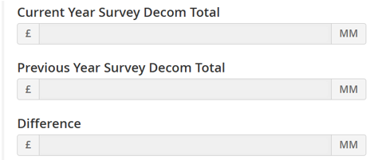

A difference of greater or less than 5% of the total decom liability is considered material,
State which factors contributed to the change in decommissioning cost (‘Difference’ value). Options are:
  - Exchange rate change
  - Inflation changes
  - Basis of estimate change
(i.e. Rig Market, Marine Vessel Market, Benchmark/Performance Forum changes)
  - Scope change
(New Assets, Mergers and Acquisitions, etc.)
If ‘yes’ is selected for Scope change, then please select all the scope change options that apply and provide a reason for the scope change.
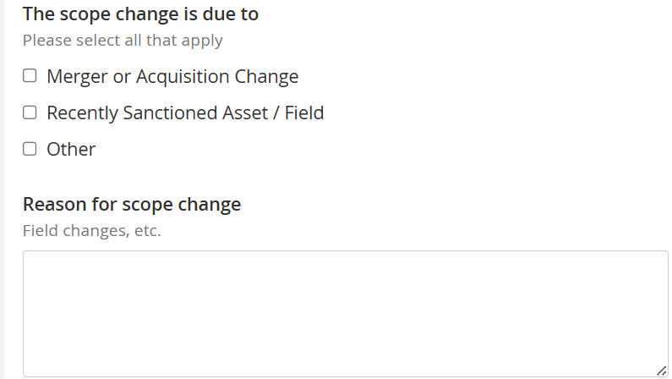

.
- CHECKLIST

Below are the some of the detailed QC steps that each section will go through. If you think your data will not pass these checks, please add as much information in the general comments section as possible to help us understand why.
- Does the Company CoP date entered match that of the Activity section? If not, why not? Please use the ‘Costs review’ section.
- Are the total decommissioning costs and phasing the same as that entered into the Activity section? Please use the ‘Costs Review’ section.
  - It is expected that the decommissioning cost estimate and phasing (previous ‘survey year’, actual ‘survey year’, forecasted years) of total expenditure entered will match the decommissioning estimate provided in the ACTIVITY section of the survey. Please use the ‘Costs Review’ section.
- Have your Decommissioning costs changed materially from the previous year's survey? If so, please use the Organisational level section to select and explain reasoning for significant increase or decrease in costs.
- Are there quantities and weights data in the ‘Quantities and Weights’ section that match the relevant cost phasing?
- Please ensure that the data provided in any of the relevant three actuals sections (below) match the details provided for the ‘survey year’ in the ‘Cost Estimate’ and ‘Quantities and Weights’ section:
  - ‘’survey year’ Well P&A Actuals’
  - ‘’survey year’ Removals actuals – recent removal projects’
  - ‘’survey year’ subsea infrastructure actuals’
e.g. if you have recorded £10MM of Well Actuals across 2 wells, £10MM should be recorded in the Cost Estimate for 2024, with 2 wells recorded in the quantities section for 2024.

- CONTACT DETAILS

If you have any issues when using the UKSS Stewardship Survey then please email stewardshipsurvey@nstauthority.co.uk and the stewardship team will respond as quick as possible.

If you find any errors with the data or question options presented on this survey form, then please report the error to the UK Energy Portal Service Desk by calling 0300 067 1682 or email ukop@nstauthority.co.uk.

