

PETROLEUM ACT 1998, Schedule 2 (Authorisations under Section 14), Part 1 (Works Authorisations), Paragraph 3

Notice of Application for a Submarine Pipeline Works Authorisation

In accordance with the above provisions, Serica Energy (UK) Limited of 4th Floor, 72 Welbeck Street, London, England, W1G 0AY hereby gives notice Serica Energy (UK) Limited to the persons directed by the North Sea Transition Authority (NSTA), that it has made an application to the NSTA for an authorisation for the construction and use of a pipeline between Bruce CR Platform Topside Umbilical Termination Unit (TUTU) and the Western Area Development WAD Manifold Towhead.

The North Sea Transition Authority (NSTA) is the business name of the Oil and Gas Authority (OGA). The OGA remains the legal name of the company. References in this notice to the NSTA should be interpreted as the OGA.

A map (or maps) delineating the route of the proposed pipelines with relevant information may be inspected free of charge at the places listed in Annex B to this notice from 10am to 4pm on each weekday from the date this notice is published until the date referred to in the following paragraph. Alternatively, view electronically on the following page: https://www.nstauthority.co.uk/licensing-consents/consents/pipeline-works-authorisations/public-notices/

Any representations with respect to the application may be made in writing to the NSTA, with a letter addressed to the NSTA, Consents and Authorisations, Third Floor, 1 Marischal Square, Broad Street, Aberdeen, AB10 1BL (FAO: NSTA Consents & Authorisations Manager, Offshore Pipeline Authorisations) with the reference "PA/5586" and sent by email to consents@nstauthority.co.uk. This letter of representations should be sent by 6 March 2026.

Dated 6 February 2026

For and on behalf of

Serica Energy (UK) Limited

Annex A

TECHNICAL ANNEX

In connection with the Serica Energy (UK) Limited’s application for a Pipeline Works Authorisation, it presents the following information about the Bruce development:

Serica Energy (UK) Limited will formally notify the Health & Safety Executive of certain details relating to the proposed new pipeline, prior to construction. This is required under regulation 20 of the Pipelines Safety Regulations (SI 1996/825) and applies only to Major Accident Hazard Pipelines, which are defined in the Regulations.
,

Design Pressure

This is not applicable to this project as the pipeline is an umbilical, no hydrocarbon fluids are to be conveyed.

Limits of Deviation

The pipeline will be laid within a boundary of 100 metres on either side of the proposed route.

Annex B

places where a map (or maps) may be inspected

If you wish to view the map(s) please email the relevant office using the email address referenced in the table below.

Serica Energy plc  72 Welbeck Street (4th Floor)  London  W1G 0AY  info@serica-energy.com | North Sea Transition Authority Consents & Authorisations  Third Floor  1 Marischal Square (1MSq)  Broad Street  Aberdeen  AB10 1BL  consents@nstauthority.co.uk
Marine Scotland Compliance  Area 1-A North  Victoria Quay  Edinburgh  EH6 6QQ  ms.marinelicensing@gov.scot | Scottish Fisheries Protection Agency  Old Harbour Buildings  Scrabster  Caithness  KW14 7UJ  FO.Scrabster@gov.scot
Orkney Fisheries Association  5 Ferry Terminal Building  Kirkwall  Orkney  KW15 1HU  FOKirkwall2@gov.scot | Fishery Office  13-19 Alexandra Buildings  Esplanade  Lerwick  Shetland  ZE1 0LL  FO.Lerwick@gov.scot
National Federation of Fishermens' Organisations  30 Monkgate  York  YO31 7PF  nffo@nffo.org.uk | Scottish Fishermen's Federation  24 Rubislaw Terrace  Aberdeen  AB10 1XE  f.hashimi@sff.co.uk

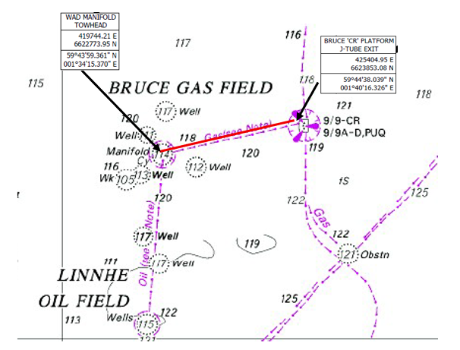

See last page for persons who should receive a copy of the notice from the applicant. The last page should be deleted before publishing the notice.

