TI 24 – 07 Technology Example – KCI Wellhead Sealing Technology

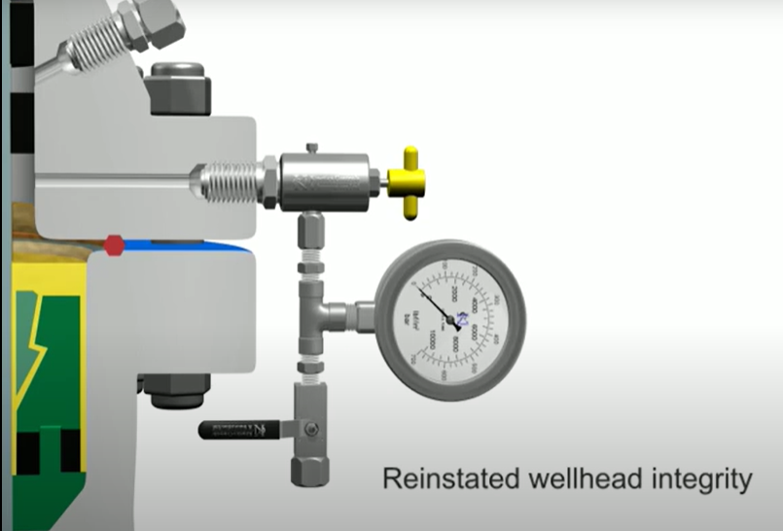

Wellhead Seal Isolations Explained through a Client Case Study

KCI Sealant Technology saves the client approximately USD 60 million
One of the Middle East’s biggest exploration and production companies has a huge well stock. The combination of ageing wells, harsh desert environment and corrosive well fluids present the operator with a big challenge in terms of maintaining life cycle Well Integrity. Therefore, there is a need to seek solutions that can increase safety, reduce well integrity deviations and production deferments.

Why are Wellhead Seal Solutions required?
- One of the most common Well Integrity failures experienced in the field relates to annuli communication through the Wellhead Hanger Seals
- These failures are typically detected during Planned Maintenance Routines (PMR’s)
- These leaks had been traditionally addressed by either pumping hard plastic packing type material into the voids which can be unreliable
- In most cases, it would require a costly hoist or rig workover operation to change out the Christmas Tree and/or the applicable Wellhead Spool Piece

How does KCI’s innovative leak sealing technology work?
- A time activated sealant is deployed in its liquid phase into the voids of wellhead sealing areas
- Once in place, the sealant converts to a resilient, self-bonding and pressure-energized solid material that acts as a static pressure-retaining barrier to re-establish full Well Integrity of the Wellhead
- The product is left to cure under pressure creating a pre-energised isolation. The sealant remains stable from -54°C to 204°C and up to 260°C for short periods so there is no expansion or shrinkage of the product
- A safe, quick and cost-effective solution for onsite Rigless Wellhead Integrity Repairs

Why choose KCI for Wellhead Seal Isolations?
- KCI services have been successfully deployed in this region since 2013
- Over 500 jobs have been completed to date with over a 99% success rate
- To date the KCI Service supplied to this customer has resulted in at least USD 60 million in cost savings on production deferments and associated rig costs on workovers

Vendors Website link: Wellhead Seal Isolations — Solutions — KCI Ltd

