TI 24 – 04 Technology Example – 4subsea PAT (Portable Annulus Tester)

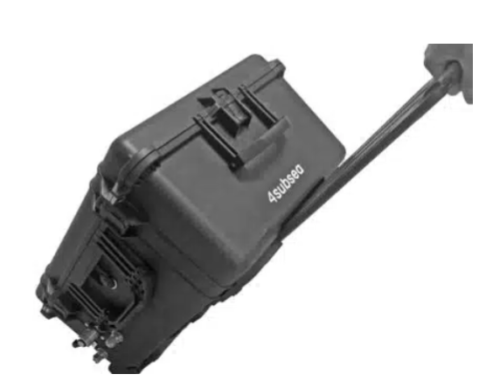

Portable Annulus Tester PAT™
PAT is a fully automated tool for integrity testing of the riser annulus of flexible risers either using pressure or vacuum. PAT can also be used as a retrofittable, temporary, or permanent riser vent gas monitoring solution.

Most oil companies operating flexible risers carry out annulus testing on an annual basis to ensure the integrity of the risers, and to detect anomalies early. The objectives of such tests are to verify the flexible riser outer sheath integrity and the functionality of the ventilation system.
With the Portable Annulus Tester PAT™ we have eliminated the need to send two technicians or engineers offshore by helicopter to perform the tests. The hand-carried test unit performs complete annulus tests, and algorithms are enabling the operator to take immediate action if anomalies are detected.
The system presents results on the FlexTrack™ digital platform, accessible to both onshore and offshore personnel. PAT™ can also function as a permanent monitoring device.

Note, this is an example of this technology, NSTA do not endorse or recommend technologies.
Vendors Website link: Portable Annulus Tester PAT - 4subsea

