TI 22 – 11 Technology Example - OPEX Group X-PAS Predictive Plant Performance Optimisation

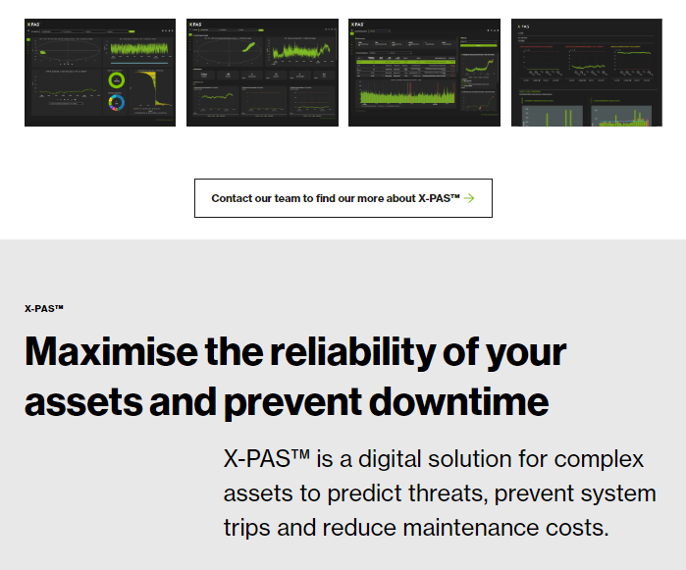

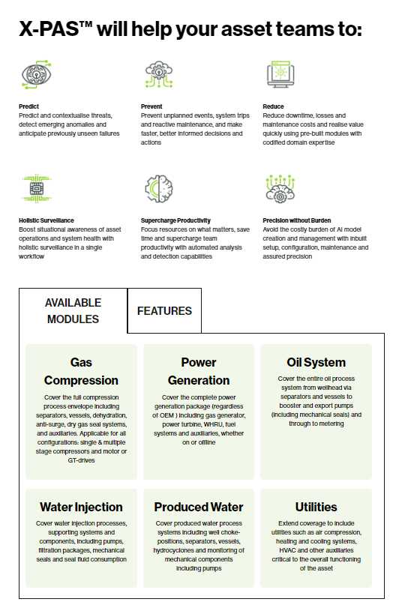

Link to Vendors website:
emissions.AI (erm.com)

